Unit 5 Lesson 11: Dividing Numbers that Result in Decimals

1 Number Talk: Evaluating Quotients (Warm up)

Student Task Statement
Find the quotients mentally.
$400÷8$
$80÷8$
$16÷8$
$496÷8$

2 Keep Dividing (Optional)

Student Task Statement
Mai used base-ten diagrams to calculate $62÷5$. She started by representing 62.
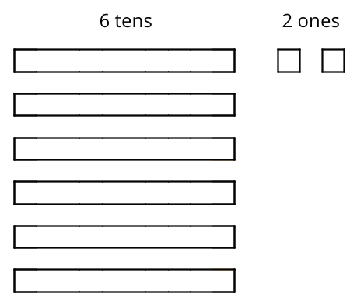
She then made 5 groups, each with 1 ten. There was 1 ten left. She unbundled it into 10 ones and distributed the ones across the 5 groups.
Here is Mai’s diagram for $62÷5$.
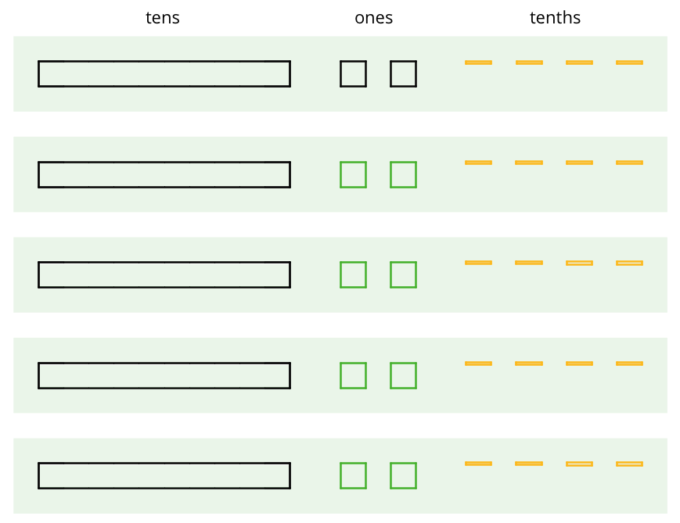
- Discuss these questions with a partner and write down your answers:
  - Mai should have a total of 12 ones, but her diagram shows only 10. Why?
  - She did not originally have tenths, but in her diagram each group has 4 tenths. Why?
  - What value has Mai found for $62÷5$? Explain your reasoning.
- Find the quotient of $511÷5$ by drawing base-ten diagrams or by using the partial quotients method. Show your reasoning. If you get stuck, work with your partner to find a solution.
- Four students share a $271 prize from a science competition. How much does each student get if the prize is shared equally? Show your reasoning.

Activity Synthesis
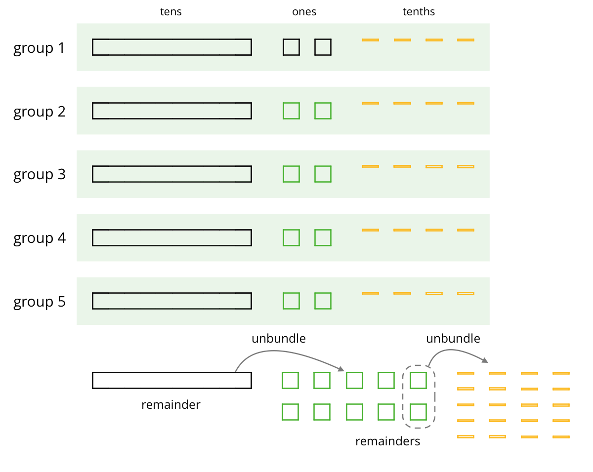

3 Using Long Division to Calculate Quotients

Student Task Statement
Here is how Lin calculated $62÷5$.
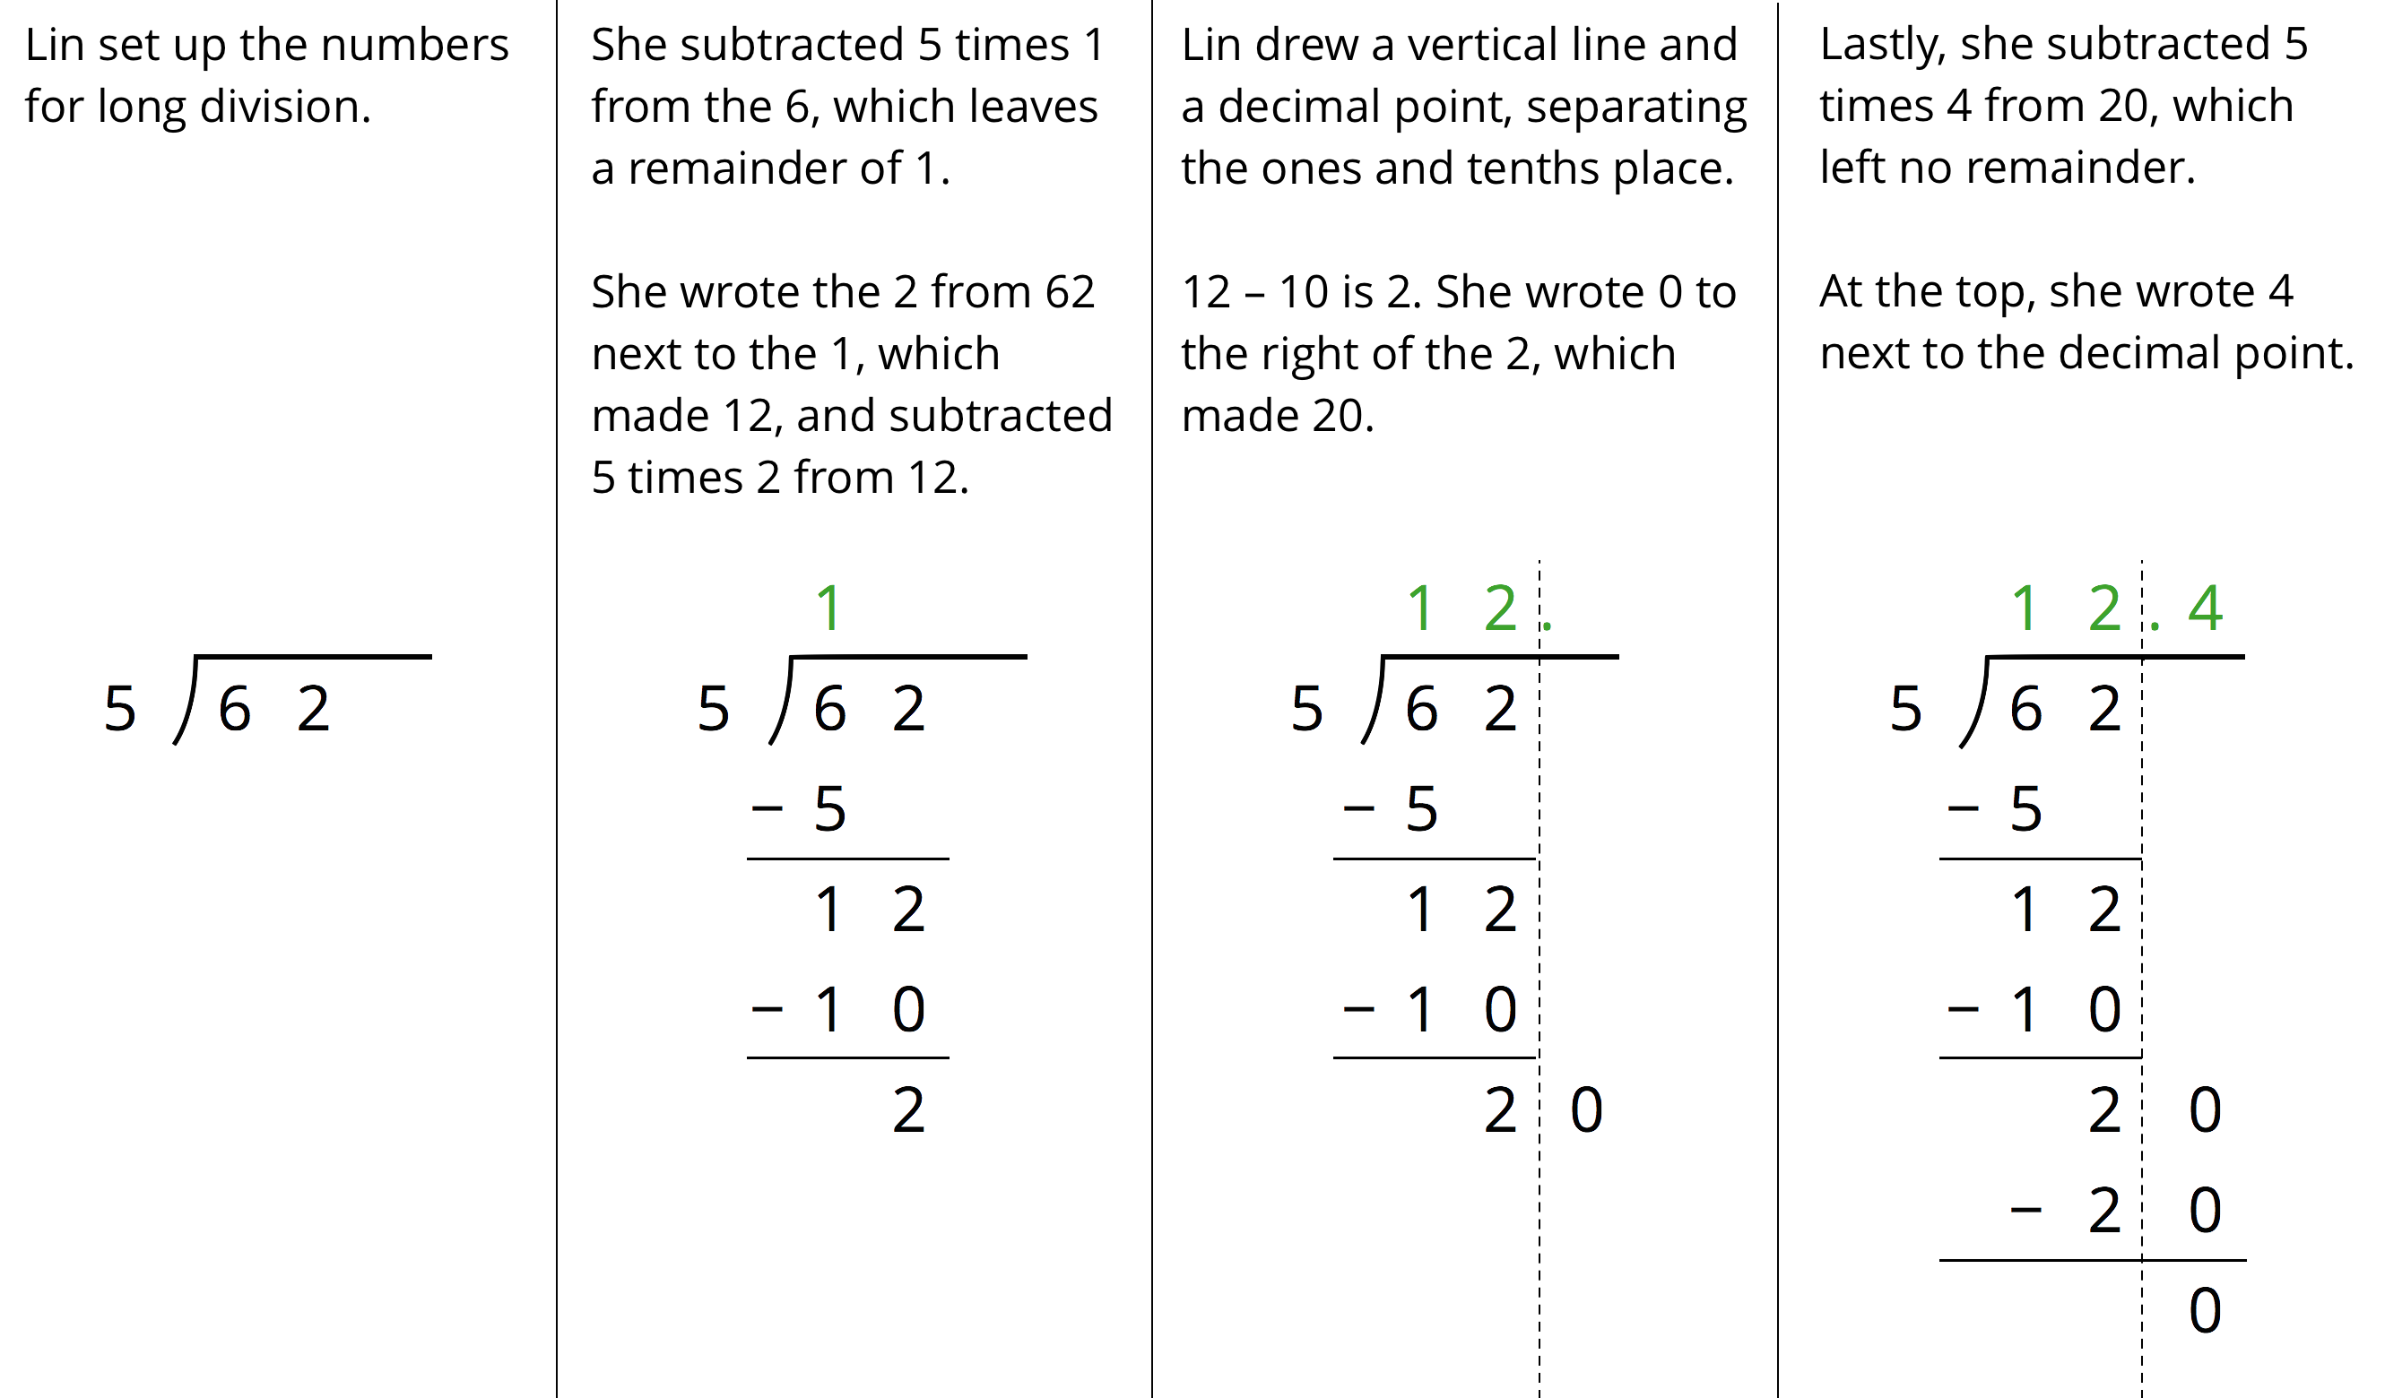
- Discuss with your partner:
  - Lin put a 0 after the remainder of 2. Why? Why does this 0 not change the value of the quotient?
  - Lin subtracted 5 groups of 4 from 20. What value does the 4 in the quotient represent?
  - What value did Lin find for $62÷5$?
- Use long division to find the value of each expression. Then pause so your teacher can review your work.
  - $126÷8$
  - $90÷12$
- Use long division to show that:
  - $5÷4$, or $\frac{5}{4}$, is 1.25.
  - $4÷5$, or $\frac{4}{5}$, is 0.8.
  - $1÷8$, or $\frac{1}{8}$, is 0.125.
  - $1÷25$, or $\frac{1}{25}$, is 0.04.
- Noah said we cannot use long division to calculate $10÷3$ because there will always be a remainder.
  - What do you think Noah meant by “there will always be a remainder”?
  - Do you agree with him? Explain your reasoning.
© CC BY Open Up Resources. Adaptations CC BY IM.

