Lesson 10 Practice Problems
- A sequence is defined by $f\left(0\right)=3,f\left(n\right)=2⋅f\left(n−1\right)$ for $n≥1$. Write a definition for the $n^{\text{th}}$ term of $f$.
- A geometric sequence, $g\left(n\right)$ starts 20, 60, . . . Define $g$ recursively and for the $n^{\text{th}}$ term.
- A geometric sequence $g$ starts at 500 and has a growth factor of 0.6. Sketch a graph of $g$ showing the first 5 terms.

- (From Unit 1, Lesson 7.)

  - An arithmetic sequence has $a\left(1\right)=4$ and $a\left(2\right)=16$. Explain or show how to find the value of $a\left(15\right)$
  - A geometric sequence has $g\left(0\right)=4$ and $g\left(1\right)=16$. Explain or show how to find the value of $g\left(15\right)$.
- (From Unit 1, Lesson 8.)
- A piece of paper has an area of 96 square inches.
  - Complete the table with the area of the piece of paper $A\left(n\right)$, in square inches, after it is folded in half $n$ times.
  - Define $A$ for the $n^{\text{th}}$ term.
  - What is a reasonable domain for the function $A$? Explain how you know.
- $n$ | - $A\left(n\right)$
- 0 | - 96
- 1
- 2
- 3
- (From Unit 1, Lesson 9.)
- Here is a growing pattern:
- 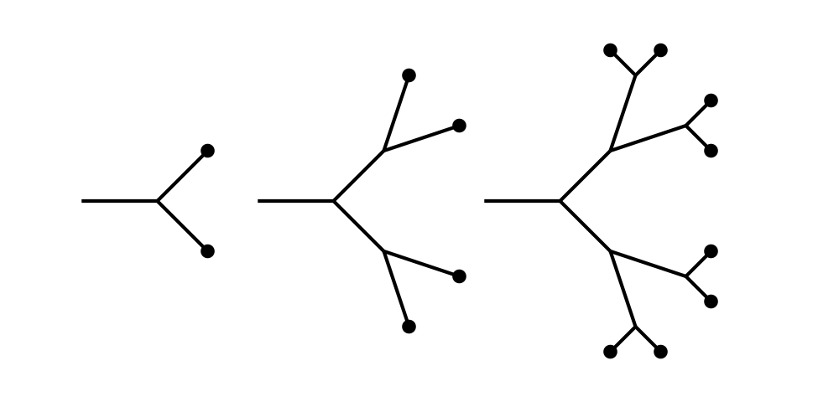
  - Describe how the number of dots increases from Stage 1 to Stage 3.
  - Write a definition for sequence $D$, so that $D\left(n\right)$ is the number of dots in Stage $n$.
  - Is $D$ a geometric sequence, an arithmetic sequence, or neither? Explain how you know.
- (From Unit 1, Lesson 9.)
- A paper clip weighs 0.5 grams and an empty envelope weighs 6.75 grams.
  - Han adds paper clips one at a time to an empty envelope. Complete the table with the weight of the envelope $w\left(n\right)$, in grams, after $n$ paper clips have been added.
  - Does $w\left(10.25\right)$ make sense? Explain how you know.
- $n$ | - $w\left(n\right)$
- 0 | - $6.75$
- 1
- 2
- 3
- (From Unit 1, Lesson 9.)
© CC BY 2019 by Illustrative Mathematics®

