Lesson 3 Practice Problems
- Line $BD$ is tangent to a circle with diameter $AB$. Explain why the measure of angle $BCA$ must equal the measure of angle $ABD$.
- 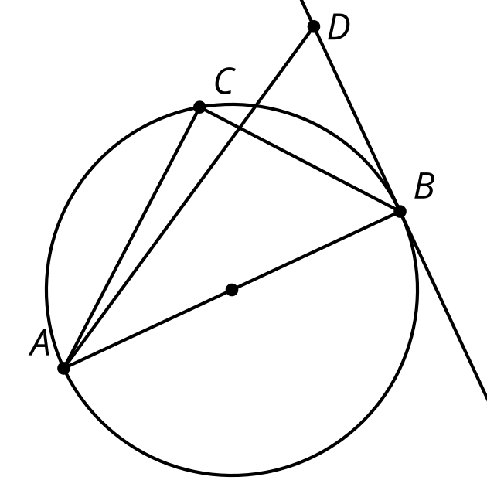
- Line $AC$ is perpendicular to the circle centered at $O$ with radius 1 unit. The length of $AC$ is 1.5 units. Find the length of segment $AB$.
- 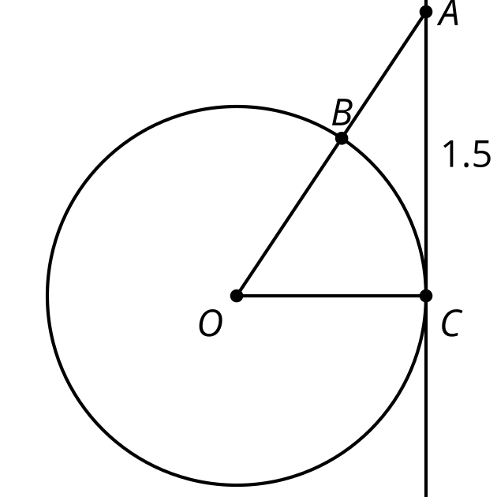
- Technology required. Line $PD$ is tangent to a circle of radius 1 inch centered at $O$. The length of $PD$ is 1.2 inches. The length of $AB$ is 1.7 inches. Which point on the circle is closest to point $P$?
- 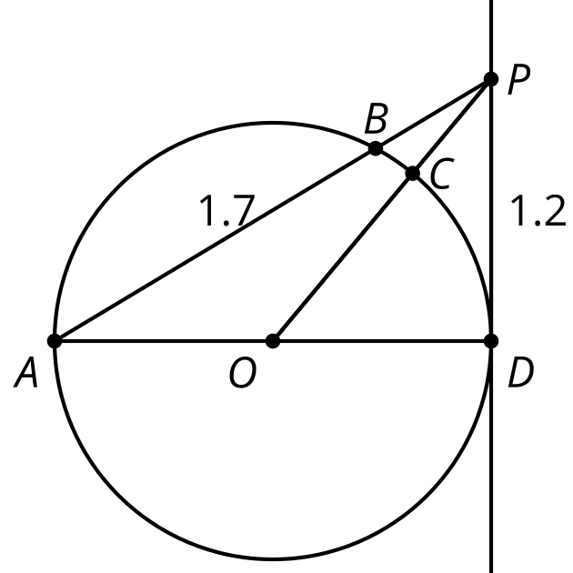
  - point $A$
  - point $B$
  - point $C$
  - point $D$
- The arc from $A$ to $B$ not passing through $C$ measures 50 degrees. Select all the true statements.
- 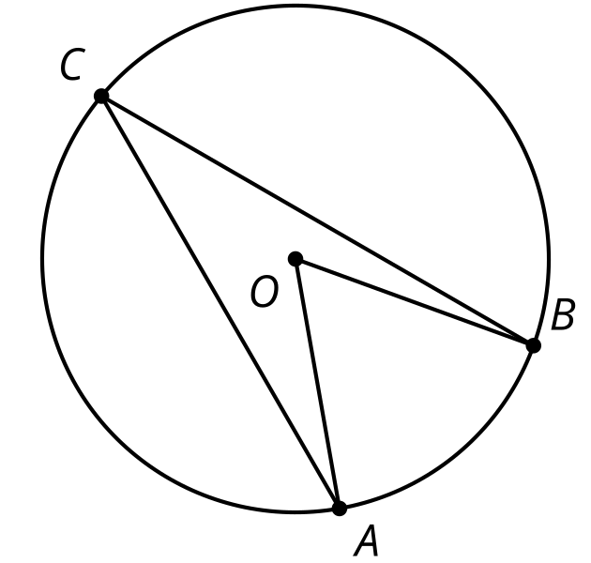
  - Angle $BCA$ measures 50 degrees.
  - Angle $BCA$ measures 25 degrees.
  - Angle $BOA$ measures 50 degrees.
  - The arc from $B$ to $C$ not passing through $A$ measures 180 degrees.
  - Angles $CBO$ and $CAO$ are congruent.
- (From Unit 7, Lesson 2.)
- Chords $AC$ and $DB$ intersect at point $E$. List 3 pairs of angles that must be congruent.
- 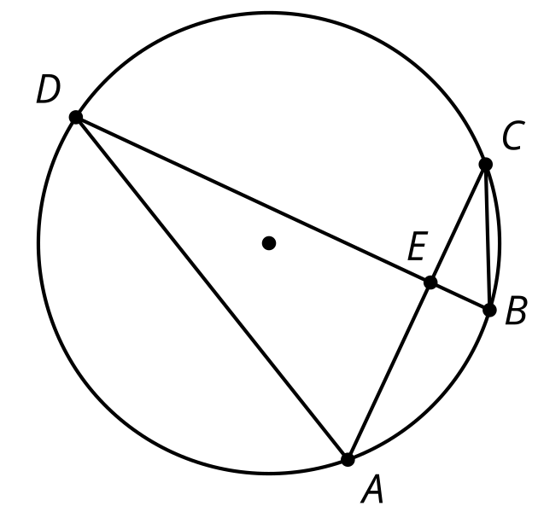
- (From Unit 7, Lesson 2.)
- The image shows a circle with diameters $AC$ and $BD$. Prove that chords $BC$ and $AD$ (not drawn) are congruent.
- 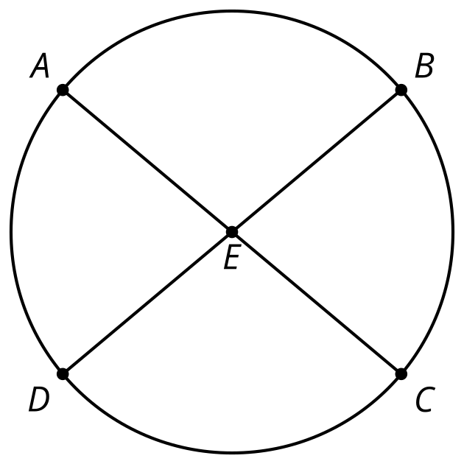
- (From Unit 7, Lesson 1.)
- The line represented by $y+3=\text{-}3\left(x+6\right)$ is transformed by the rule $\left(x,y\right)→\left(\text{-}x,\text{-}y\right)$. What is the slope of the image?
  - 3
  - $\frac{1}{3}$
  - $\text{-}\frac{1}{3}$
  - -3
- (From Unit 6, Lesson 12.)
© CC BY 2019 by Illustrative Mathematics®

