Lesson 20 Practice Problems
- Decide whether each number is rational or irrational.
- 10 | - $\frac{4}{5}$ | - $\sqrt{4}$ | - $\sqrt{10}$ | - -3 | - $\sqrt{\frac{25}{4}}$ | - $\sqrt{0.6}$

- Here are the solutions to some quadratic equations. Select all solutions that are rational.
  - $5±2$
  - $\sqrt{4}±1$
  - $\frac{1}{2}±3$
  - $10±\sqrt{3}$
  - $±\sqrt{25}$
  - $1±\sqrt{2}$
- Solve each equation. Then, determine if the solutions are rational or irrational.
  - ${\left(x+1\right)}^{2}=4$
  - ${\left(x−5\right)}^{2}=36$
  - ${\left(x+3\right)}^{2}=11$
  - ${\left(x−4\right)}^{2}=6$
- Here is a graph of the equation $y=81{\left(x−3\right)}^{2}−4$.
  - Based on the graph, what are the solutions to the equation $81{\left(x−3\right)}^{2}=4$?
  - 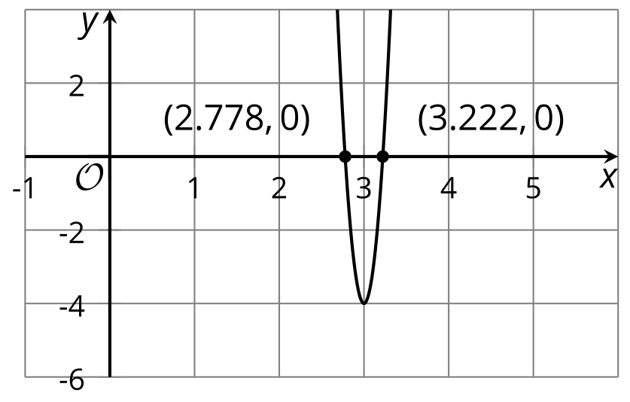
  - Can you tell whether they are rational or irrational? Explain how you know.
  - Solve the equation using a different method and say whether the solutions are rational or irrational. Explain or show your reasoning.
- Match each equation to an equivalent equation with a perfect square on one side.
  - $x^{2}−9x=\frac{1}{2}$
  - $x^{2}+6.4x−8.9=0$
  - $x^{2}−5x=11$
  - $x^{2}+0.1x+0.0005=0$
  - $x^{2}−\frac{6}{7}x=\frac{1}{49}$
  - $x^{2}+1.21x=6.28$
  - ${\left(x−2.5\right)}^{2}=17.25$
  - ${\left(x−\frac{9}{2}\right)}^{2}=\frac{83}{4}$
  - ${\left(x−\frac{3}{7}\right)}^{2}=\frac{10}{49}$
  - ${\left(x+0.05\right)}^{2}=0.002$
  - ${\left(x+3.2\right)}^{2}=19.14$
  - ${\left(x+0.605\right)}^{2}=6.646025$
- (From Unit 7, Lesson 13.)
- To derive the quadratic formula, we can multiply $ax^{2}+bx+c=0$ by an expression so that the coefficient of $x^{2}$ is a perfect square and the coefficient of $x$ is an even number.
  - Which expression, $a$, $2a$, or $4a$, would you multiply $ax^{2}+bx+c=0$ by to get started deriving the quadratic formula?
  - What does the equation $ax^{2}+bx+c=0$ look like when you multiply both sides by your answer?
- (From Unit 7, Lesson 19.)
- Here is a graph that represents $y=x^{2}$.
- On the same coordinate plane, sketch and label the graph that represents each equation:
  - $y=\text{-}x^{2}−4$
  - $y=2x^{2}+4$
- 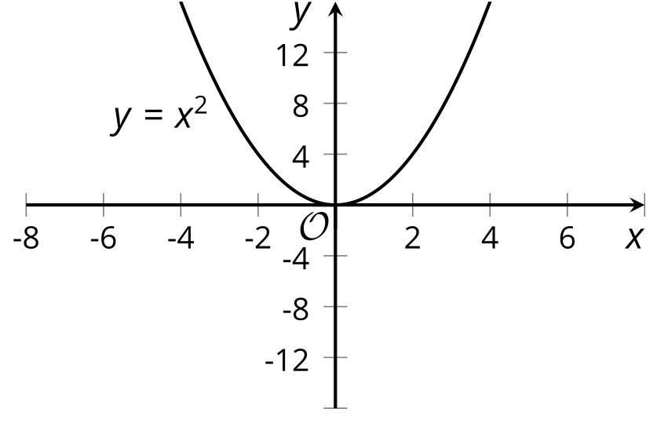
- (From Unit 6, Lesson 12.)
- Which quadratic expression is in vertex form?
  - $x^{2}−6x+8$
  - ${\left(x−6\right)}^{2}+3$
  - $\left(x−3\right)\left(x−6\right)$
  - $\left(8−x\right)x$
- (From Unit 6, Lesson 15.)
- Function $f$ is defined by the expression $\frac{5}{x−2}$.
  - Evaluate $f\left(12\right)$.
  - Explain why $f\left(2\right)$ is undefined.
  - Give a possible domain for $f$.
- (From Unit 4, Lesson 10.)
© CC BY 2019 by Illustrative Mathematics®

