Unit 1 Lesson 8: Formula for the Area of a Triangle

1 Bases and Heights of a Triangle (Warm up)

Student Task Statement
Study the examples and non-examples of bases and heights in a triangle.
- Examples: These dashed segments represent heights of the triangle.
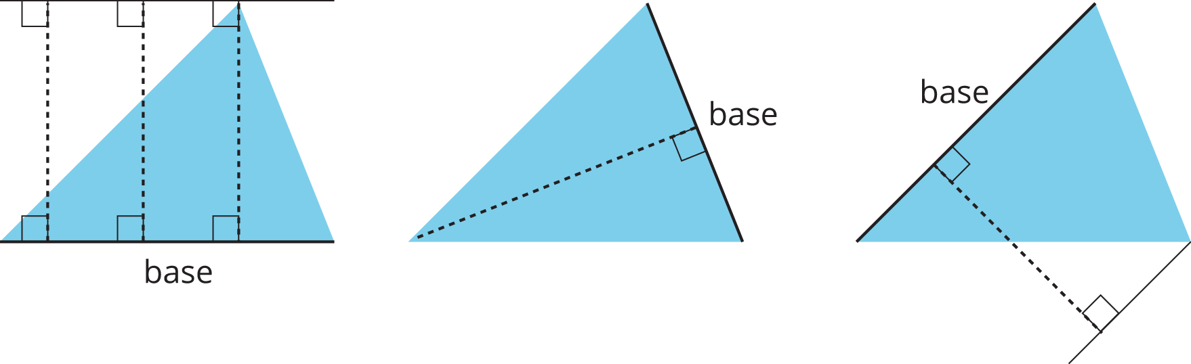
- Non-examples: These dashed segments do not represent heights of the triangle.
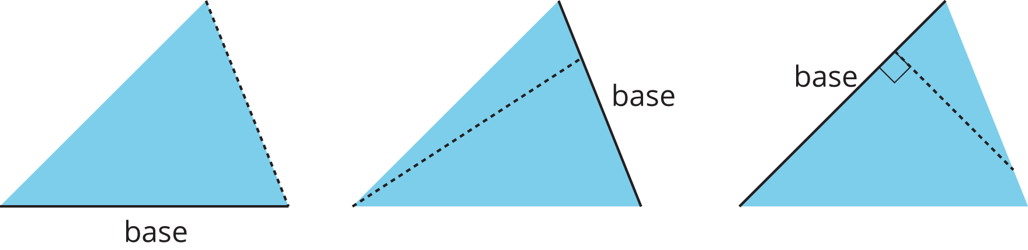
Select all the statements that are true about bases and heights in a triangle.
- Any side of a triangle can be a base.
- There is only one possible height.
- A height is always one of the sides of a triangle.
- A height that corresponds to a base must be drawn at an acute angle to the base.
- A height that corresponds to a base must be drawn at a right angle to the base.
- Once we choose a base, there is only one segment that represents the corresponding height.
- A segment representing a height must go through a vertex.

2 Finding a Formula for Area of a Triangle

Student Task Statement
For each triangle:
- Identify a base and a corresponding height, and record their lengths in the table.
- Find the area of the triangle and record it in the last column of the table.
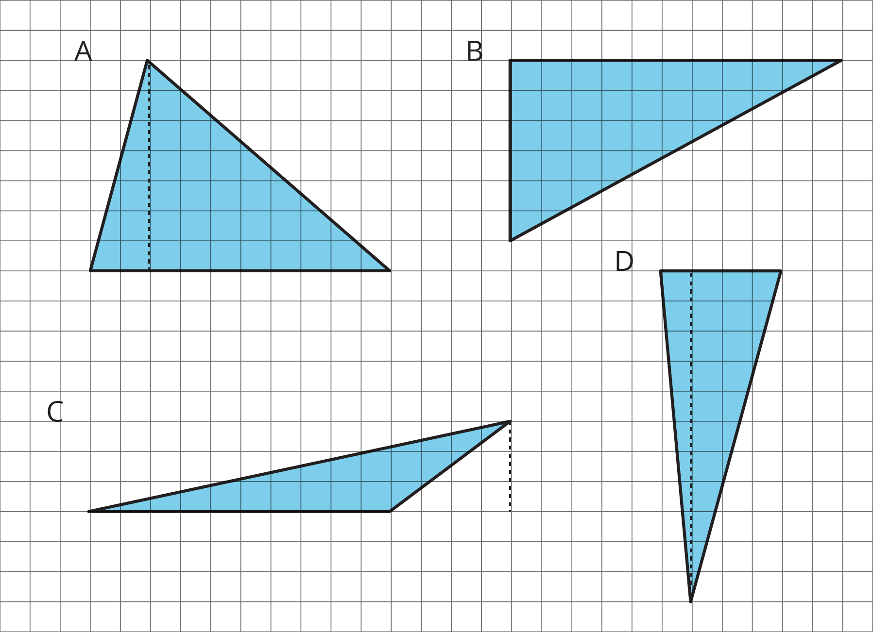
triangle | base (units) | height (units) | area (square units)
A
B
C
D
any triangle | $b$ | $h$
In the last row, write an expression for the area of any triangle, using $b$ and $h$.

Activity Synthesis
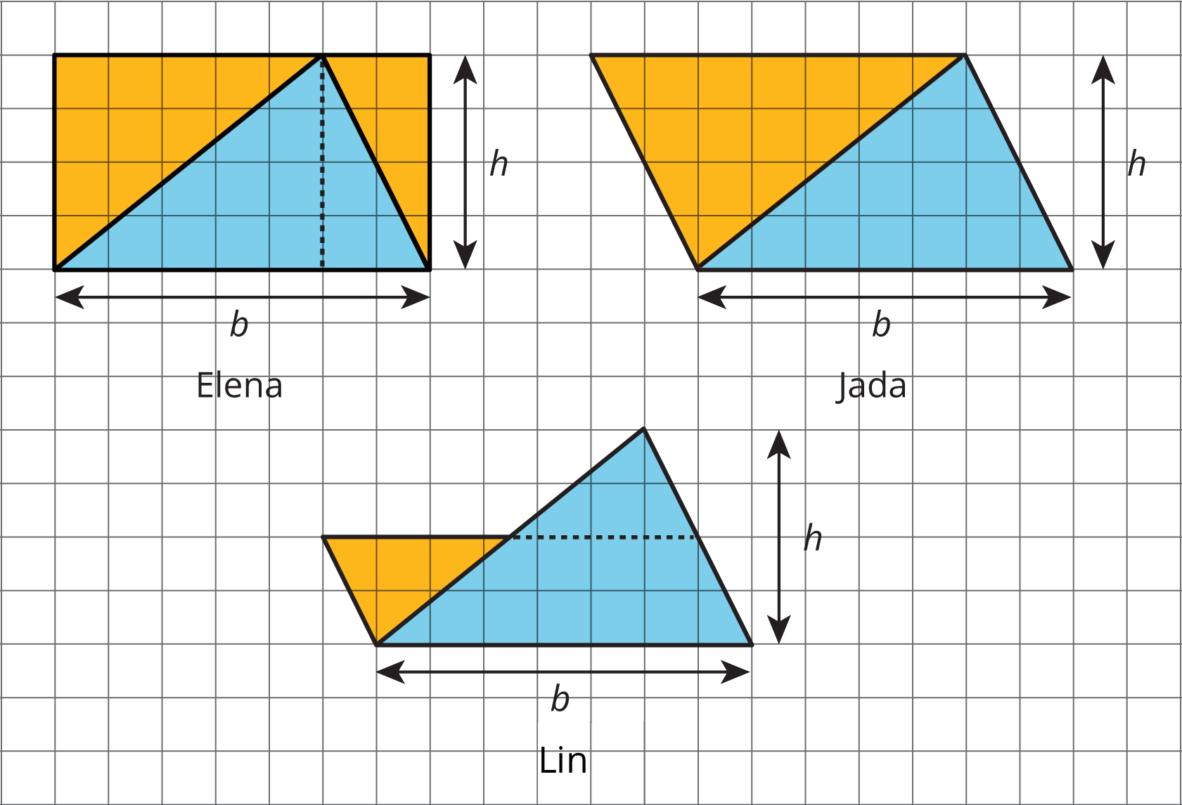

3 Applying the Formula for Area of Triangles

Student Task Statement
For each triangle, circle a base measurement that you can use to find the area of the triangle. Then, find the area of any three triangles. Show your reasoning.
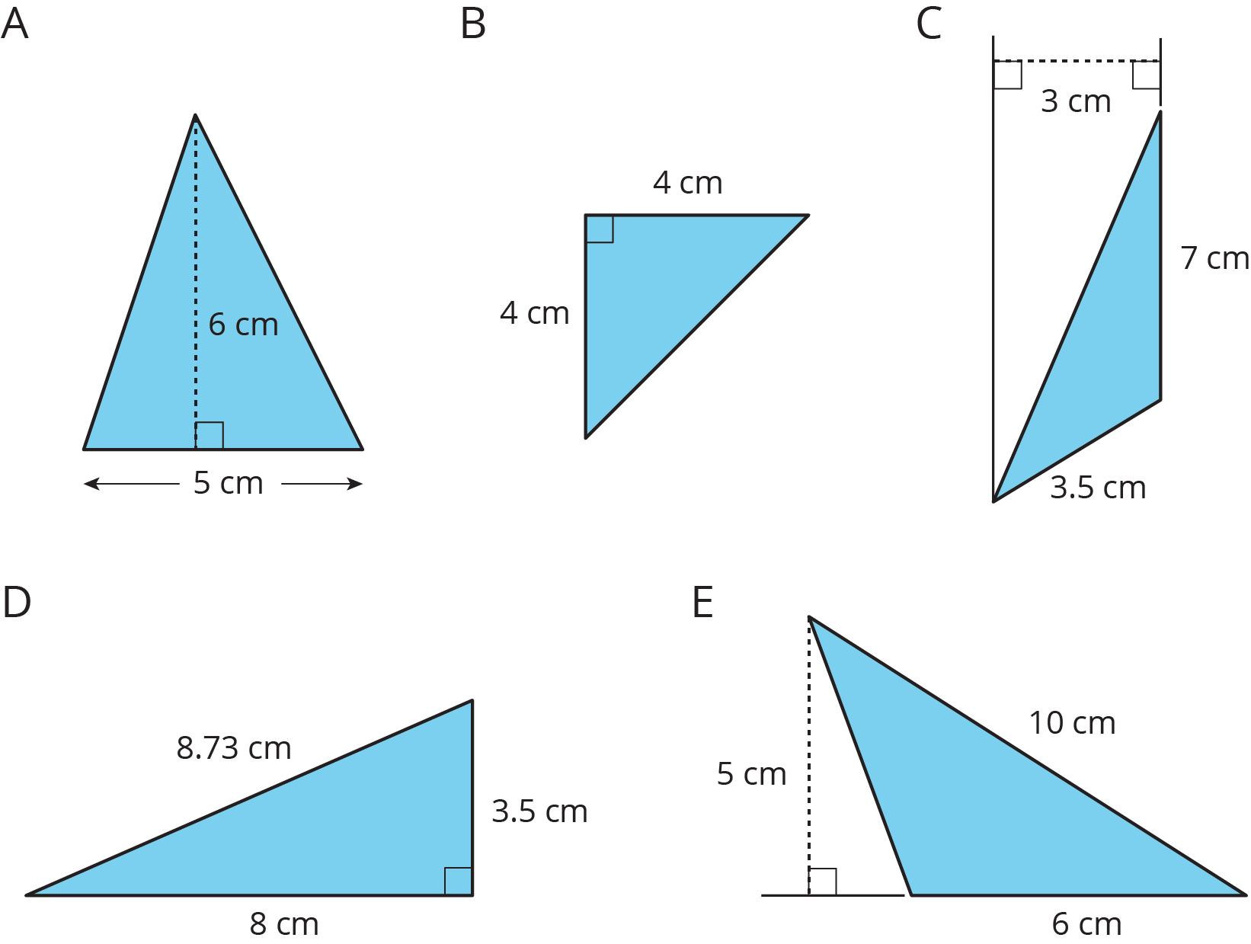

© CC BY Open Up Resources. Adaptations CC BY IM.

