Lesson 9 Practice Problems
- A party will have hexagonal tables placed together with space for one person on each open side:
- 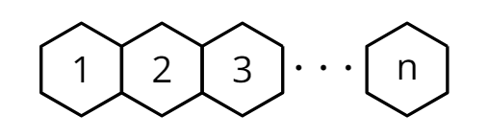
  - Complete this table showing the number of people $P\left(n\right)$ who can sit at $n$ tables.
- $n$ | - 1 | - 2 | - 3 | - 4 | - 5
- $P\left(n\right)$ | - 6
  - Describe how the number of people who can sit at the tables changes with each step.
  - Explain why $P\left(3.2\right)$ does not make sense in this scenario.
  - Define $P$ recursively and for the $n^{\text{th}}$ term.
- Diego is making a stack of pennies. He starts with 5 and then adds them 1 at at time. A penny is 1.52 mm thick.
  - Complete the table with the height of the stack $h\left(n\right)$, in mm, after $n$ pennies have been added.
  - Does $h\left(1.52\right)$ make sense? Explain how you know.
- $n$ | - $h\left(n\right)$
- 0 | - $7.6$
- 1
- 2
- 3
- A piece of paper has an area of 80 square inches. A person cuts off $\frac{1}{4}$ of the piece of paper. Then a second person cuts off $\frac{1}{4}$ of the remaining paper. A third person cuts off $\frac{1}{4}$ what is left, and so on.
  - Complete the table where $A\left(n\right)$ is the area, in square inches, of the remaining paper after the $n^{th}$ person cuts off their fraction.
  - Define $A$ for the $n^{\text{th}}$ term.
  - What is a reasonable domain for the function $A$? Explain how you know.
- $n$ | - $A\left(n\right)$
- 0 | - 80
- 1
- 2
- 3
- Here is the recursive definition of a sequence: $f\left(1\right)=35,f\left(n\right)=f\left(n−1\right)−8$ for $n≥2$.
  - List the first 5 terms of the sequence.
  - Graph the value of each term as a function of the term number.
- 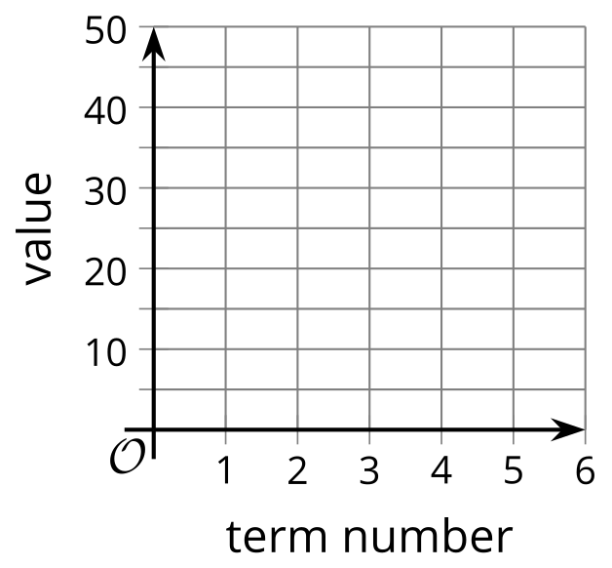
- (From Unit 1, Lesson 7.)
- Here is a graph of sequence $q$. Define $q$ recursively using function notation.
- 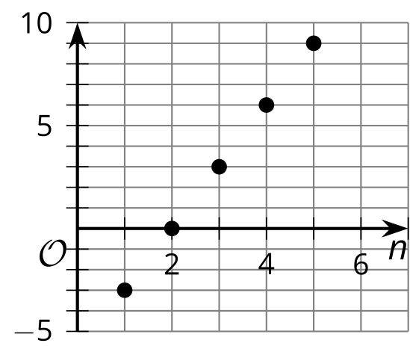
- (From Unit 1, Lesson 6.)
- Here is a recursive definition for a sequence $f$: $f\left(0\right)=19,f\left(n\right)=f\left(n−1\right)−6$ for $n≥1$. The definition for the $n^{\text{th}}$ term is $f\left(n\right)=19−6⋅n$ for $n≥0$.
  - Explain how you know that these definitions represent the same sequence.
  - Select a definition to calculate $f\left(20\right)$, and explain why you chose it.
- (From Unit 1, Lesson 8.)
- An arithmetic sequence $j$ starts 20, 16, . . . Explain how you would calculate the value of the 500th term.
- (From Unit 1, Lesson 8.)
© CC BY 2019 by Illustrative Mathematics®

