Lesson 19 Practice Problems

  - The quadratic equation $x^{2}+7x+10=0$ is in the form of $ax^{2}+bx+c=0$. What are the values of $a$, $b$, and $c$?
  - Some steps for solving the equation by completing the square have been started here. In the third line, what might be a good reason for multiplying each side of the equation by 4?
  - $\begin{matrix} & & & \\ x^{2}+7x+10 & =0 & & \text{Original equation} \\ & & & \\ x^{2}+7x & =\text{-}10 & & \text{Subtract 10 from each side} \\ & & & \\ 4x^{2}+4\left(7x\right) & =4\left(\text{-}10\right) & & \text{Multiply each side by 4} \\ & & & \\ {\left(2x\right)}^{2}+2\left(7\right)2x+{\underset{_}{​}}^{2} & ={\underset{_}{​}}^{2}−4\left(10\right) & & \text{Rewrite }4x^{2}\text{ as }{\left(2x\right)}^{2} \\ & & & \text{and }4\left(7x\right)\text{ as }2\left(7\right)2x \\ & & & \\ {\left(2x+\underset{_}{​}\right)}^{2} & ={\underset{_}{​}}^{2}−4\left(10\right) & & \\ & & & \\ 2x+\underset{_}{​} & =±\sqrt{{\underset{_}{​}}^{2}−4\left(10\right)} & & \\ & & & \\ 2x & =\underset{_}{​}±\sqrt{{\underset{_}{​}}^{2}−4\left(10\right)} & & \\ & & & \\ x & = & & \end{matrix}$
  - Complete the unfinished steps, and explain what happens in each step in the second half of the solution.
  - Substitute the values of $a$, $b$, and $c$ into the quadratic formula, $x=\frac{\text{-}b±\sqrt{b^{2}−4ac}}{2a}$, but do not evaluate any of the expressions. Explain how this expression is related to solving $x^{2}+7x+10=0$ by completing the square.
- Consider the equation $x^{2}−39=0$.
  - Does the quadratic formula work to solve this equation? Explain or show how you know.
  - Can you solve this equation using square roots? Explain or show how you know.
- Clare is deriving the quadratic formula by solving $ax^{2}+bx+c=0$ by completing the square.
- She arrived at this equation.
- ${\left(2ax+b\right)}^{2}=b^{2}−4ac$
- Briefly describe what she needs to do to finish solving for $x$ and then show the steps.
- Tyler is solving the quadratic equation $x^{2}+8x+11=4$.
- Study his work and explain the mistake he made. Then, solve the equation correctly.
- $\begin{matrix}x^{2}+8x+11 & =4 \\ x^{2}+8x+16 & =4 \\ {\left(x+4\right)}^{2} & =4 \\ x=\text{-}8 & \text{ or } x=0\end{matrix}$
- (From Unit 7, Lesson 12.)
- Solve the equation by using the quadratic formula. Then, check if your solutions are correct by rewriting the quadratic expression in factored form and using the zero product property.
  - $2x^{2}−3x−5=0$
  - $x^{2}−4x=21$
  - $3−x−4x^{2}=0$
- (From Unit 7, Lesson 16.)
- A tennis ball is hit straight up in the air, and its height, in feet above the ground, is modeled by the equation $f\left(t\right)=4+12t−16t^{2}$, where $t$ is measured in seconds since the ball was thrown.
  - Find the solutions to $6=4+12t−16t^{2}$ without graphing. Show your reasoning.
  - What do the solutions say about the tennis ball?
- (From Unit 7, Lesson 17.)
- Consider the equation $y=2x\left(6−x\right)$.
  - What are the $x$-intercepts of the graph of this equation? Explain how you know.
  - What is the $x$-coordinate of the vertex of the graph of this equation? Explain how you know.
  - What is the $y$-coordinate of the vertex? Show your reasoning.
  - Sketch the graph of this equation.
  - 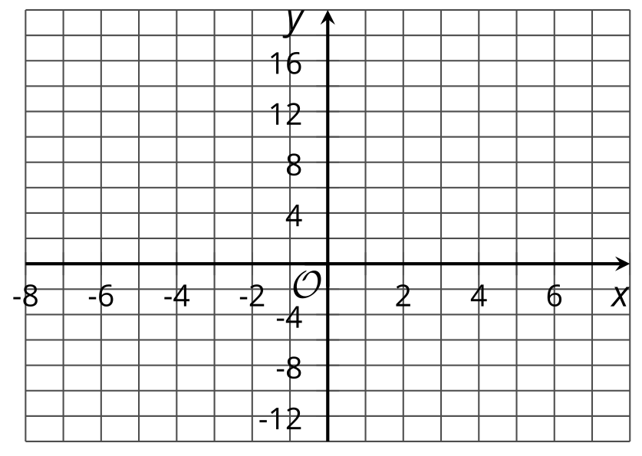
- (From Unit 6, Lesson 11.)
© CC BY 2019 by Illustrative Mathematics®

