Unit 1 Lesson 7: Area of Triangles

1 Composing Parallelograms (Warm up)

Student Task Statement
Here is Triangle M.
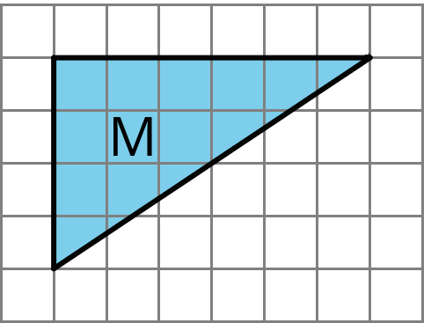
Han made a copy of Triangle M and composed three different parallelograms using the original M and the copy, as shown here.
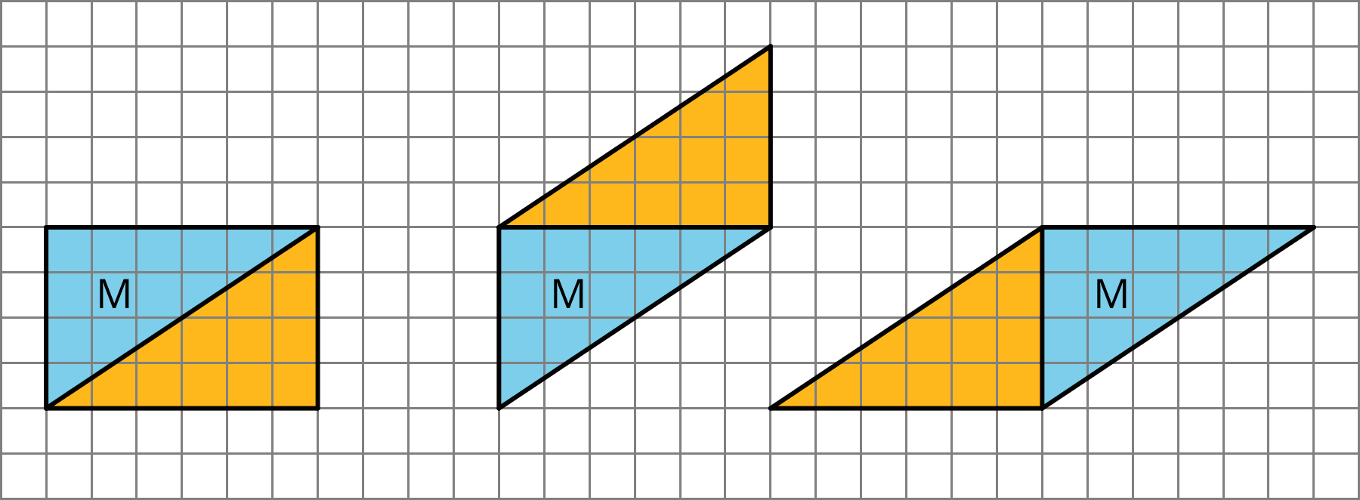
- For each parallelogram Han composed, identify a base and a corresponding height, and write the measurements on the drawing.
- Find the area of each parallelogram Han composed. Show your reasoning.

2 More Triangles

Student Task Statement
Find the areas of at least two of these triangles. Show your reasoning.
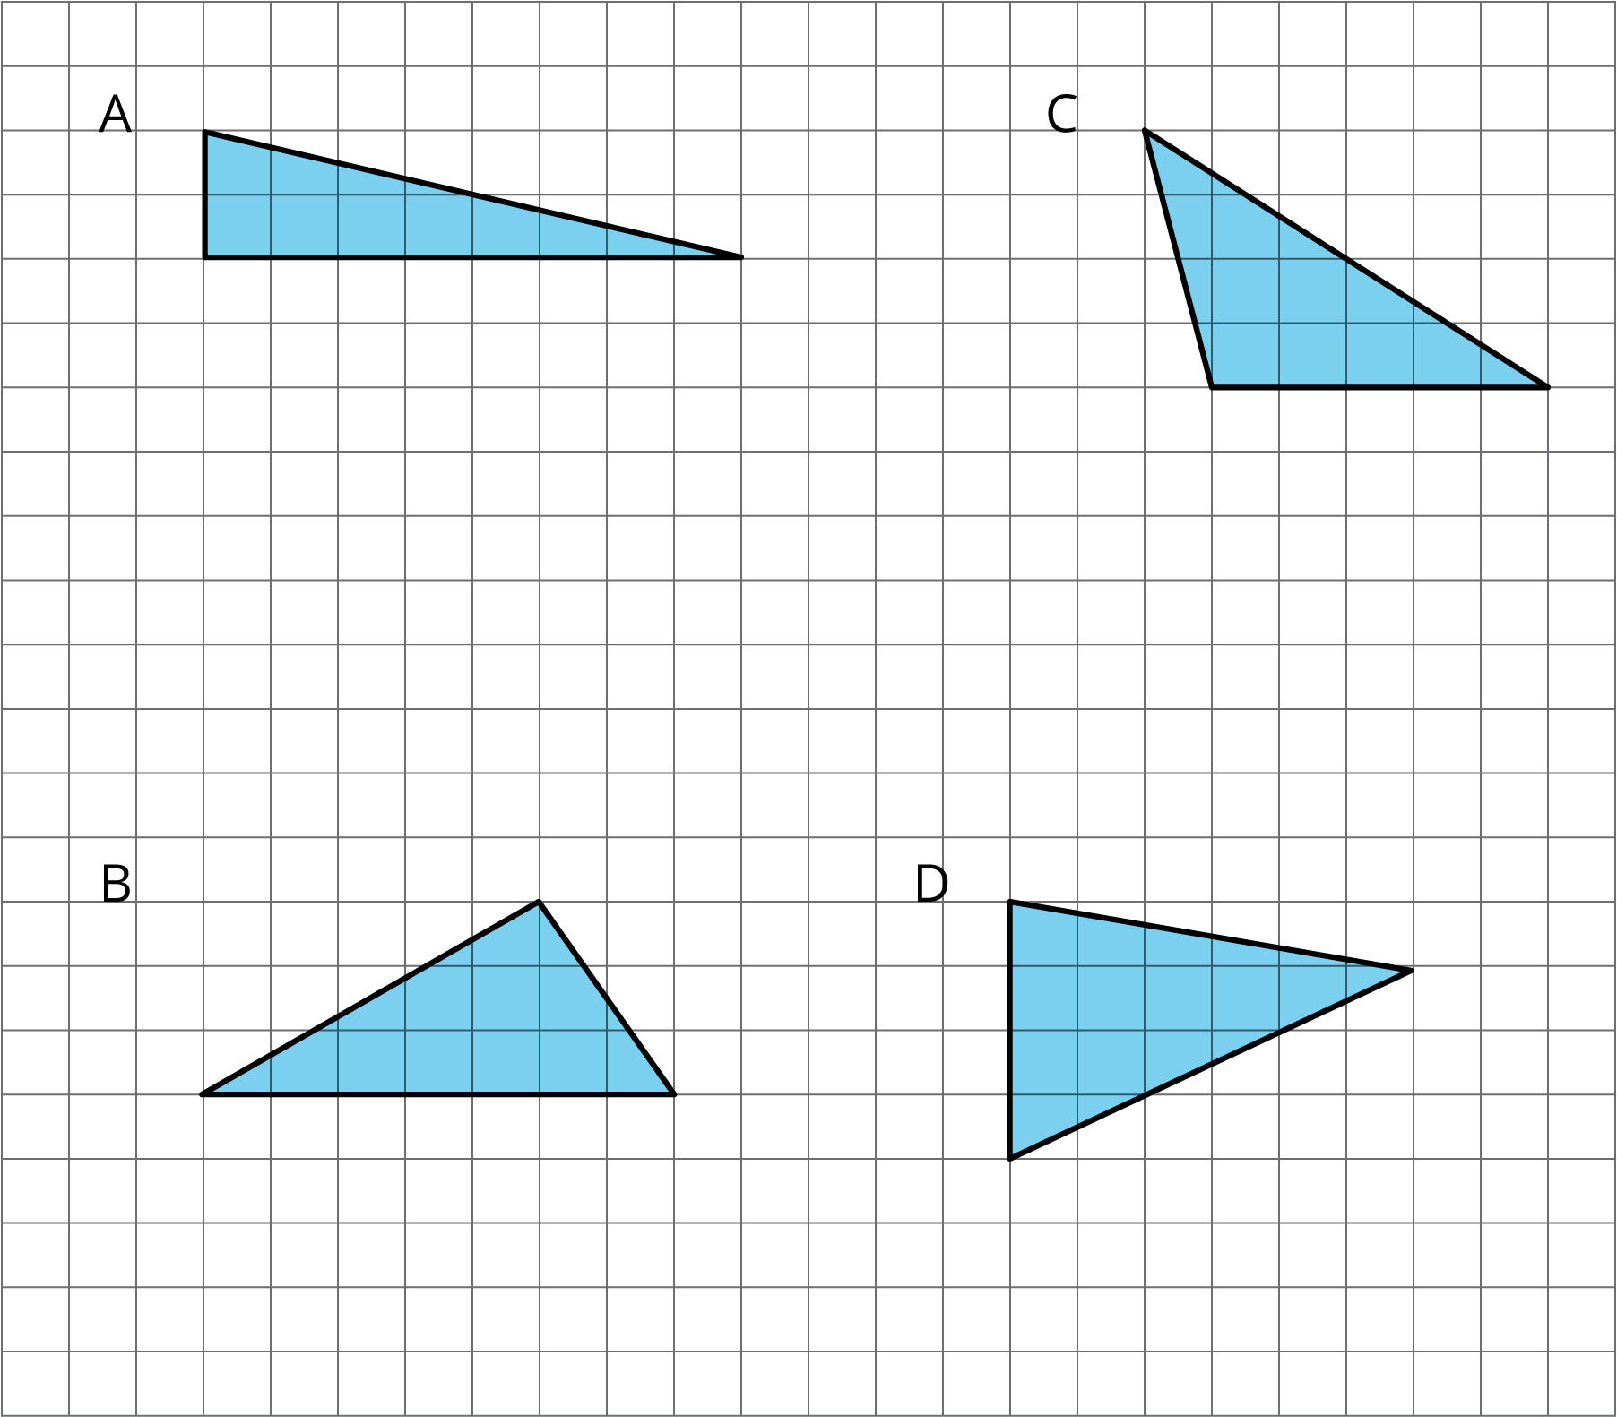

3 Decomposing a Parallelogram (Optional)

Student Task Statement
- Your teacher will give you two copies of a parallelogram. Glue or tape one copy of your parallelogram here and find its area. Show your reasoning.
- Decompose the second copy of your parallelogram by cutting along the dotted lines. Take only the small triangle and the trapezoid, and rearrange these two pieces into a different parallelogram. Glue or tape the newly composed parallelogram on your paper.
- Find the area of the new parallelogram you composed. Show your reasoning.
- What do you notice about the relationship between the area of this new parallelogram and the original one?
- How do you think the area of the large triangle compares to that of the new parallelogram: Is it larger, the same, or smaller? Why is that?
- Glue or tape the remaining large triangle to your paper. Use any part of your work to help you find its area. Show your reasoning.
© CC BY Open Up Resources. Adaptations CC BY IM.

