Unit 1 Lesson 15: Adding the Angles in a Triangle

1 Can You Draw It? (Warm up)

Student Task Statement
- Complete the table by drawing a triangle in each cell that has the properties listed for its column and row. If you think you cannot draw a triangle with those properties, write “impossible” in the cell.
- Share your drawings with a partner. Discuss your thinking. If you disagree, work to reach an agreement.
 | acute (all angles acute) | right (has a right angle) | obtuse (has an obtuse angle)
scalene (side lengths all different)

isosceles (at least two side lengthsare equal)

equilateral (three side lengths equal)

2 Find All Three (Optional)

Student Task Statement
Your teacher will give you a card with a picture of a triangle.
- The measurement of one of the angles is labeled. Mentally estimate the measures of the other two angles.
- Find two other students with triangles congruent to yours but with a different angle labeled. Confirm that the triangles are congruent, that each card has a different angle labeled, and that the angle measures make sense.
- Enter the three angle measures for your triangle on the table your teacher has posted.

3 Tear It Up

Images for Launch
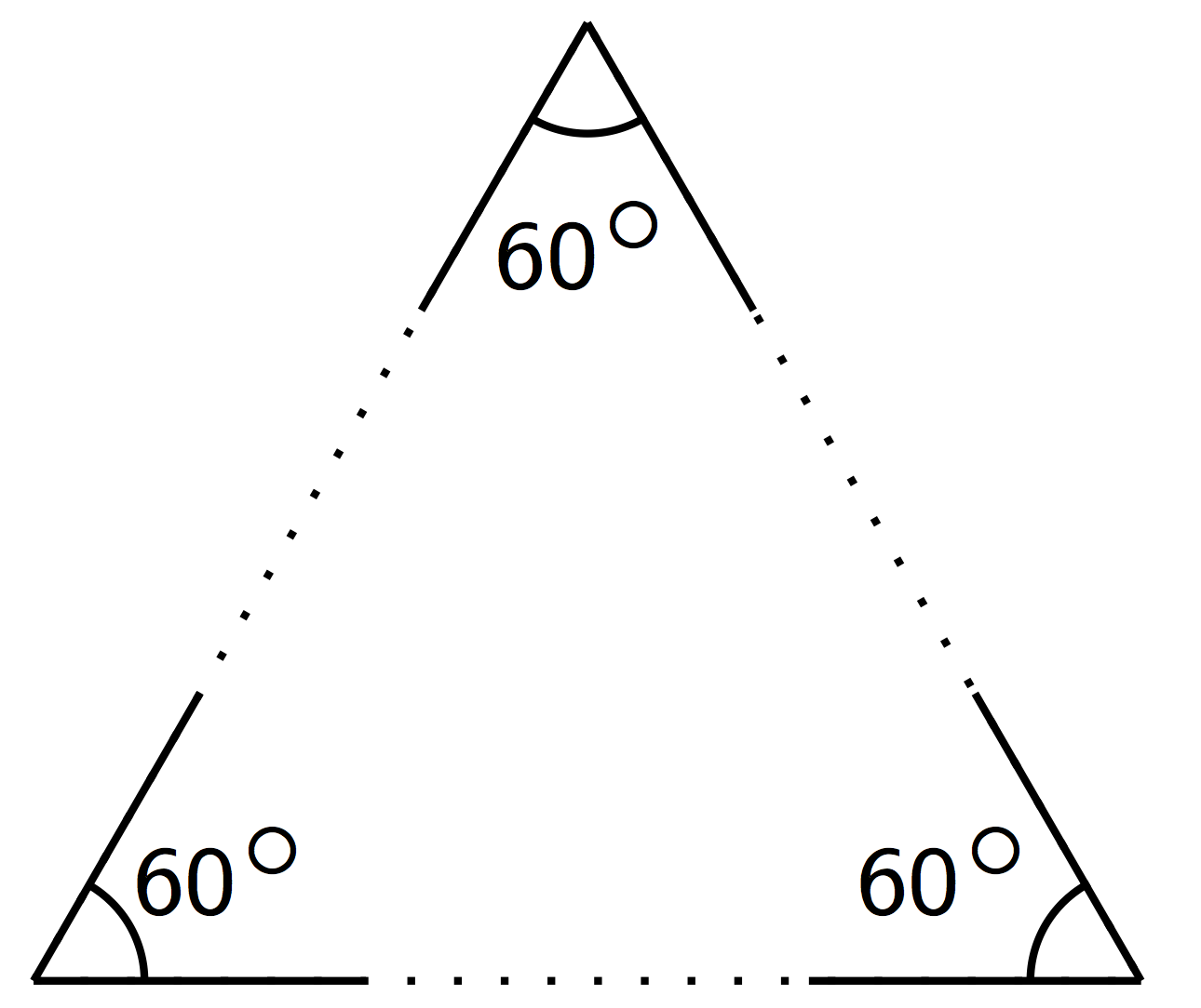

Student Task Statement
Your teacher will give you a page with three sets of angles and a blank space. Cut out each set of three angles. Can you make a triangle from each set that has these same three angles?
© CC BY Open Up Resources. Adaptations CC BY IM.

