Unit 1 Lesson 5: Areas of Parallelograms

1 A Parallelogram and Its Rectangles (Warm up)

Student Task Statement
Elena and Tyler were finding the area of this parallelogram:
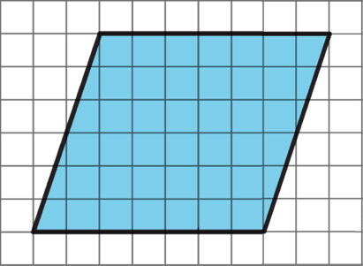
Here is how Elena did it:
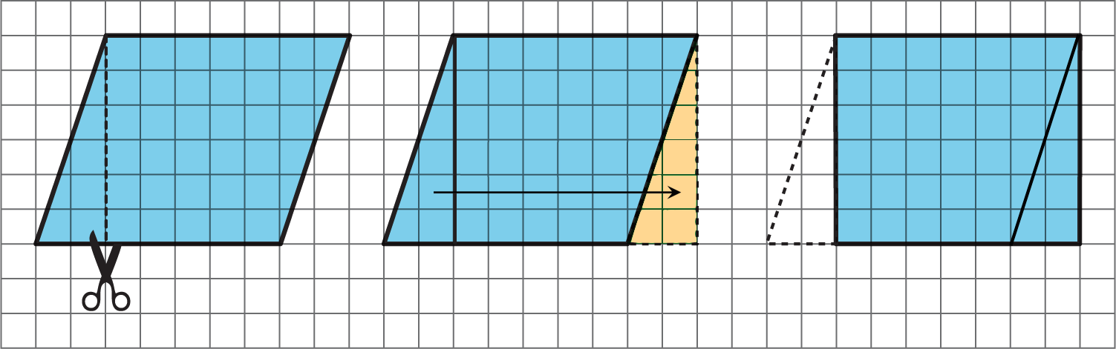
Here is how Tyler did it:
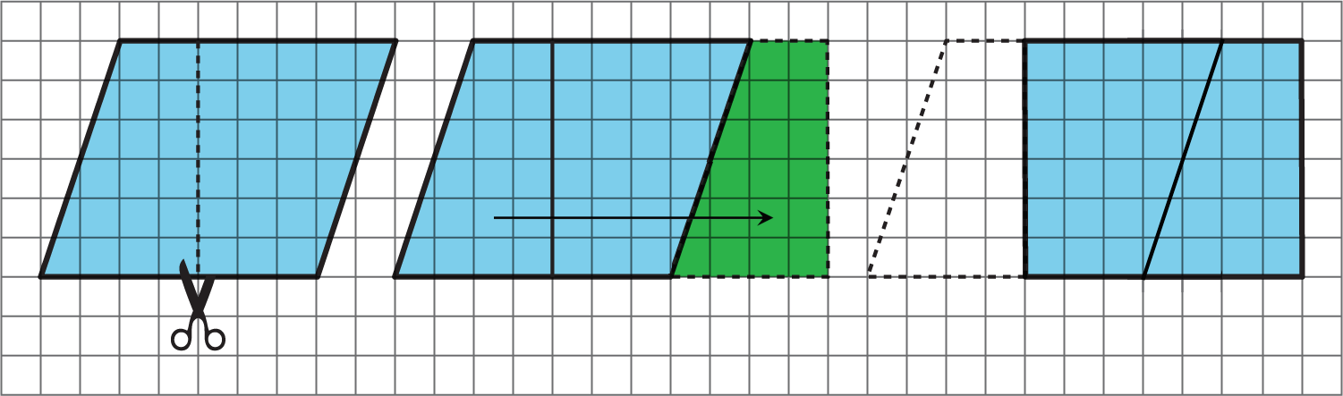
How are the two strategies for finding the area of a parallelogram the same? How they are different?

Activity Synthesis
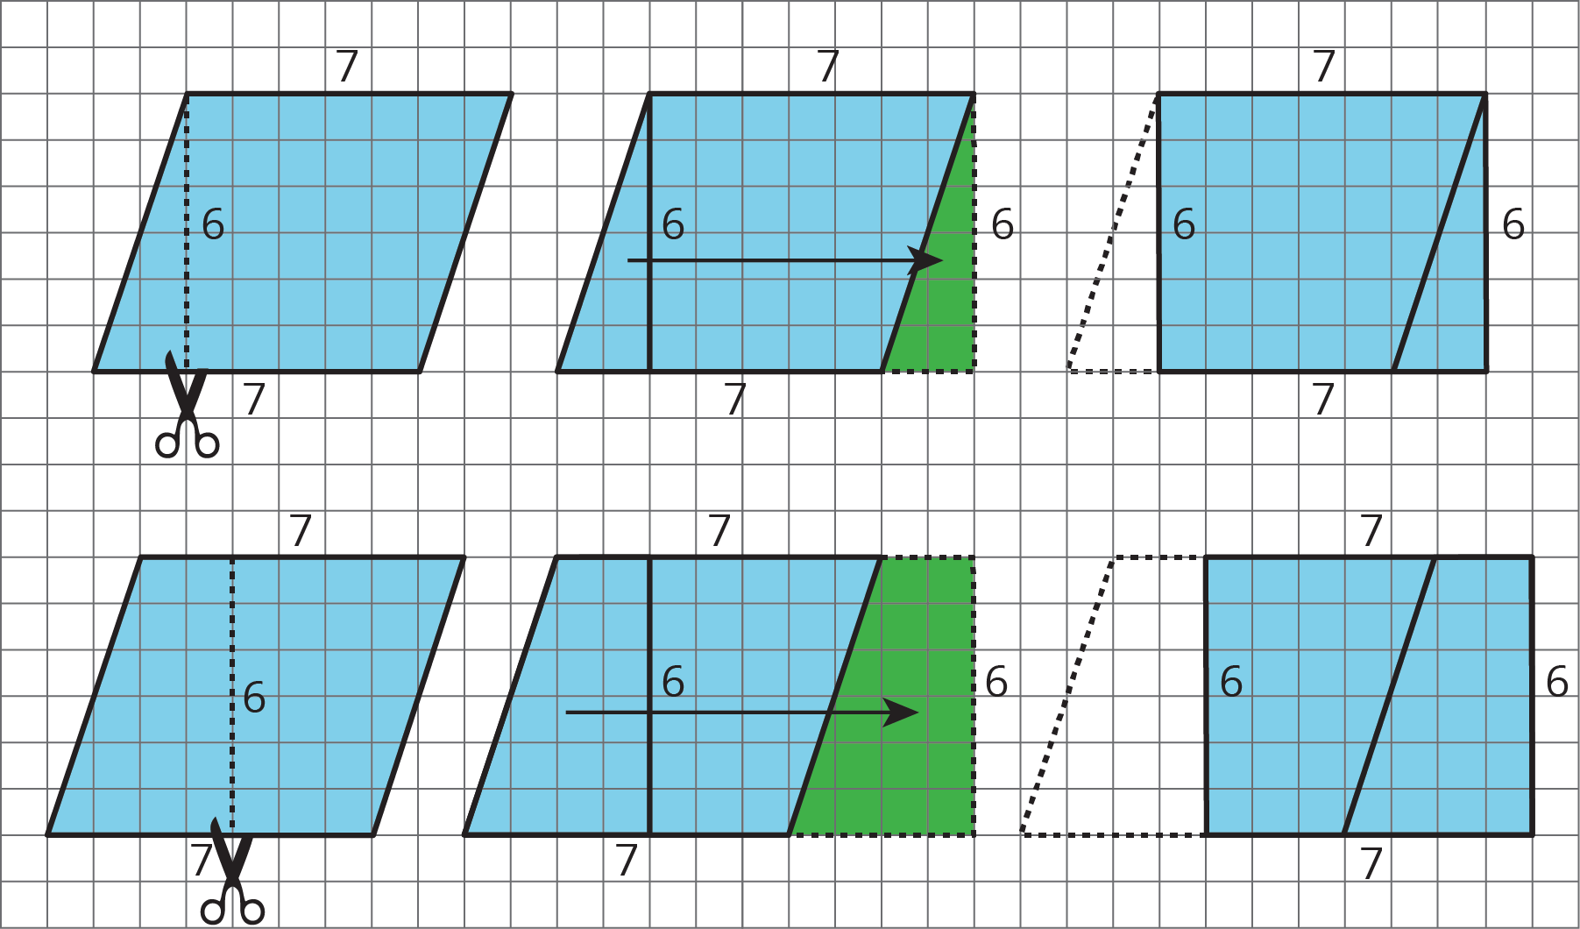

2 Finding the Formula for Area of Parallelograms

Student Task Statement
For each parallelogram:
- Identify a base and a corresponding height, and record their lengths in the table.
- Find the area of the parallelogram and record it in the last column of the table.
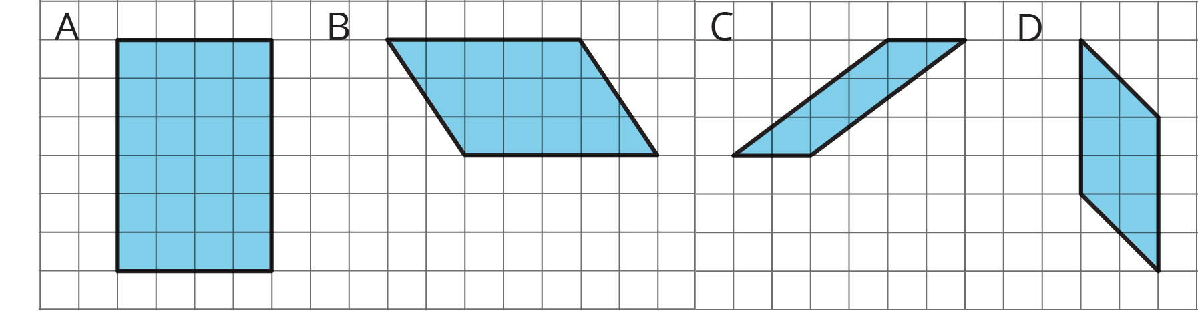
parallelogram | base (units) | height (units) | area (sq units)
A
B
C
D
any parallelogram | $b$ | $h$
In the last row, write an expression for the area of any parallelogram, using $b$ and $h$ .

3 More Areas of Parallelograms

Student Task Statement
- Find the area of each parallelogram. Show your reasoning.
- 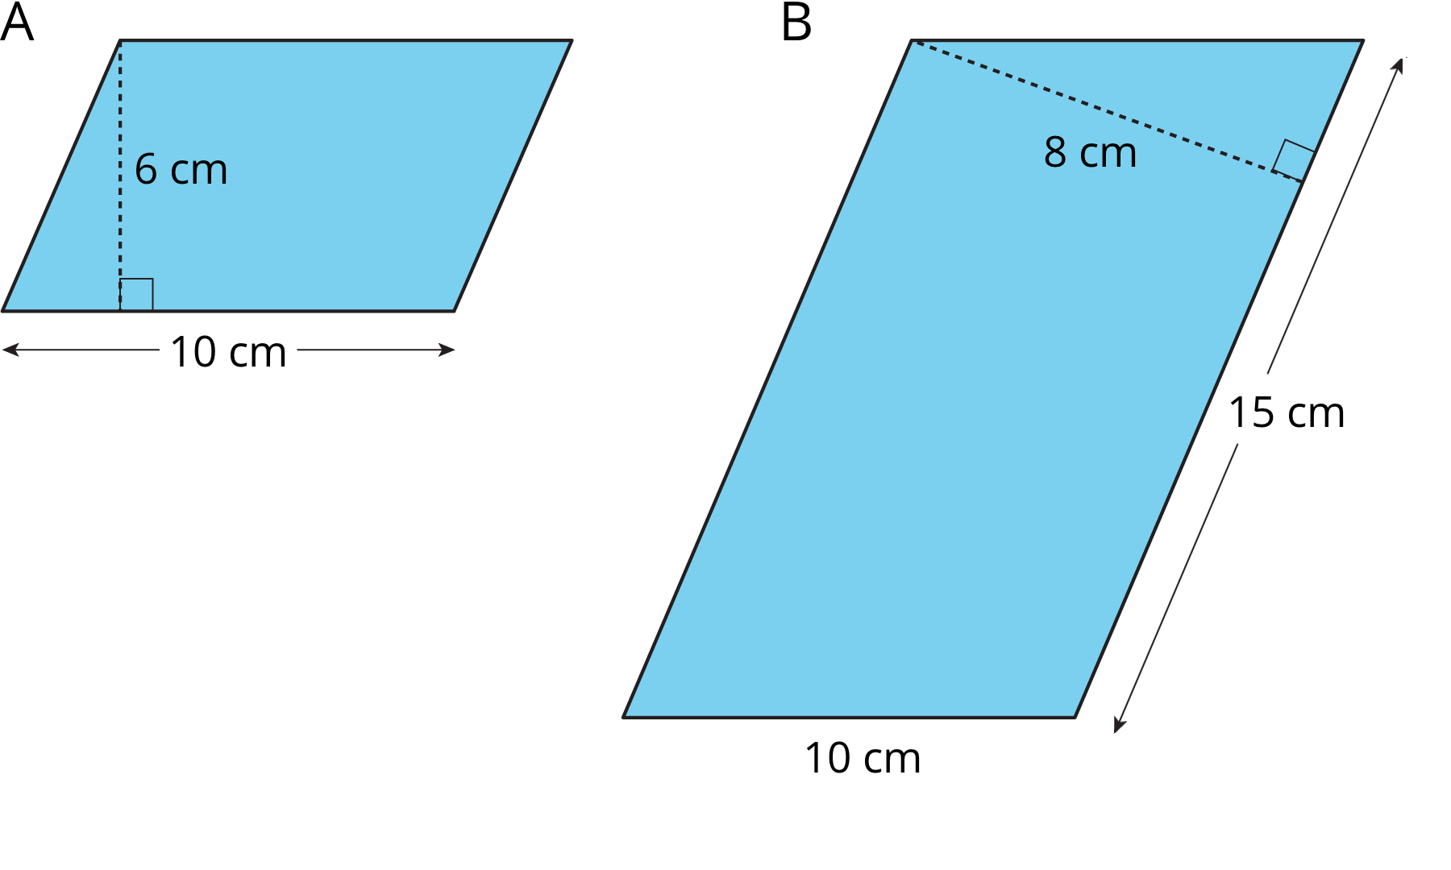
- 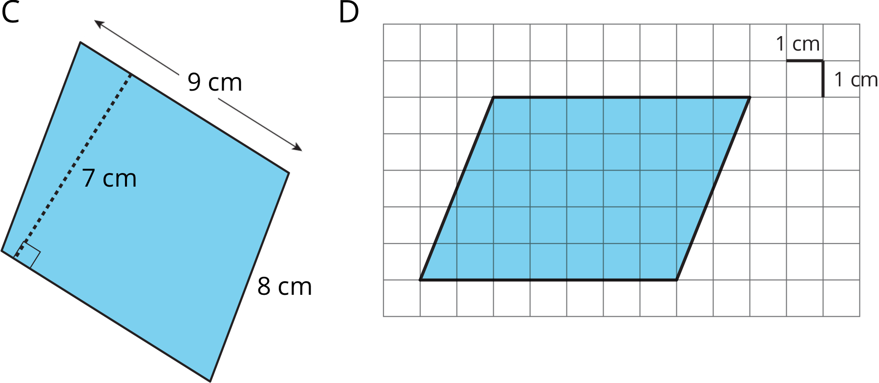
- In Parallelogram B, what is the corresponding height for the base that is 10 cm long? Explain or show your reasoning.
- Two different parallelograms P and Q both have an area of 20 square units. Neither of the parallelograms are rectangles.
- On the grid, draw two parallelograms that could be P and Q.
© CC BY Open Up Resources. Adaptations CC BY IM.

