Unit 1 Lesson 13: Congruence

1 Not Just the Vertices (Warm up)

Student Task Statement
Trapezoids $ABCD$ and $A^{′}B^{′}C^{′}D^{′}$ are congruent.
- Draw and label the points on $A^{′}B^{′}C^{′}D^{′}$ that correspond to $E$ and $F$.
- Draw and label the points on $ABCD$ that correspond to $G^{′}$ and $H^{′}$.
- Draw and label at least three more pairs of corresponding points.
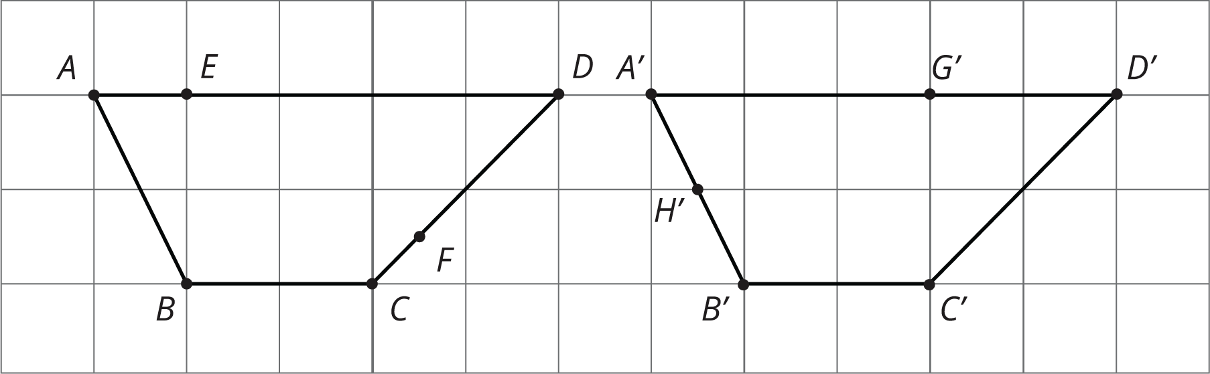

2 Congruent Ovals

Student Task Statement
Are any of the ovals congruent to one another? Explain how you know.
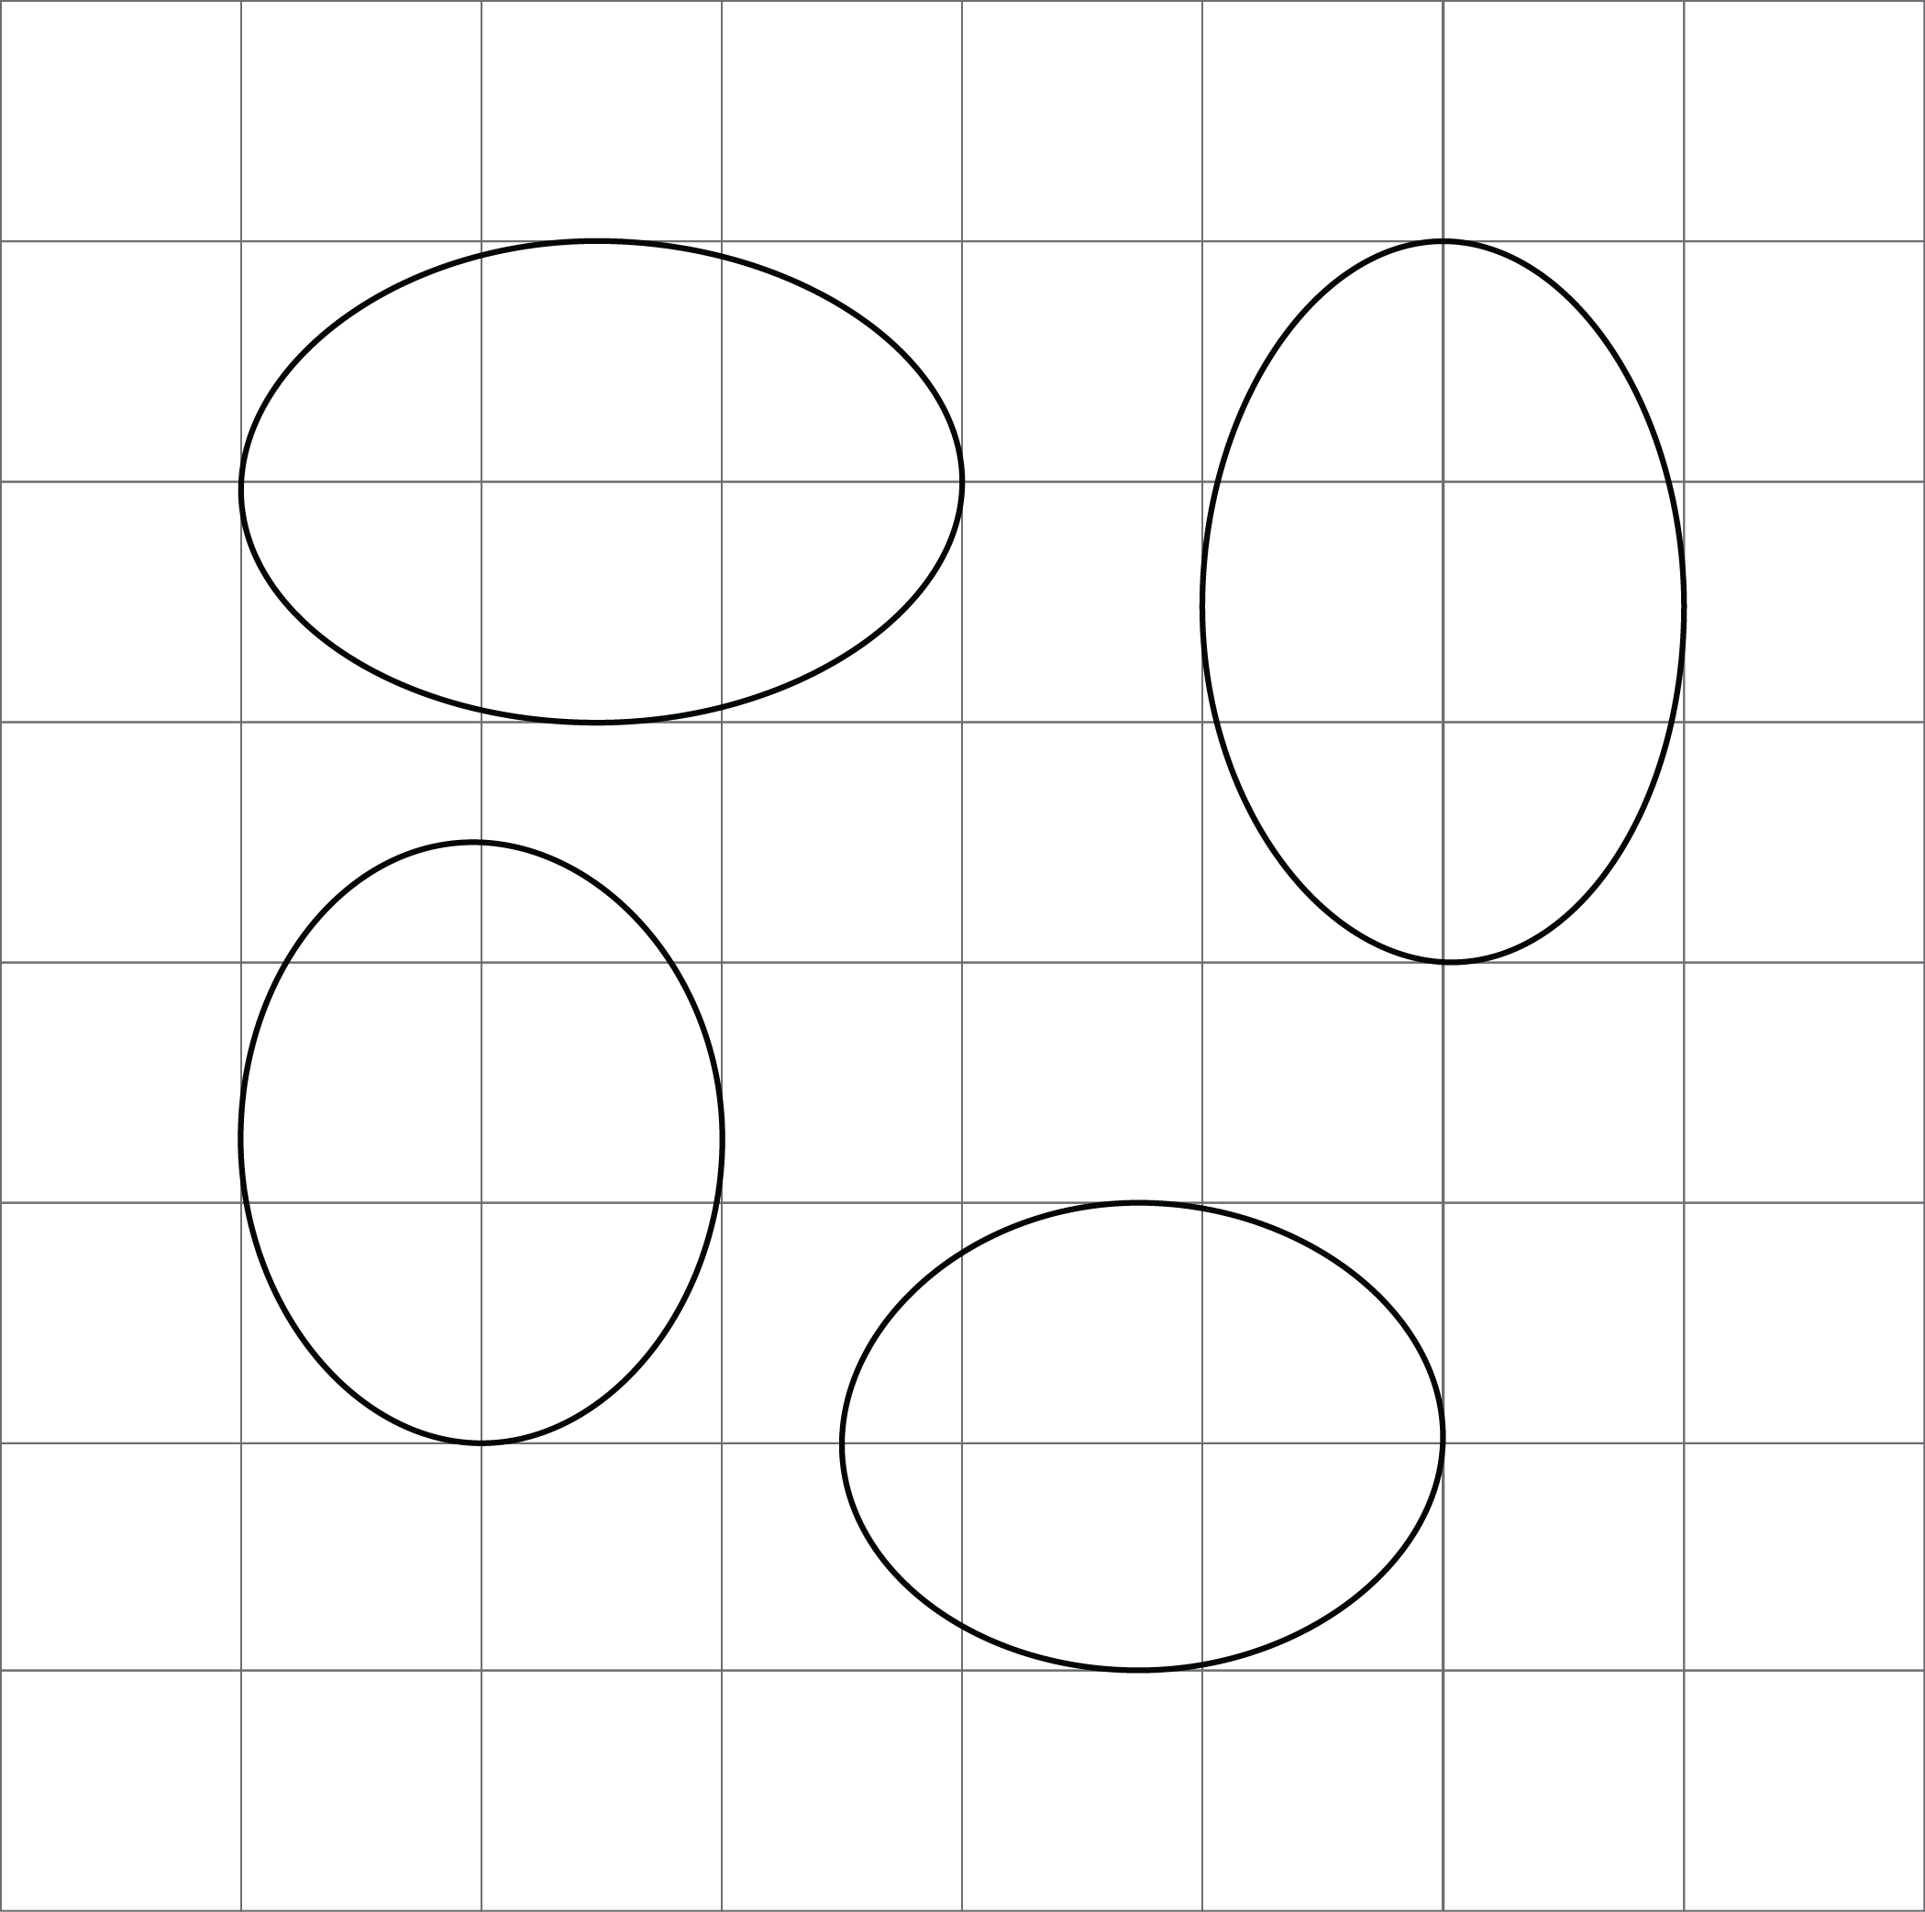

3 Corresponding Points in Congruent Figures

Student Task Statement
Here are two congruent shapes with some corresponding points labeled.
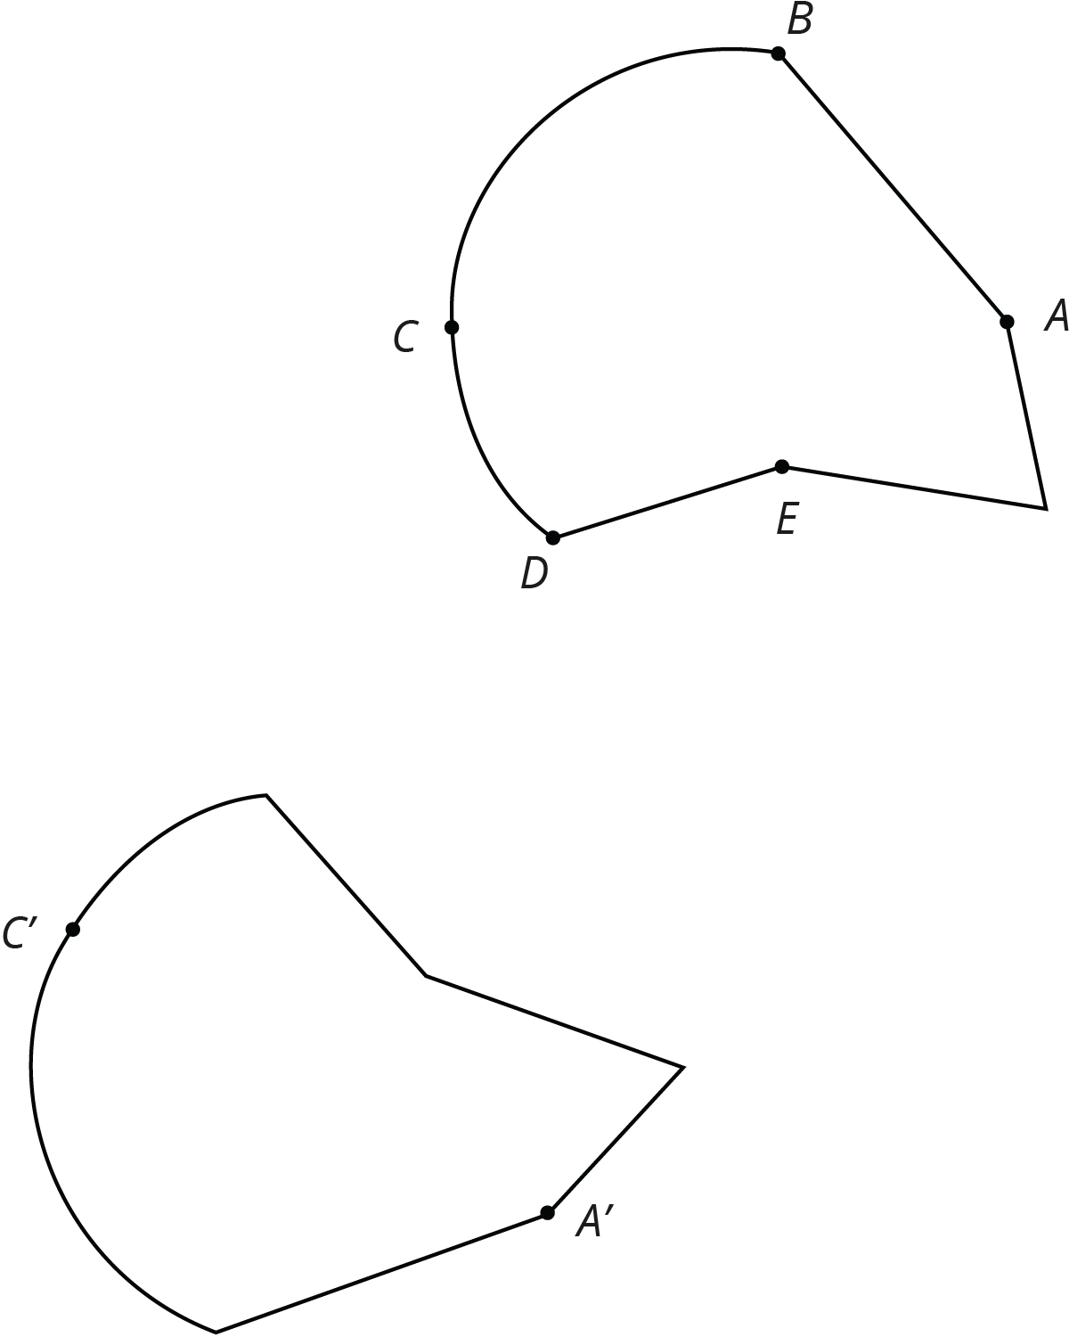
- Draw the points corresponding to $B$, $D$, and $E$, and label them $B^{′}$, $D^{′}$, and $E^{′}$.
- Draw line segments $AD$ and $A^{′}D^{′}$ and measure them. Do the same for segments $BC$ and $B^{′}C^{′}$ and for segments $AE$ and $A^{′}E^{′}$. What do you notice?
- Do you think there could be a pair of corresponding segments with different lengths? Explain.

4 Astonished Faces (Optional)

Student Task Statement
Are these faces congruent? Explain your reasoning.
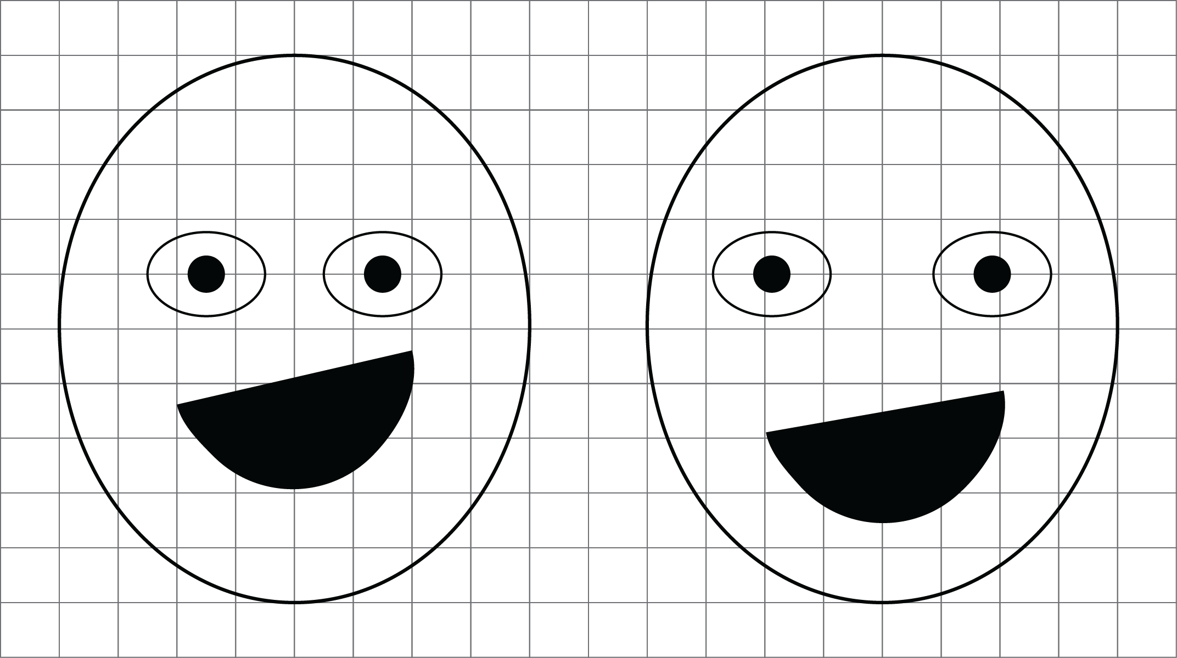

Images for Activity Synthesis
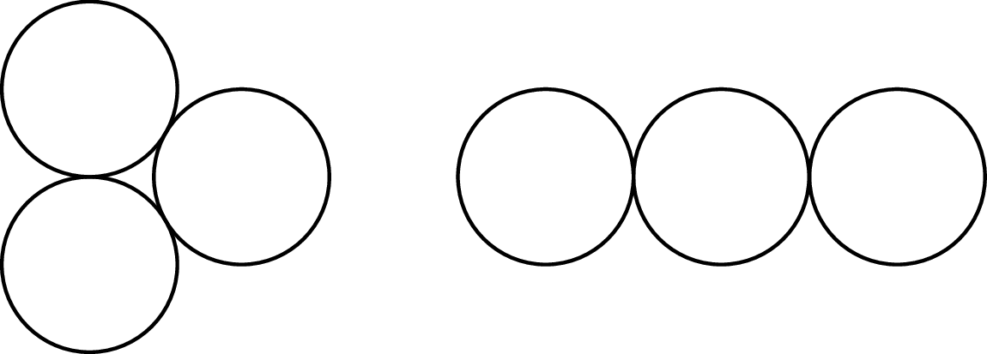
© CC BY Open Up Resources. Adaptations CC BY IM.

