Unit 2 Lesson 13: Tables and Double Number Line Diagrams

1 Number Talk: Constant Dividend (Warm up)

Student Task Statement
Find the quotients mentally.
$150÷2$
$150÷4$
$150÷8$
Locate and label the quotients on the number line.

2 Moving 3,000 Meters

Student Task Statement
The other day, we saw that Han can run 100 meters in 20 seconds.
Han wonders how long it would take him to run 3,000 meters at this rate. He made a table of equivalent ratios.
- Do you agree that this table represents the situation? Explain your reasoning.
- 20 | - 100
- 10 | - 50
- 1 | - 5
- 3,000
- Complete the last row with the missing number.
- What question about the situation does this number answer?
- What could Han do to improve his table?
- Priya can bike 150 meters in 20 seconds. At this rate, how long would it take her to bike 3,000 meters?
- Priya’s neighbor has a dirt bike that can go 360 meters in 15 seconds. At this rate, how long would it take them to ride 3,000 meters?

3 The International Space Station

Images for Launch
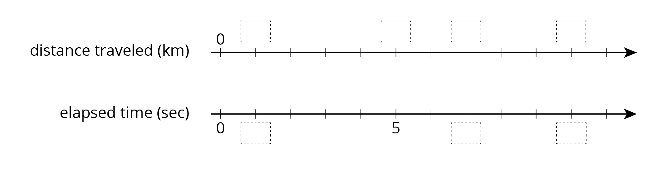

Student Task Statement
The International Space Station orbits around the Earth at a constant speed. Your teacher will give you either a double number line or a table that represents this situation. Your partner will get the other representation.
- Complete the parts of your representation that you can figure out for sure.
- Share information with your partner, and use the information that your partner shares to complete your representation.
- What is the speed of the International Space Station?
- Place the two completed representations side by side. Discuss with your partner some ways in which they are the same and some ways in which they are different.
- Record at least one way that they are the same and one way they are different.

Activity Synthesis
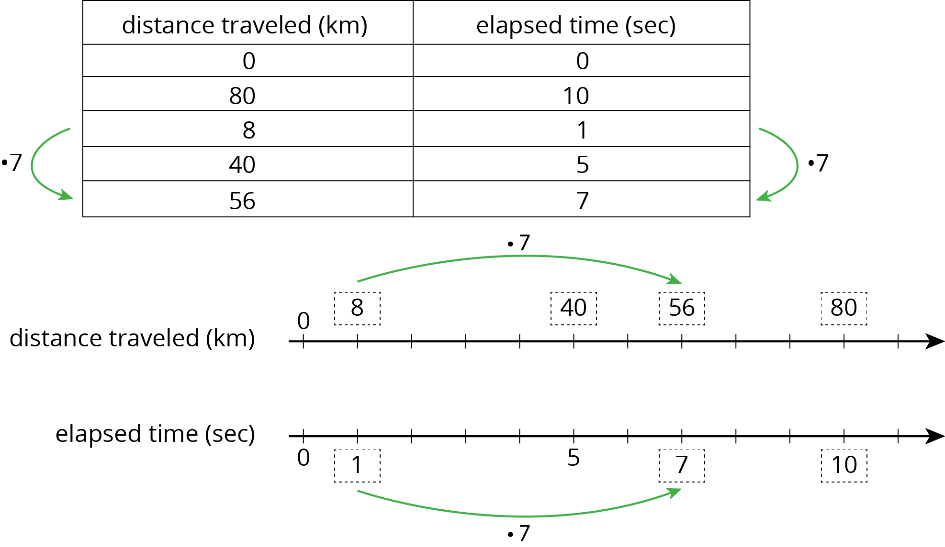
© CC BY Open Up Resources. Adaptations CC BY IM.

