Lesson 16 Practice Problems
- For each equation, identify the values of $a$, $b$, and $c$ that you would substitute into the quadratic formula to solve the equation.
  - $3x^{2}+8x+4=0$
  - $2x^{2}−5x+2=0$
  - $\text{-}9x^{2}+13x−1=0$
  - $x^{2}+x−11=0$
  - $\text{-}x^{2}+16x+64=0$
- Use the quadratic formula to show that the given solutions are correct.
  - $x^{2}+9x+20=0$. The solutions are $x=\text{-}4$ and $x=\text{-}5$.
  - $x^{2}−10x+21=0$. The solutions are $x=3$ and $x=7$.
  - $3x^{2}−5x+1=0$. The solutions are $x=\frac{5}{6}±\frac{\sqrt{13}}{6}$.
- Select all the equations that are equivalent to $81x^{2}+180x−200=100$
  - $81x^{2}+180x−100=0$
  - $81x^{2}+180x+100=200$
  - $81x^{2}+180x+100=400$
  - ${\left(9x+10\right)}^{2}=400$
  - ${\left(9x+10\right)}^{2}=0$
  - ${\left(9x−10\right)}^{2}=10$
  - ${\left(9x−10\right)}^{2}=20$
- (From Unit 7, Lesson 14.)
- Technology required. Two objects are launched upward. Each function gives the distance from the ground in meters as a function of time, $t$, in seconds.
- Object A: $f\left(t\right)=25+20t−5t^{2}$
- Object B: $g\left(t\right)=30+10t−5t^{2}$
- Use graphing technology to graph each function.
  - Which object reaches the ground first? Explain how you know.
  - What is the maximum height of each object?
- (From Unit 6, Lesson 6.)
- Identify the values of $a$, $b$, and $c$ that you would substitute into the quadratic formula to solve the equation.
  - $x^{2}+9x+18=0$
  - $4x^{2}−3x+11=0$
  - $81−x+5x^{2}=0$
  - $\frac{4}{5}x^{2}+3x=\frac{1}{3}$
  - $121=x^{2}$
  - $7x+14x^{2}=42$
- On the same coordinate plane, sketch a graph of each function.
  - Function $v$, defined by $v\left(x\right)=\left|x+6\right|$
  - Function $z$, defined by $z\left(x\right)=\left|x\right|+9$
- 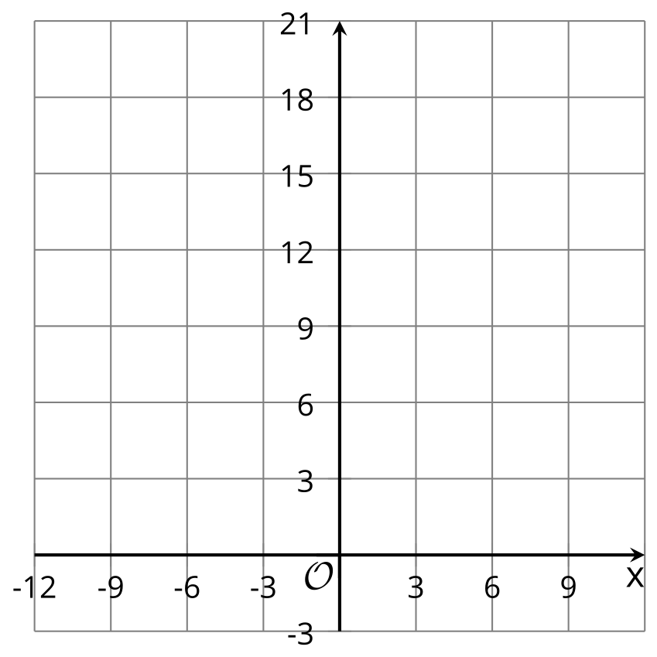
- (From Unit 4, Lesson 14.)
© CC BY 2019 by Illustrative Mathematics®

