Unit 1 Lesson 3: Reasoning to Find Area

1 Comparing Regions (Warm up)

Student Task Statement
Is the area of Figure A greater than, less than, or equal to the area of the shaded region in Figure B? Be prepared to explain your reasoning.
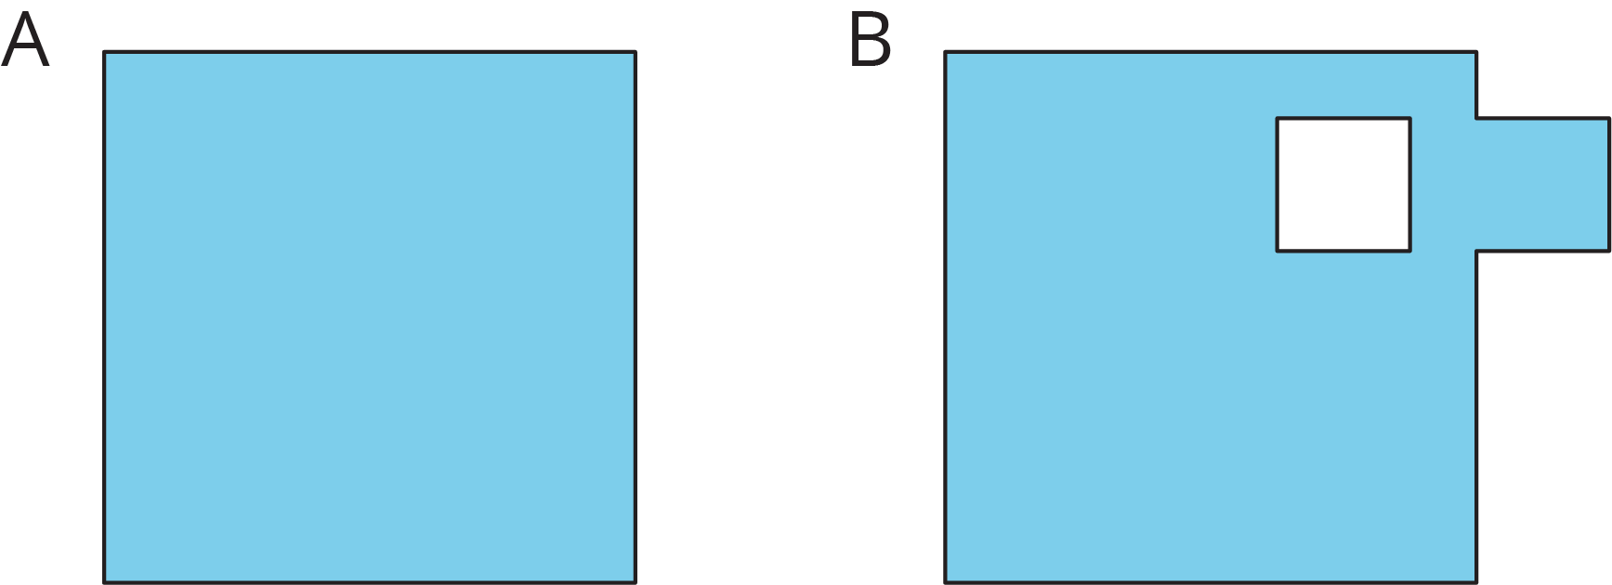

2 On the Grid

Student Task Statement
Each grid square is 1 square unit. Find the area, in square units, of each shaded region without counting every square. Be prepared to explain your reasoning.
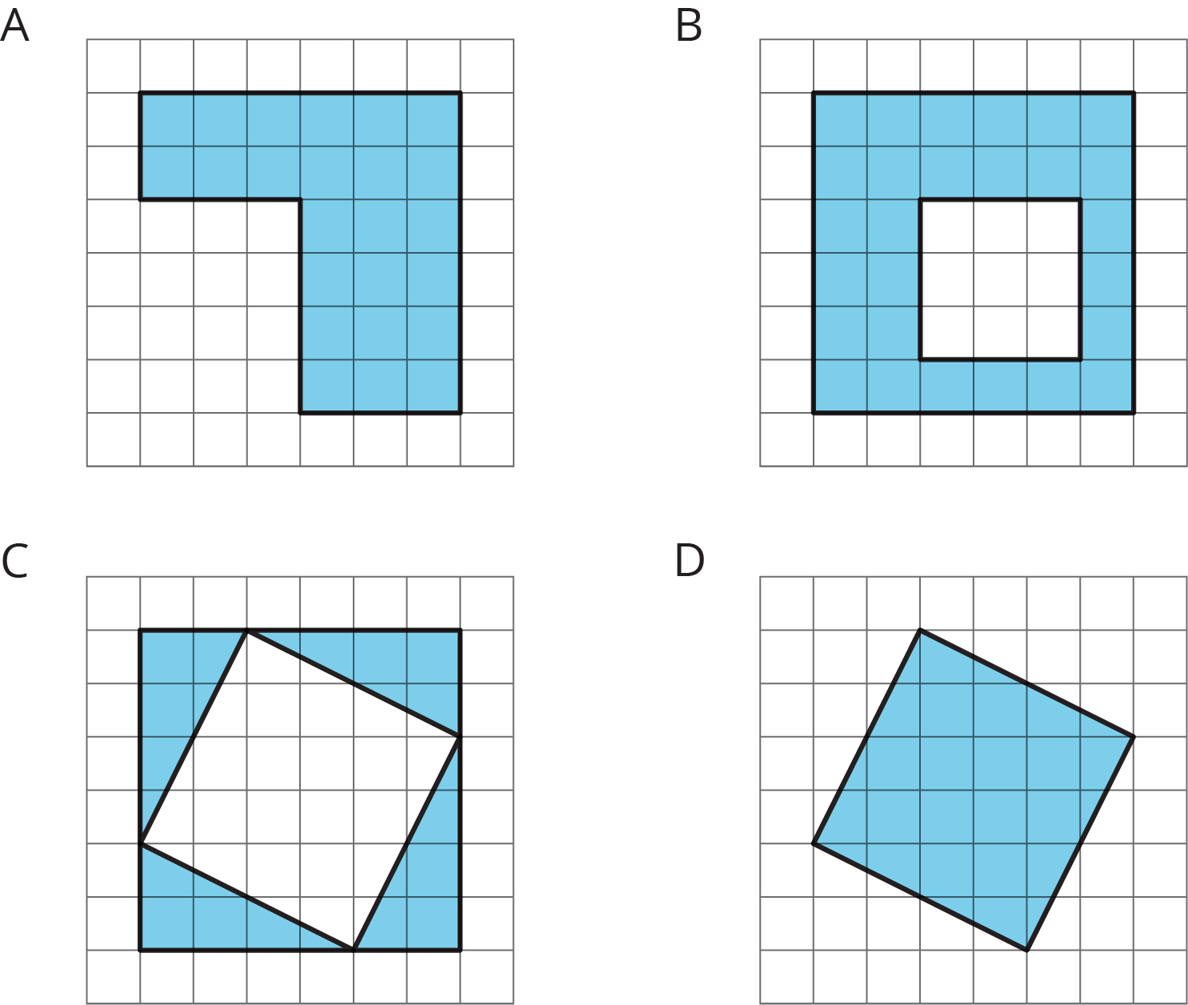

3 Off the Grid

Student Task Statement
Find the area of the shaded region(s) of each figure. Explain or show your reasoning.
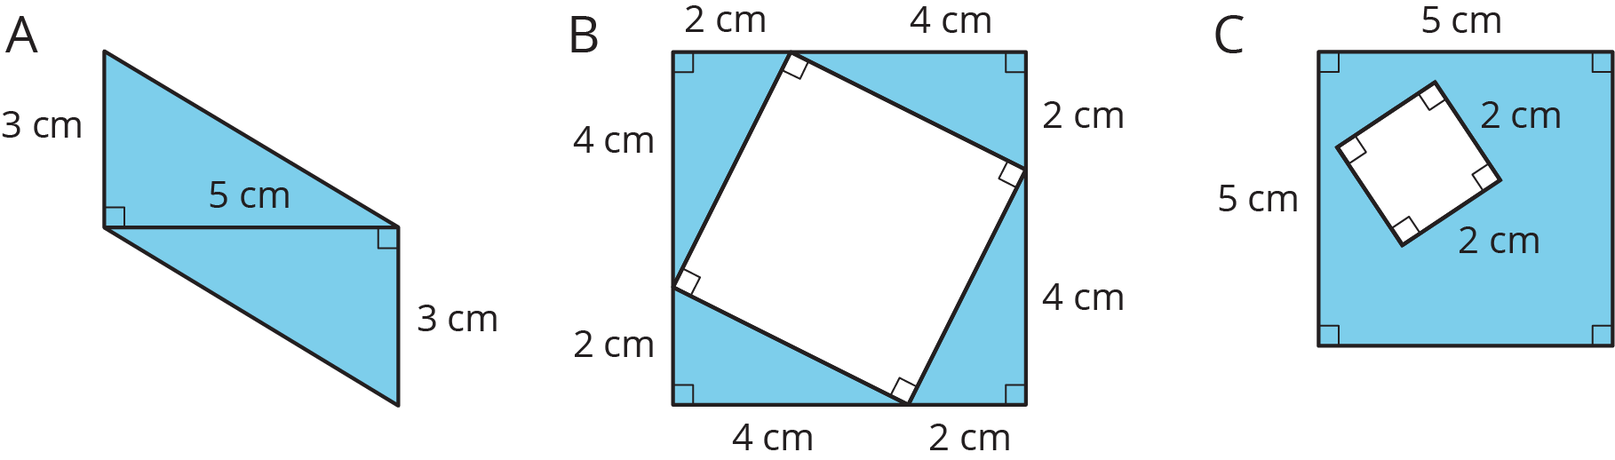

© CC BY Open Up Resources. Adaptations CC BY IM.

