Lesson 2: Milésimas en cuadrículas y en palabras

Standards Alignments
Addressing | 5.NBT.A, 5.NBT.A.3

Teacher-facing Learning Goals
- Represent fractions and decimals to thousandths on hundredths grids.
- Write fractions and decimals to thousandths to represent shaded amounts on hundredths grids.

Student-facing Learning Goals
- Representemos números como decimales, como fracciones, con palabras y en cuadrículas de centésimas.

Lesson Purpose
The purpose of this lesson is for students to read and write decimals to the thousandths place and represent the decimals with diagrams.
The purpose of this lesson is for students to represent decimals to the thousandths in different ways. First, students use hundredths grids to represent fractions and decimals and also write decimals representing a shaded region. Then students analyze language to describe a decimal represented on a hundredths grid, focusing on the value of each digit in a decimal and how it is represented in the corresponding diagram. These different ways of viewing a decimal lead naturally to the expanded form and word form of decimals which students will study in greater detail in future lessons.

Access for:

Students with Disabilities
- Engagement (Activity 1)

English Learners
- MLR2 (Activity 1)

Instructional Routines
Estimation Exploration (Warm-up)

Lesson Timeline
Warm-up | 10 min
Activity 1 | 20 min
Activity 2 | 15 min
Lesson Synthesis | 10 min
Cool-down | 5 min

Teacher Reflection Question
Think about a recent time from class when your students were confused. What did you do to support them in reasoning about their confusion together as a community of learners?

Cool-down
(to be completed at the end of the lesson) 5min
Sombrea las milésimas

Standards Alignments
Addressing | 5.NBT.A

Student-facing Task Statement
- Sombrea la cuadrícula para representar 0.149.
- ¿De qué otra manera podrías representar 0.149?
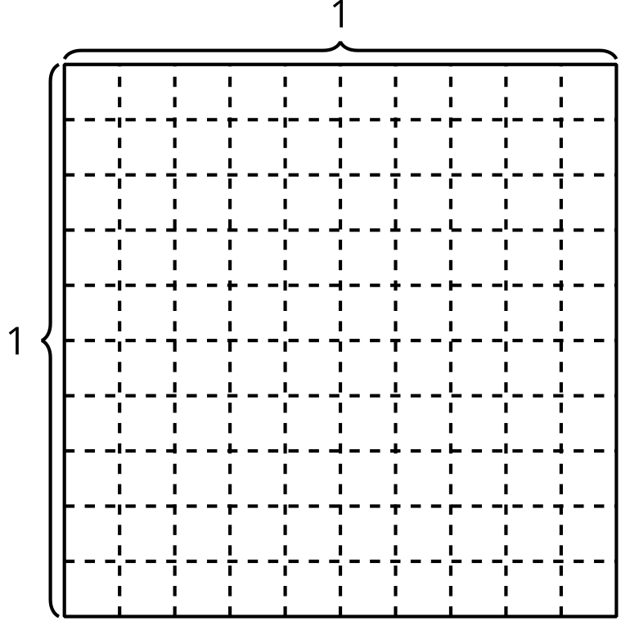

Student Responses
- Sample response:
- 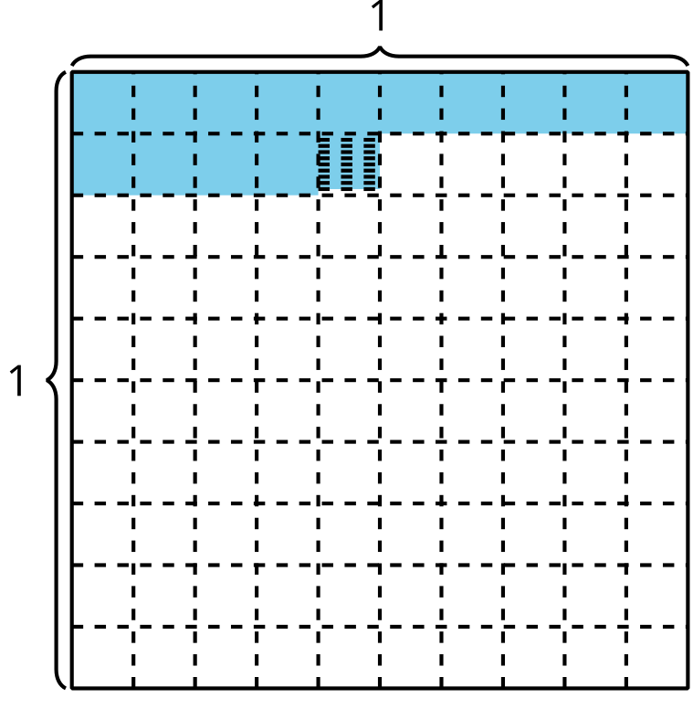
- Sample responses:
  - one tenth, four hundredths, and nine thousandths
  - one hundred forty-nine thousandths
  - $\frac{149}{1,​000}$

