Lesson 8 Practice Problems
- A sequence is defined by $f\left(0\right)=\text{-}20,f\left(n\right)=f\left(n−1\right)−5$ for $n≥1$.
  - Explain why $f\left(1\right)=\text{-}20−5$.
  - Explain why $f\left(3\right)=\text{-}20−5−5−5$.
  - Complete the expression: $f\left(10\right)=\text{-}20−\underset{_}{​}$. Explain your reasoning.
- A sequence is defined by $f\left(0\right)=\text{-}4,f\left(n\right)=f\left(n−1\right)−2$ for $n≥1$. Write a definition for the $n^{\text{th}}$ term of the sequence.
- Here is the recursive definition of a sequence: $f\left(1\right)=3,f\left(n\right)=2⋅f\left(n−1\right)$ for $n≥2$.
  - Find the first 5 terms of the sequence.
  - Graph the value of the term as a function of the term number.
  - Is the sequence arithmetic, geometric, or neither? Explain how you know.
- 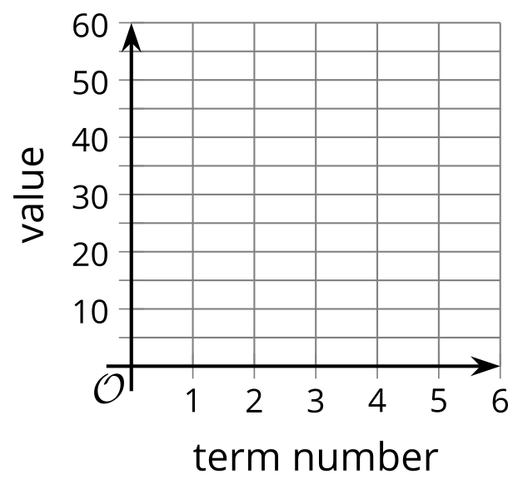
- (From Unit 1, Lesson 7.)
- Here is a graph of sequence $M$. Define $M$ recursively using function notation.
- 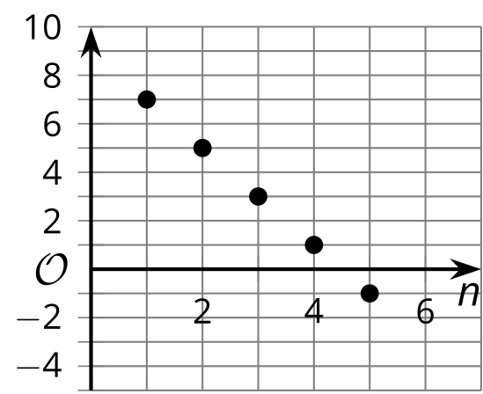
- (From Unit 1, Lesson 6.)
- Write the first five terms of each sequence. Determine whether each sequence is arithmetic, geometric, or neither.
  - $a\left(1\right)=5,a\left(n\right)=a\left(n−1\right)+3$ for $n≥2$.
  - $b\left(1\right)=1,b\left(n\right)=3⋅b\left(n−1\right)$ for $n≥2$.
  - $c\left(1\right)=3,c\left(n\right)=\text{-}c\left(n−1\right)+1$ for $n≥2$.
  - $d\left(1\right)=5,d\left(n\right)=d\left(n−1\right)+n$ for $n≥2$.
- (From Unit 1, Lesson 5.)
- Here is the graph of a sequence:
  - Is this sequence arithmetic or geometric? Explain how you know.
  - List at least the first five terms of the sequence.
  - Write a recursive definition of the sequence.
- 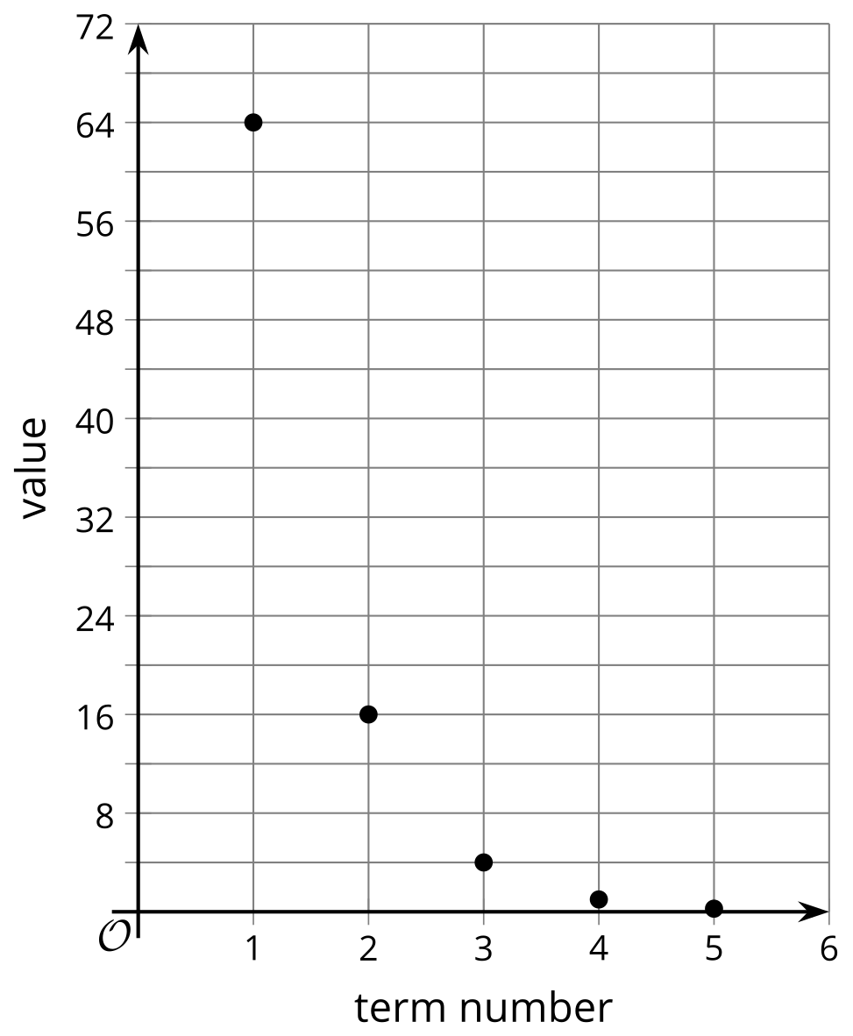
- (From Unit 1, Lesson 7.)
© CC BY 2019 by Illustrative Mathematics®

