Lesson 1 Practice Problems
- Find the values of $x,y,$ and $z$.
- 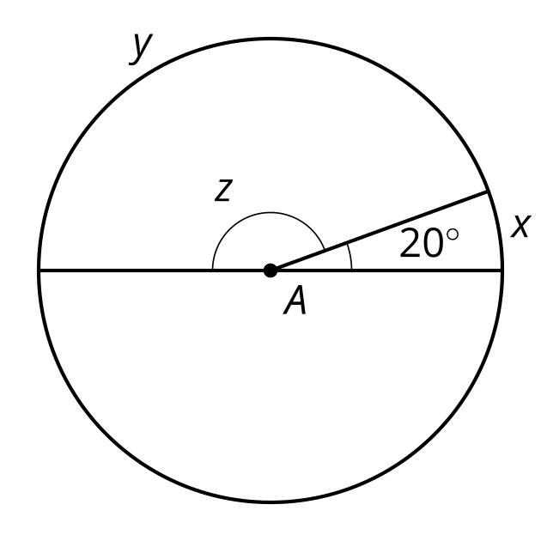
- Give an example from the image of each kind of segment.
  - a diameter
  - a chord that is not a diameter
  - a radius
- 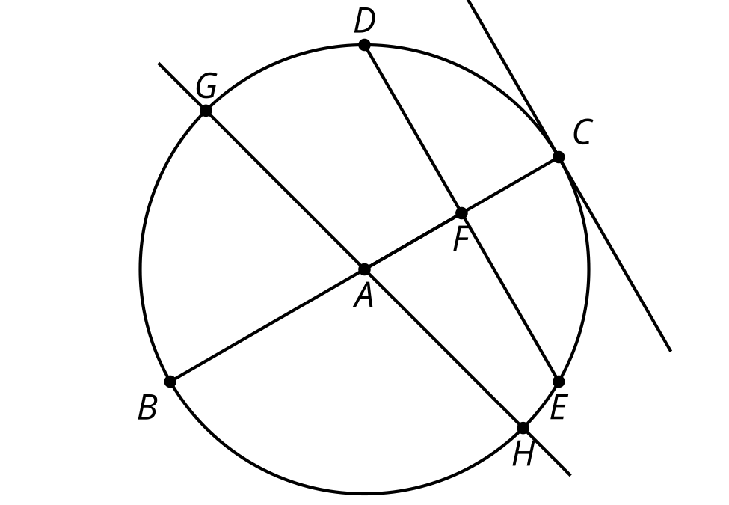
- Identify whether each statement must be true, could possibly be true, or definitely can’t be true.
  - A diameter is a chord.
  - A radius is a chord.
  - A chord is a diameter.
  - A central angle measures 90$​^{∘}$.
- Write an equation of the altitude from vertex $A$.
- 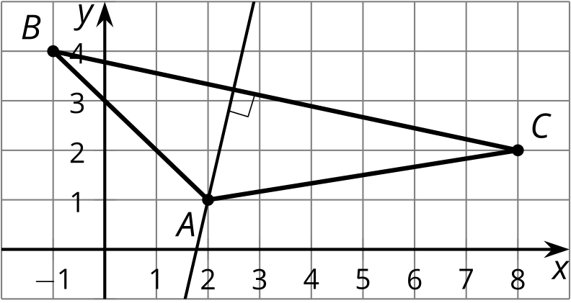

- (From Unit 6, Lesson 17.)
- Triangle $ABC$ has vertices at $\left(5,0\right),\left(1,6\right),$ and $\left(9,3\right)$. What is the point of intersection of the triangle’s medians?
  - The medians do not intersect in a single point.
  - $\left(3,3\right)$
  - $\left(5,3\right)$
  - $\left(3,4.5\right)$
- (From Unit 6, Lesson 16.)
- Consider the parallelogram with vertices at $\left(0,0\right),\left(8,0\right),\left(4,6\right),$ and $\left(12,6\right)$. Where do the diagonals of this parallelogram intersect?
- (From Unit 6, Lesson 15.)
- Lines $ℓ$ and $p$ are parallel. Select all true statements.
- 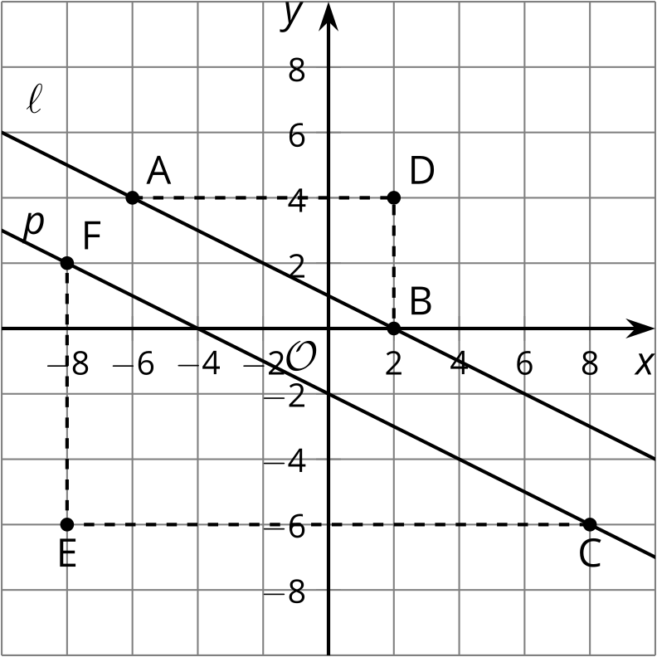
  - Triangle $ADB$ is congruent to triangle $CEF$.
  - The slope of line $ℓ$ is equal to the slope of line $p$.
  - Triangle $ADB$ is similar to triangle $CEF$.
  - $sin\left(A\right)=sin\left(C\right)$
  - $cos\left(B\right)=sin\left(C\right)$
- (From Unit 6, Lesson 10.)
- Mai wrote a proof that triangle $AED$ is congruent to triangle $CEB$. Mai's proof is incomplete. How can Mai fix her proof?
- We know side $AE$ is congruent to side $CE$ and angle $A$ is congruent to angle $C$. By the Angle-Side-Angle Triangle Congruence Theorem, triangle $AED$ is congruent to triangle $CEB$.

- $∠A≅∠C,\overset{¯}{AE}≅\overset{¯}{CE}$
- 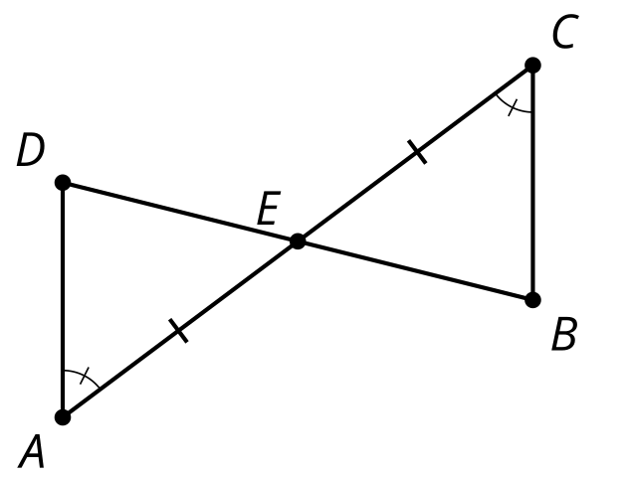
- (From Unit 2, Lesson 7.)
© CC BY 2019 by Illustrative Mathematics®

