Lesson 18 Practice Problems
- Mai and Jada are solving the equation $2x^{2}−7x=15$ using the quadratic formula but found different solutions.
- Mai wrote:
$\begin{matrix}x & =\frac{\text{-}7±\sqrt{7^{2}−4\left(2\right)\left(\text{-}15\right)}}{2\left(2\right)} \\ x & =\frac{\text{-}7±\sqrt{49−\left(\text{-}120\right)}}{4} \\ x & =\frac{\text{-}7±\sqrt{169}}{4} \\ x & =\frac{\text{-}7±13}{4} \\ x & =\text{-}5 \text{ or } x=\frac{3}{2}\end{matrix}$
- Jada wrote:
- $\begin{matrix}x & =\frac{\text{-}\left(\text{-}7\right)±\sqrt{\text{-}7^{2}−4\left(2\right)\left(\text{-}15\right)}}{2\left(2\right)} \\ x & =\frac{7±\sqrt{\text{-}49−\left(\text{-}120\right)}}{4} \\ x & =\frac{7±\sqrt{71}}{4}\end{matrix}$
  - If this equation is written in standard form, $ax^{2}+bx+c=0$, what are the values of $a,b$, and $c$?
  - Do you agree with either of them? Explain your reasoning.
- The equation $h\left(t\right)=\text{-}16t^{2}+80t+64$ represents the height, in feet, of a potato $t$ seconds after it was launched from a mechanical device.
  - Write an equation that would allow us to find the time the potato hits the ground.
  - Solve the equation without graphing. Show your reasoning.
- Priya found $x=3$ and $x=\text{-}1$ as solutions to $3x^{2}−6x−9=0$. Is she correct? Show how you know.
- Lin says she can tell that $25x^{2}+40x+16$ and $49x^{2}−112x+64$ are perfect squares because each expression has the following characteristics, which she saw in other perfect squares in standard form:
  - The first term is a perfect square. The last term is also a perfect square.
  - If we multiply a square root of the first term and a square root of the last term and then double the product, the result is the middle term.
  - Show that each expression has the characteristics Lin described.
  - Write each expression in factored form.
- (From Unit 7, Lesson 11.)
- What are the solutions to the equation $2x^{2}−5x−1=0$?
  - $x=\frac{\text{-}5±\sqrt{17}}{4}$
  - $x=\frac{5±\sqrt{17}}{4}$
  - $x=\frac{\text{-}5±\sqrt{33}}{4}$
  - $x=\frac{5±\sqrt{33}}{4}$
- (From Unit 7, Lesson 16.)
- Solve each equation by rewriting the quadratic expression in factored form and using the zero product property, or by completing the square. Then, check if your solutions are correct by using the quadratic formula.
  - $x^{2}+11x+24=0$
  - $4x^{2}+20x+25=0$
  - $x^{2}+8x=5$
- (From Unit 7, Lesson 16.)
- Here are the graphs of three equations.
- Match each graph with the appropriate equation.
- 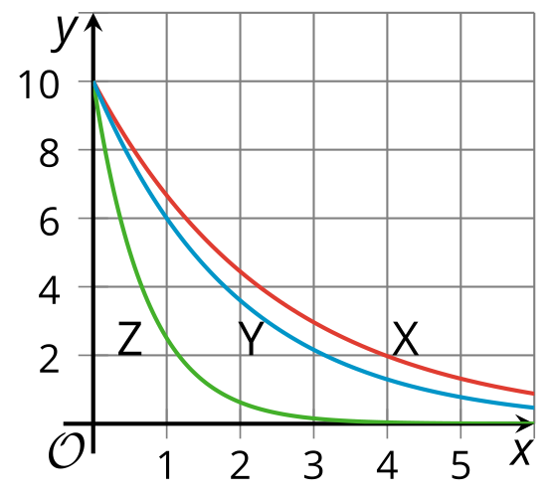
  - $y=10{\left(\frac{2}{3}\right)}^{x}$
  - $y=10{\left(\frac{1}{4}\right)}^{x}$
  - $y=10{\left(\frac{3}{5}\right)}^{x}$
  - X
  - Y
  - Z
- (From Unit 5, Lesson 12.)
- The function $f$ is defined by $f\left(x\right)=\left(x+1\right)\left(x+6\right)$.
  - What are the $x$-intercepts of the graph of $f$?
  - Find the coordinates of the vertex of the graph of $f$. Show your reasoning.
  - Sketch a graph of $f$.
  - 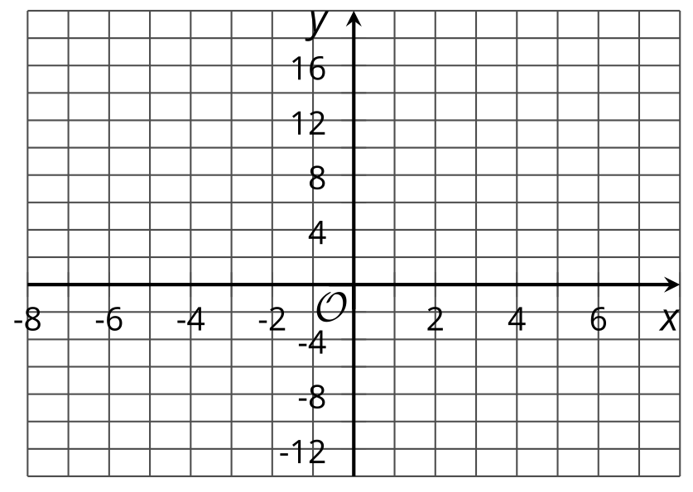
- (From Unit 6, Lesson 11.)
© CC BY 2019 by Illustrative Mathematics®

