Lesson 2: Describing Patterns
- Let’s explore visual patterns.

2.1: Continue the Pattern
Consider a list that starts $1,\frac{5}{2},…$ What would be the next three numbers in the list, if it followed a pattern that grew:
- exponentially?
- linearly?

2.2: Patterns of Sticks
- Here’s a pattern.
- 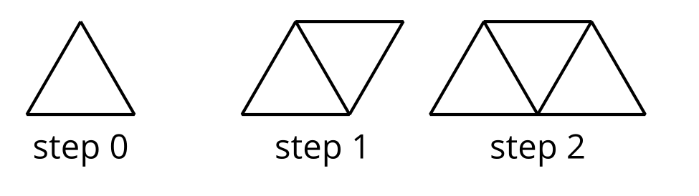

  - How do you see the pattern changing?
  - Extend the pattern to show your prediction of the next two steps.
- Here are tables that represent the pattern.
- step | - 0 | - 1 | - 2 | - 3 | - 6 | - 11 | - $n$
 | - 3 | - 5 | - 7

- step | - 0 | - 1 | - 2 | - 3 | - 6 | - 11 | - $n$
 | - 3 | - 4 | - 5 |  | - 9
  - In each pattern, what quantity is represented in the second row?
  - Complete each table.
  - Describe each pattern as linear, exponential, or neither. Be prepared to explain how you know.
- Here is another pattern.
- 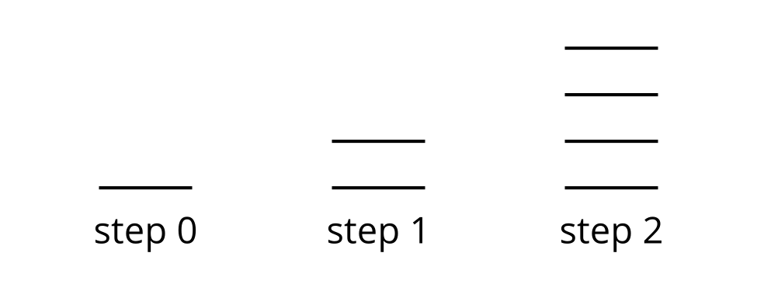
  - Lin says that step 3 will have 8 segments. Andre says that step 3 will have 7 segments. How does each student see the pattern growing?
  - Complete the tables to show the relationship between step number and number of segments, as Lin and Andre would see it.
  - Describe each pattern as linear, exponential, or neither. Be prepared to explain how you know.
Lin
step | 0 | 1 | 2 | 3 | 6 | 9 | $n$
number of segments | 1 | 2 | 4
Andre
step | 0 | 1 | 2 | 3 | 6 | 9
number of segments | 1 | 2 | 4

2.3: Patterns of Dots
- Here is a pattern of dots.
- 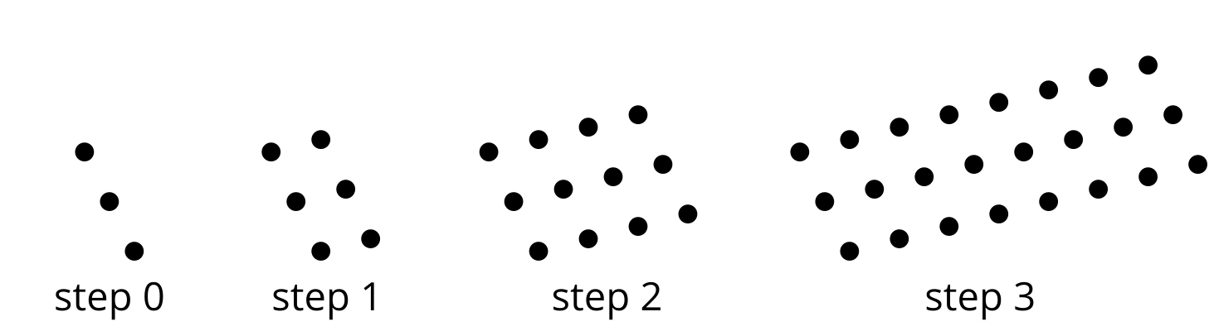

  - Describe how you see the pattern growing.
  - Draw the next step.
  - Complete the table to continue the pattern.
- step | - 0 | - 1 | - 2 | - 3 | - 4 | - 6 | - $n$
- number of dots | - 3 | - 6
  - Is the relationship between step number and number of dots linear, exponential, or neither? Explain how you know.
- Here is another pattern of dots.
- 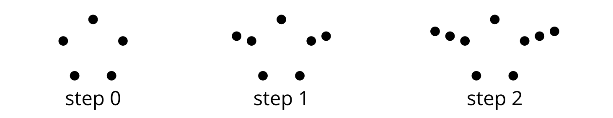

  - Describe how you see the pattern growing.
  - Draw the next step.
  - Complete the table to continue the pattern.
- step | - 0 | - 1 | - 2 | - 3 | - 4 | - 6 | - $n$
- number of dots | - 5 | - 7
  - Is the relationship between step number and number of dots linear, exponential, or neither? Explain how you know.
© CC BY 2019 by Illustrative Mathematics®

