Unit 4 Lesson 11: Domain and Range (Part 2)

1 Which One Doesn't Belong: Unlabeled Graphs (Warm up)

Student Task Statement
Which one doesn't belong?

A
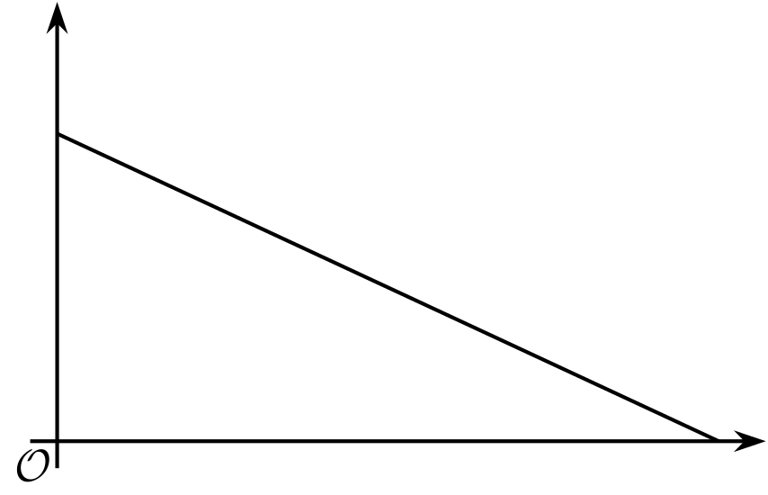

B
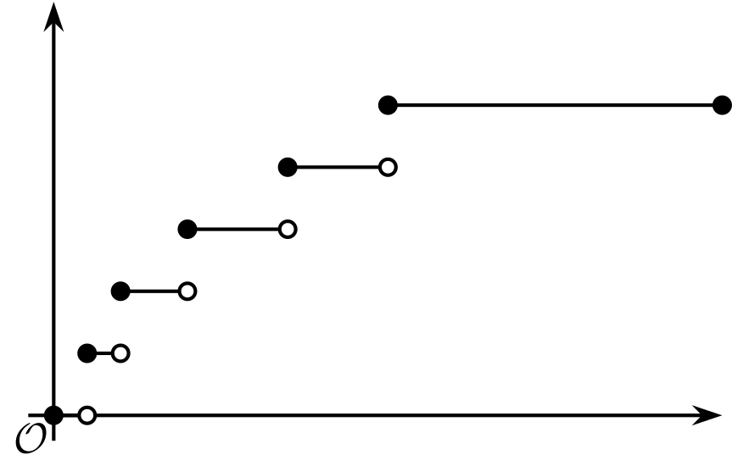

C

D
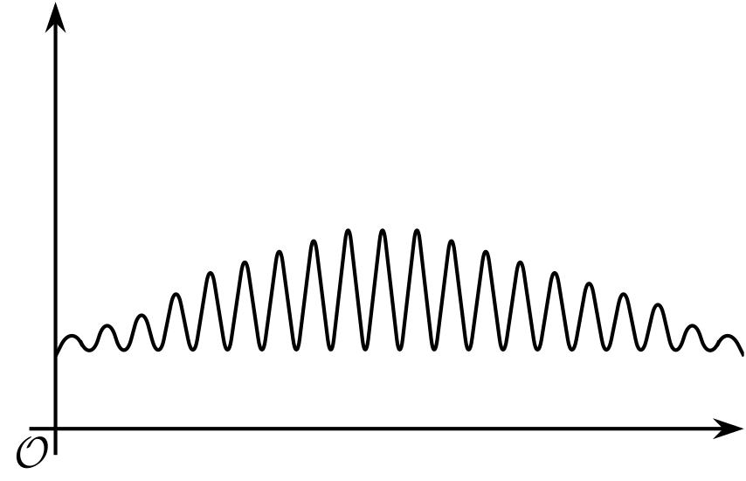

2 Time on the Swing

Student Task Statement
A child gets on a swing in a playground, swings for 30 seconds, and then gets off the swing.
- Here are descriptions of four functions in the situation and four graphs representing them.
- The independent variable in each function is time, measured in seconds.
- 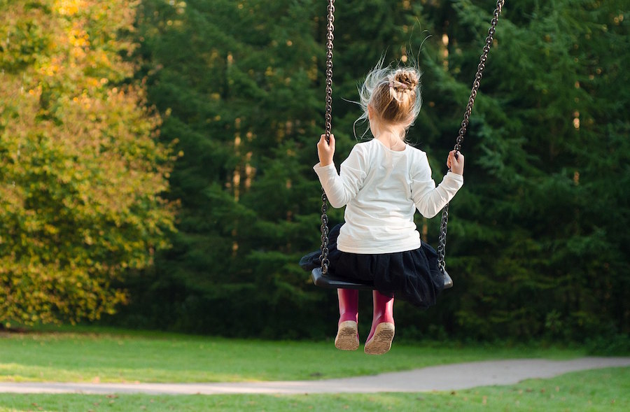
- Match each function with a graph that could represent it. Then, label the axes with the appropriate variables. Be prepared to explain how you make your matches.
  - Function $h$: The height of the swing, in feet, as a function of time since the child gets on the swing
  - Function $r$: The amount of time left on the swing as a function of time since the child gets on the swing
  - Function $d$: The distance, in feet, of the swing from the top beam (from which the swing is suspended) as a function of time since the child gets on the swing
  - Function $s$: The total number of times an adult pushes the swing as a function of time since the child gets on the swing

- A

- B
- ​​​​​​

- C

- D
- On each graph, mark one or two points that—if you have the coordinates—could help you determine the domain and range of the function. Be prepared to explain why you chose those points.
- Once you receive the information you need from your teacher, describe the domain and range that would be reasonable for each function in this situation.

3 Back to the Bouncing Ball

Student Task Statement
A tennis ball was dropped from a certain height. It bounced several times, rolled along for a short period, and then stopped. Function $H$ gives its height over time.
Here is a partial graph of $H$. Height is measured in feet. Time is measured in seconds.
Use the graph to help you answer the questions.
Be prepared to explain what each value or set of values means in this situation.
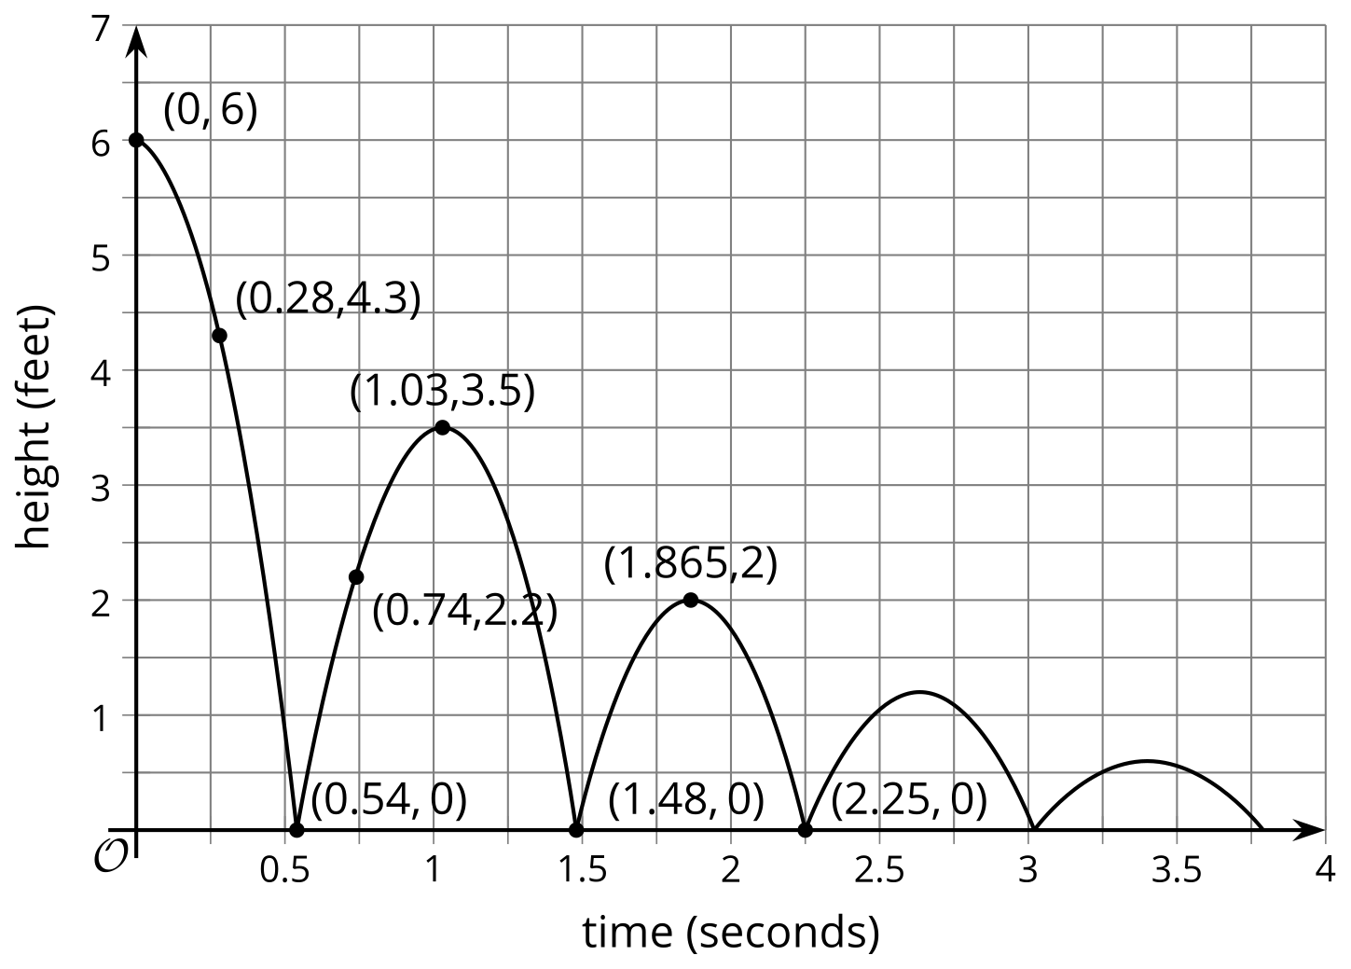
- Find $H\left(0\right)$.
- Solve $H\left(x\right)=0$.
- Describe the domain of the function.
- Describe the range of the function.

Images for Activity Synthesis
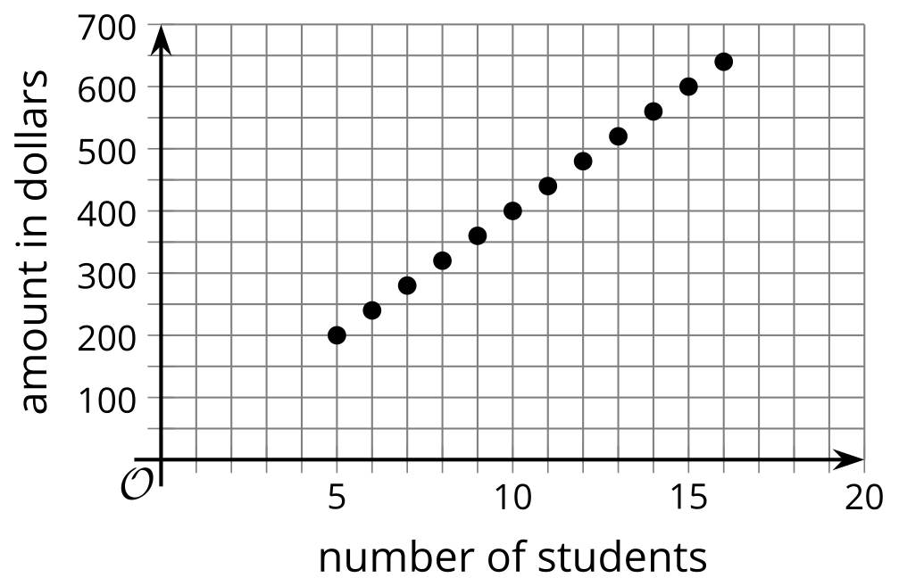
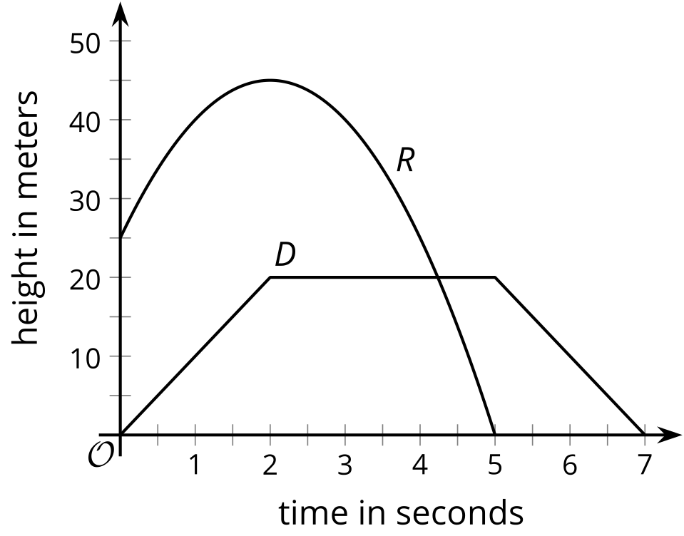
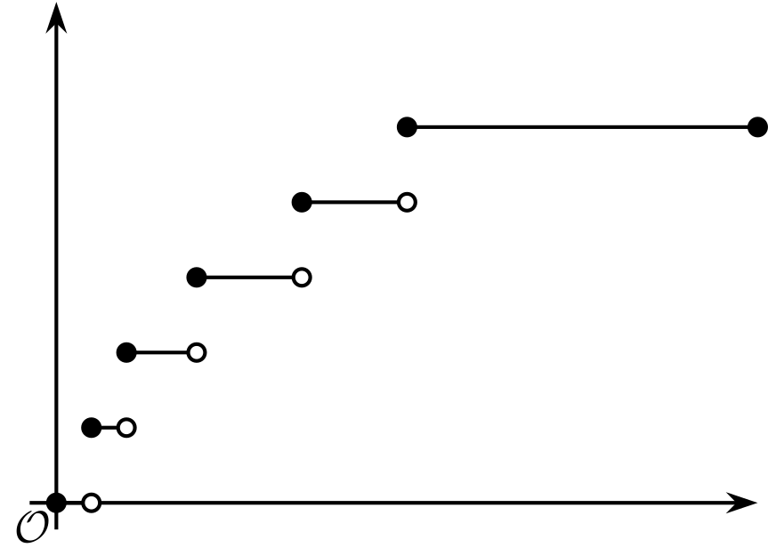
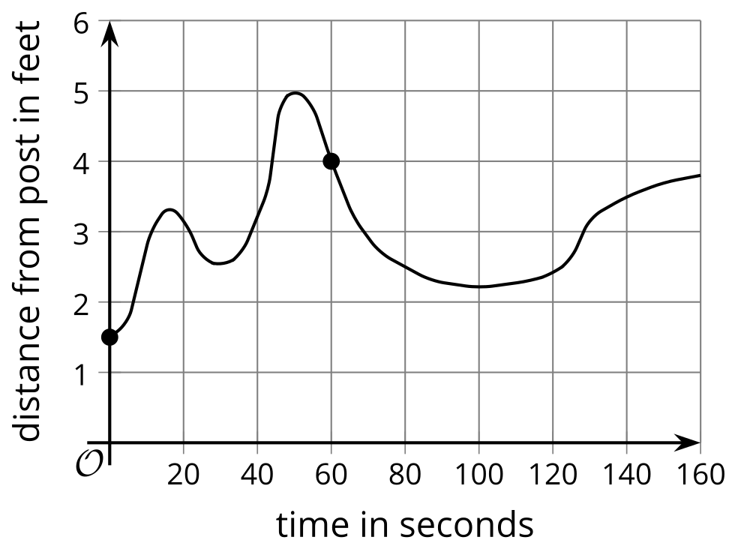
© CC BY 2019 by Illustrative Mathematics®

