Lesson 4: Describing Distributions
- Let’s remember what standard deviation means, and discuss distributions.

4.1: Which One Doesn't Belong: Cracking Glass
Four different kinds of glass are hit with a hammer and the length of the longest crack formed is recorded. The process is repeated 150 times for each type of glass.
Which one doesn’t belong?

A
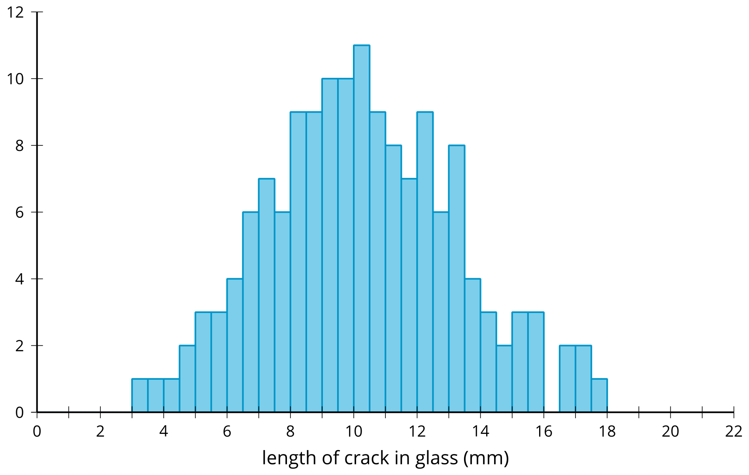

B
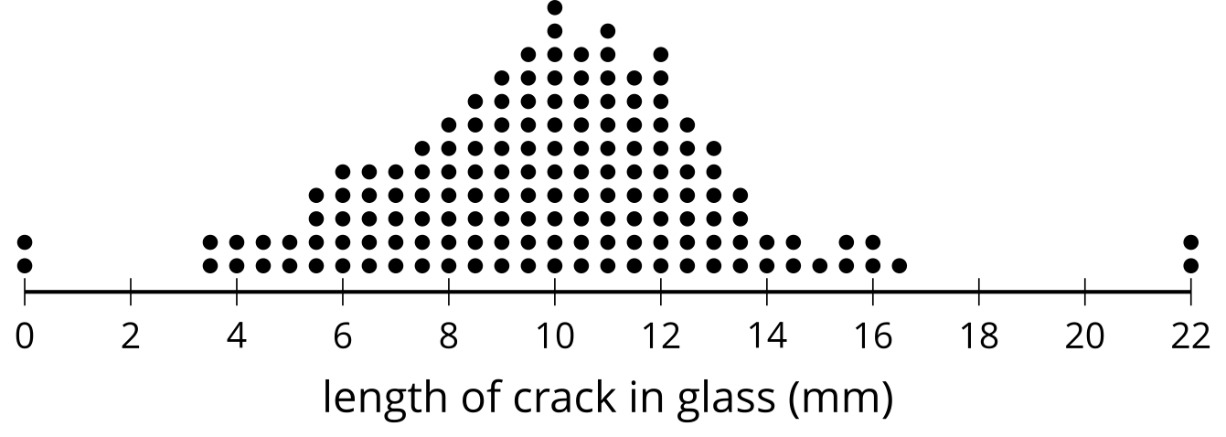

C
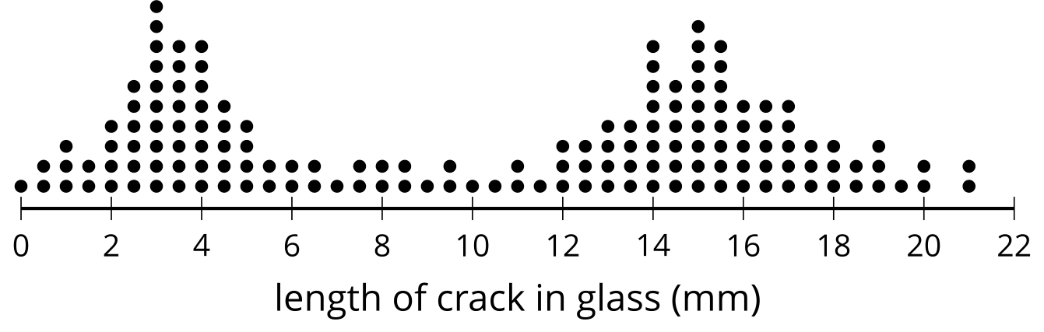

D
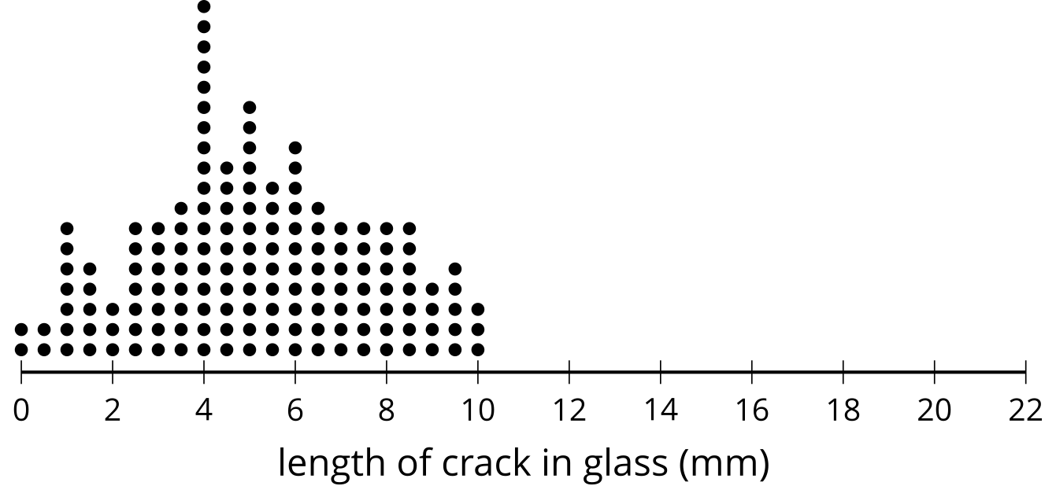

4.2: Name That Distribution Shape
Take turns with your partner to select a dot plot and describe the distribution.
- For each distribution you describe, use the terms symmetric, skewed, bell-shaped, uniform, and bimodal where appropriate.
- For each distribution your partner describes, listen carefully to their description. If you disagree, discuss your thinking and work to reach an agreement.
- Each student in the class measures the length of their step in centimeters, then walks across the room counting the number of steps to estimate the length of the classroom in centimeters.
- 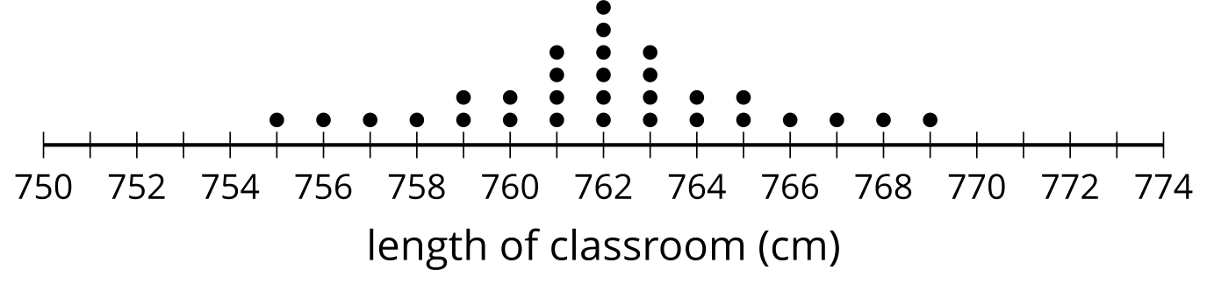
- As a test for fitness, students are asked to do as many push-ups as they can without stopping.
- 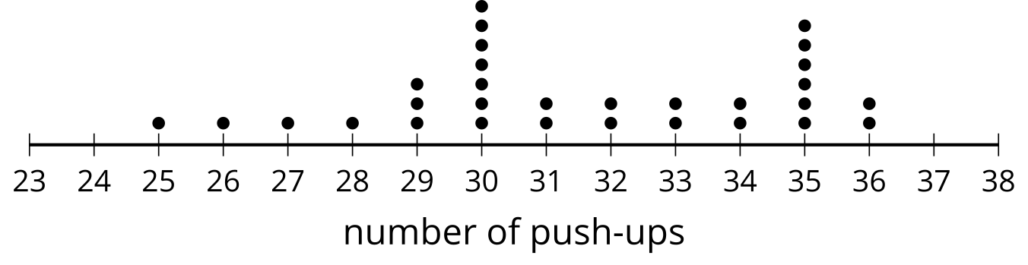
- A group of 30 students are asked how many times they eat a meal not made at home each week.
- 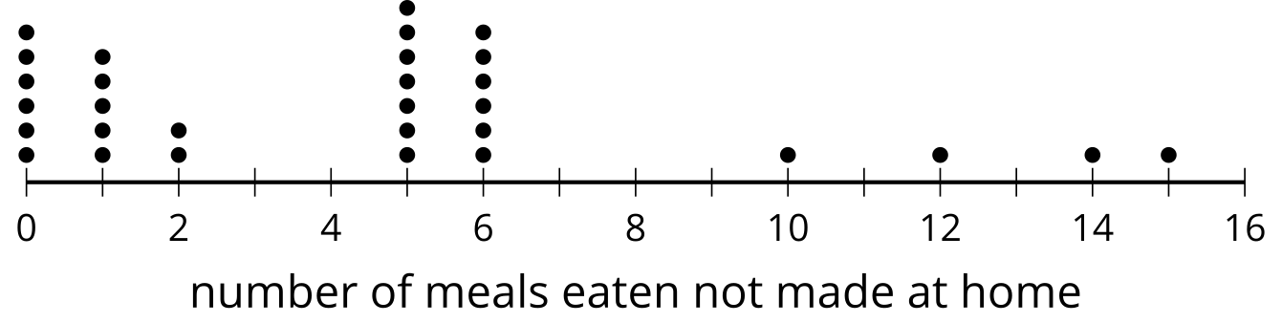
- A company sells small colored erasers in packages of 24 erasers. Thirty packages are inspected, and the number of red erasers in the package are counted.
- 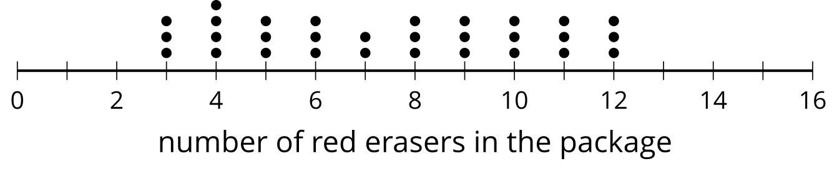

4.3: Matching Distributions and Statistics
Take turns with your partner to match a dot plot with the summary statistics for the data shown.
- For each match you find, explain to your partner how you know it’s a match.
- For each match your partner finds, listen carefully to their explanation. If you disagree, discuss your thinking and work to reach an agreement.
- Mean: 3, median: 2, standard deviation: 2.91
- Mean: 5, median: 5, standard deviation: 2.19
- Mean: 5, median: 5, standard deviation: 3.74
- Mean: 7.13, median: 8, standard deviation: 2.79

A
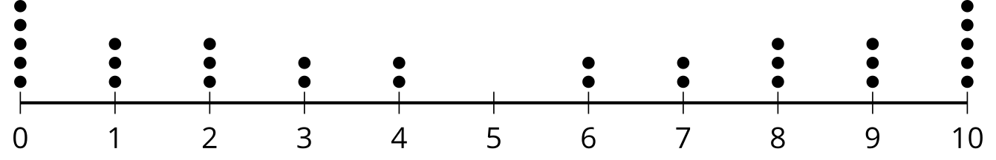

B
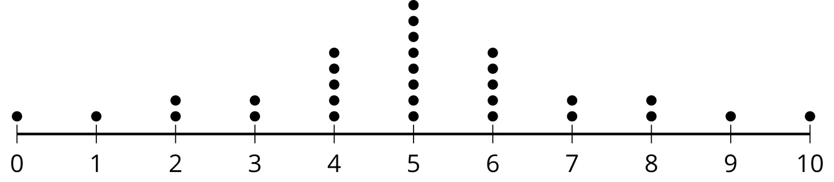

C
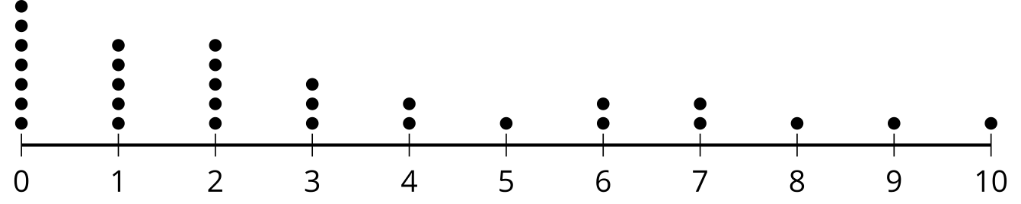

D
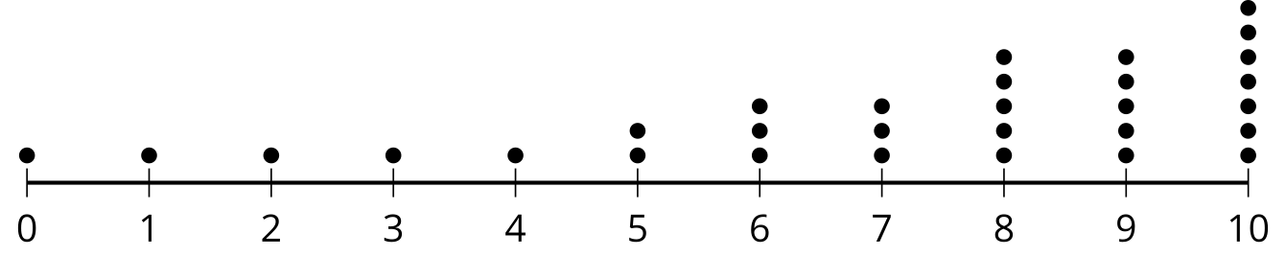

Are you ready for more?
Write out the data points from distribution $A$ in increasing order $0,0,0,0,0,1,1,1,2,2,2,…$. Do the same for distribution $B$. Form a new distribution $E$ where the first data point is the first number from your list for $A$ minus the first number in our list for $B$. The second data point is the second number from your list for $A$ minus the second number in our list for $B$.
- Make a dot plot of the new distribution $E$.
- Find its mean, median, and standard deviation.
- Which of these statistics would change if we reversed the order of our list for $B$?

Lesson 4 Summary
The distribution of a set of data can be described by its shape. Data can be symmetric around the mean or skewed to one side or the other.
For example, the first dot plot shows a distribution that is symmetric around the value 10. The second dot plot is skewed to the right since it is not symmetric and the tail is longer on the right side.
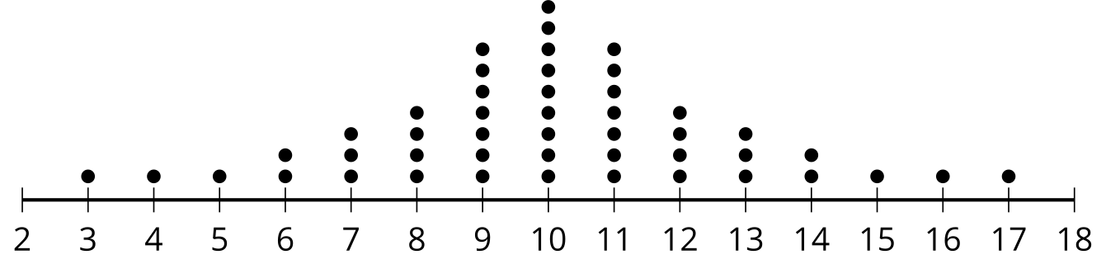
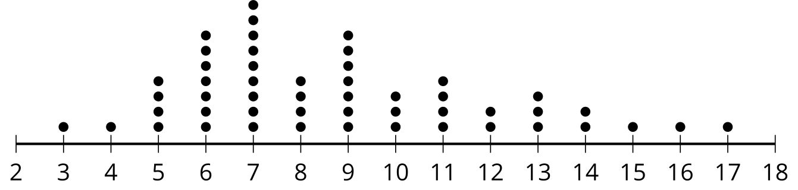
A special type of distribution that will be important in this unit is called a bell-shaped distribution. Bell-shaped distributions have these properties:
- a single, central peak
- symmetric
- the farther a value is from the center, the less often it appears in the data set
Since the distribution is symmetric, the mean and median are equal.
Standard deviation uses the squared distance from each point to the mean to measure the variability of a data set. A greater value for standard deviation means that the values tend to be farther from the mean. A lesser value for standard deviation means that the values tend to be closer to the mean.
© CC BY 2019 by Illustrative Mathematics®

