Lesson 3: Randomness in Groups
- Let’s explore why randomness is important in studies.

3.1: Study Selection
A reporter wants to know how people feel about the governor of her state. She decides to ask 100 people their opinions and thinks of several ways to ask the 100 people. For each method, explain the benefits and drawbacks, then choose the method for selecting 100 people that would best represent the people of the state.
- Go to the capital city and find 100 people interested in politics to respond to the survey.
- Ask the 100 most politically influential people in the state to respond to the survey.
- Obtain census data for the state and select 100 people from the list to survey using a random process.
- Ask 50 registered voters who voted for the governor and 50 registered voters who did not vote for the governor to respond to the survey.

3.2: Hip Hop Memory
A research group interested in comparing the effect of different types of music on short-term memory gathers 200 volunteers for a study. One group will listen to a hip hop music playlist while trying to memorize a list of 20 words. A second group will listen to a playlist of orchestral music while trying to memorize the list of 20 words. After a break, the number of words recalled correctly by each individual is measured and the results for the two groups are compared.
- Is this an experimental study or an observational study? Explain your reasoning.
- Which group do you hypothesize will recall more words? Explain your reasoning.
- Here are some options for splitting the volunteers into groups. Which method will best address the intention of the study? Explain your reasoning.
  - Divide groups based on their preferred music style.
  - Divide groups based on their age. The youngest 100 listen to hip hop music, and the older 100 listen to orchestral music.
  - Divide groups based on the order in which they come in to do the study. The first 100 listen to hip hop music, and the next 100 listen to orchestral music.
  - Write all the volunteer names on slips of paper, put them in a jar and shake it, then draw out 100 slips. These will listen to the hip hop playlist while the others listen to orchestral music.

3.3: Random Rectangles
A company offers solar power systems made up of 1 square meter cells arranged into rectangles. They use the designs for their first 100 customers to list the ways people arrange the cells. They are interested in investigating this question: “What is the mean area of the rectangles created by our customers?”
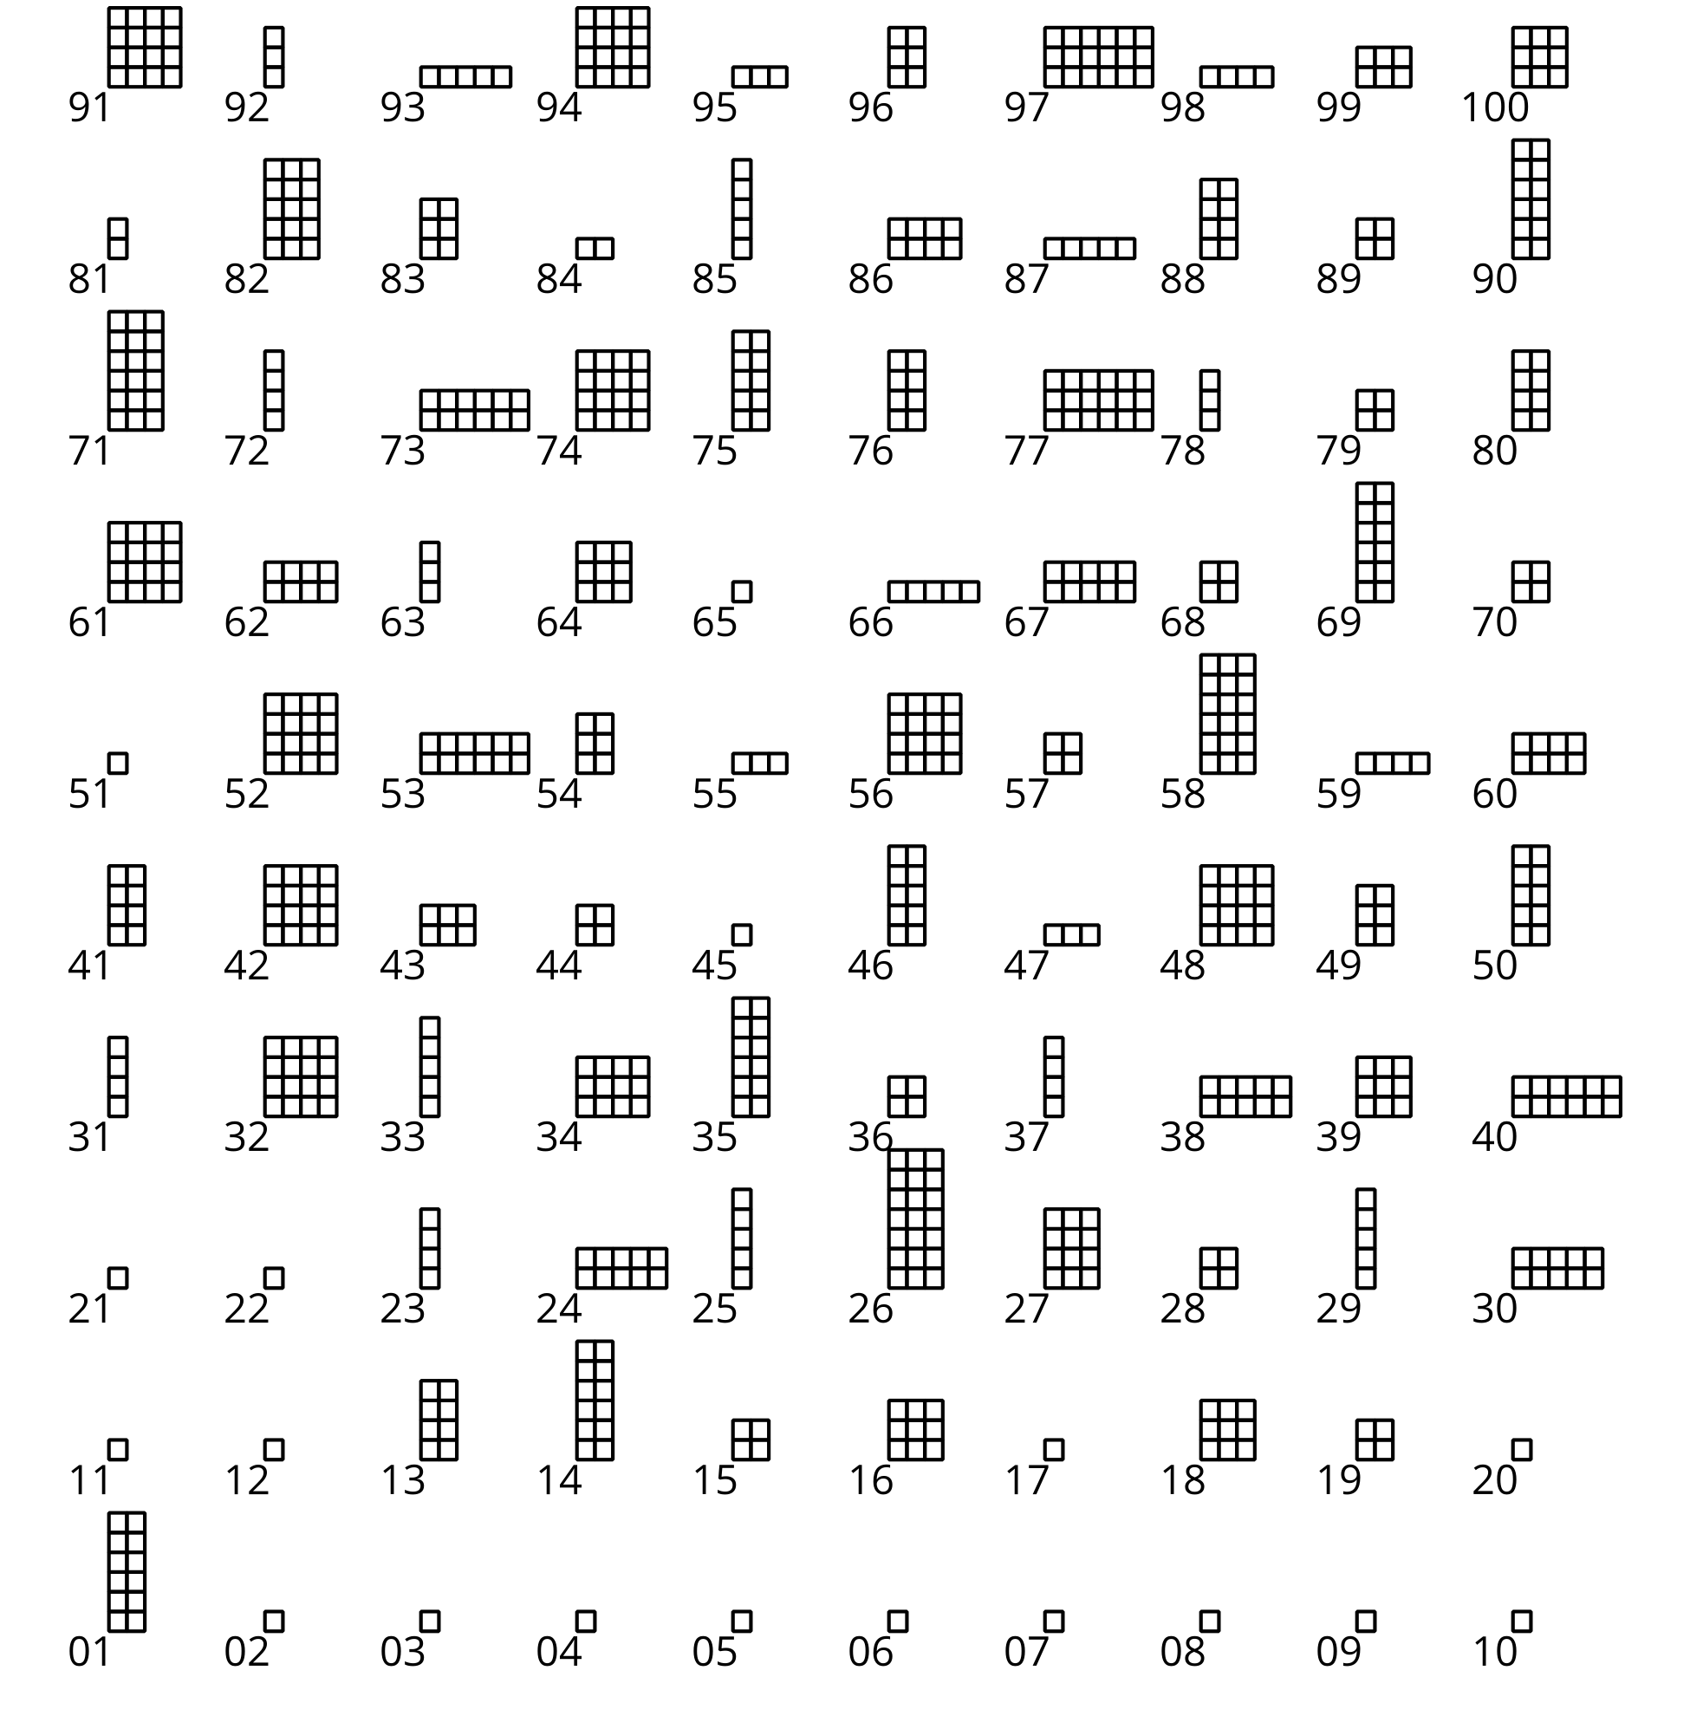
- Collect a sample of 5 rectangles using the methods here.
  - Look quickly at the chart and select 5 rectangles by their numbers. Record the numbers of the rectangles you choose.
  - Select a number between 1 and 95. Use that number and the next 4 numbers for another sample of 5 rectangles. For example, if you select 8, then you would use rectangles 8, 9, 10, 11, and 12.
  - Look closer at the rectangles and choose your 5 favorite. Record the numbers of the rectangles you choose.
  - Use a random number generator to select 5 numbers between 1 and 100.
- For each method, find the mean area of the rectangles in the sample.
- Which method do you think is best for estimating the mean area for the entire population? Explain your reasoning.

Are you ready for more?
How does a computer that runs predetermined instructions actually generate a “random number”? One way would be to try to connect the computer to something in nature that we consider random (like a number cube roll). This is doable, but generally not efficient, and the results cannot be replicated, so many computer programs use what is called pseudo-random number generation. Essentially, they create lists of numbers that “seem” random and for many purposes, that is sufficient.
Here is a version of one such method. Start with some number $s$ (called the seed). To get the next number on the list, multiply the previous number by 6. If our new number is greater than 13, then divide by 13 and take the remainder. For example, if $s=1$ our list of numbers is $1,6,10,8,9,2,12,7,3,5,4,11,1,…$. Once we get back to our seed, our list will repeat.
- What would our list be if we start with the seed $s=2$? How does this relate to the list we had with $s=1$?
- What would our list be if we started with the seed $s=1$, but instead of multiplying by 6 each time, we multiplied by 7 each time? Why does this list not seem as “random”?

Lesson 3 Summary
A statistical study begins with a research question, which describes what you want to know clearly and simply. Most research questions are about a population, like a particular group of people, animals, or things. It is often not feasible to collect data from every individual in the population.
For example, a quality control engineer at a factory that makes snack-sized bags of trail mix wants to know if the bags of trail mix produced on a certain day contain the right amount of pretzels. Imagine a conveyor belt moving thousands of bags of trail mix through the process of mixing the ingredients, seasoning them, and packaging them into bags. How would they know if the bags today contained too many or too few pretzels?
Do they have to count the pretzels in every bag of trail mix that is produced? Of course not—that wouldn’t be practical. Also, they wouldn’t want to open every bag, because then they wouldn’t be able to sell them! What do they do instead? They select a sample of bags of trail mix from that day’s production and count the pretzels.
To get information about a characteristic of a population, people often measure that characteristic on a sample of individuals chosen from a population of interest. The idea is to draw conclusions about the population based on data collected from only the sample. To correctly generalize from the sample to the population, the researcher needs to know that the sample is representative of the population as a whole.
Suppose the engineer counted the pretzels only in the last 25 bags of trail mix that were produced that day, and found that they contained too many pretzels. Should they conclude that all the bags of trail mix produced that day contained too many pretzels? Not necessarily. Something might have happened late in the day that affected the number of pretzels in the bags. The last 25 bags of trail mix may not be a representative sample from the population.
So how do we get a representative sample? The best way is to let chance select the sample. For example, you might randomly select 25 different times throughout the day to remove the next bag of trail mix from the conveyor belt and count its pretzels. Using a process based on chance, in which each individual in the population is equally likely to be selected, is called random selection of the sample.
In experimental studies, it is often necessary to assign the individual participants in the sample to one or more groups. It is also best to assign individuals to groups using a random process.
For example, say that you were studying the effect of students turning off electronic devices while doing homework. After a representative sample is selected, you need to assign the individuals in the sample to two groups: one group makes no changes to the conditions by which they normally do homework, and another group that turns off electronic devices while doing homework for the duration of the study. Examples of assignment processes that are not random include:
- Assigning students whose names start with A–L to one group and M–Z to the other group
- Assigning students who play a musical instrument to one group and the rest to the other group
- Asking for volunteers to be part of the group that turns off electronic devices
In order to assign individuals randomly to groups, every individual must have an equal chance of being assigned to either group. Examples of assignment processes that are random include:
- Writing each participant’s name on a slip of paper and mixing the slips well in a bag. Drawing half of the names from the bag and assigning these participants to one group, and the rest to the other group.
- Flipping a coin for each participant, and placing them in one group if the result is heads and the other group if the result is tails.
- Getting a list of participants and numbering the list. Using a random number generator to select participants for one group.
When subjects are not assigned to experimental groups using a random process, other factors may influence the results from the experimental study so that the data does not answer the initial question. In this example, if the groups are split by volunteering, the impact of turning off the devices may be impacted by similar traits by the subjects who volunteer, such as their not using electronic devices much already or having a personality that is willing to volunteer to try something new. These traits may influence the results so the data from the experimental study does not accurately address the question about the impact of electronic devices on student homework.
© CC BY 2019 by Illustrative Mathematics®

