Lesson 13 Practice Problems

  - Find the arc length of an arc with a central angle of $\frac{2π}{3}$ radians and a radius of 6 units.
  - Find the arc length of an arc with a central angle of $\frac{5π}{6}$ radians and a circumference of 12 units.
  - Find the measure (in radians) of a central angle of an arc with arc length 4 units and radius 3 units.
- A circle has radius 10 units. For each angle measure, find the area of a sector of this circle with that central angle.
  - $\frac{π}{8}$ radians
  - $\frac{3π}{4}$ radians
  - 1 radian
  - 2 radians
- Each circle has a shaded sector with a central angle measured in radians. What fraction of the circle is each sector?

- circle A
- 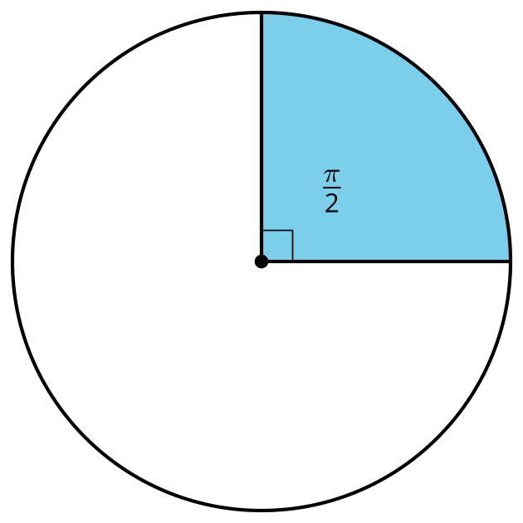

- circle B
- 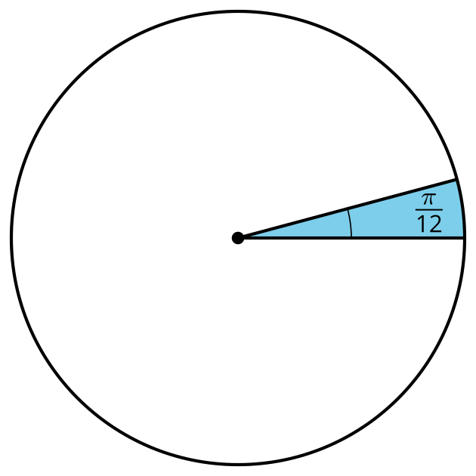

- circle C
- 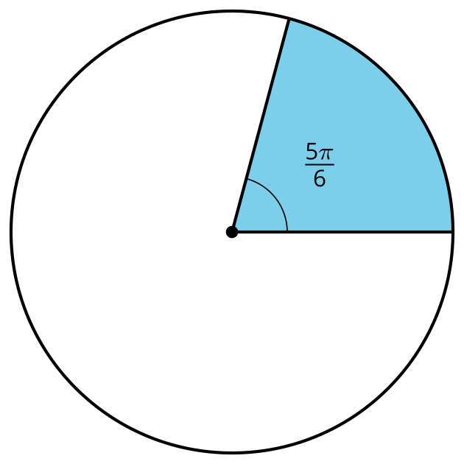
- Find the radian measure of each angle.
  - 30 degrees
  - 45 degrees
  - 50 degrees
- (From Unit 7, Lesson 12.)
- Find the degree measure of each angle.
  - $\frac{π}{3}$ radians
  - $\frac{π}{2}$ radians
  - $\frac{3π}{4}$ radians
  - 3 radians
- (From Unit 7, Lesson 12.)
- Calculate the radian measure of a 225 degree angle. Use any method you like, including sketching in the circle diagram provided. Explain or show your reasoning.
- 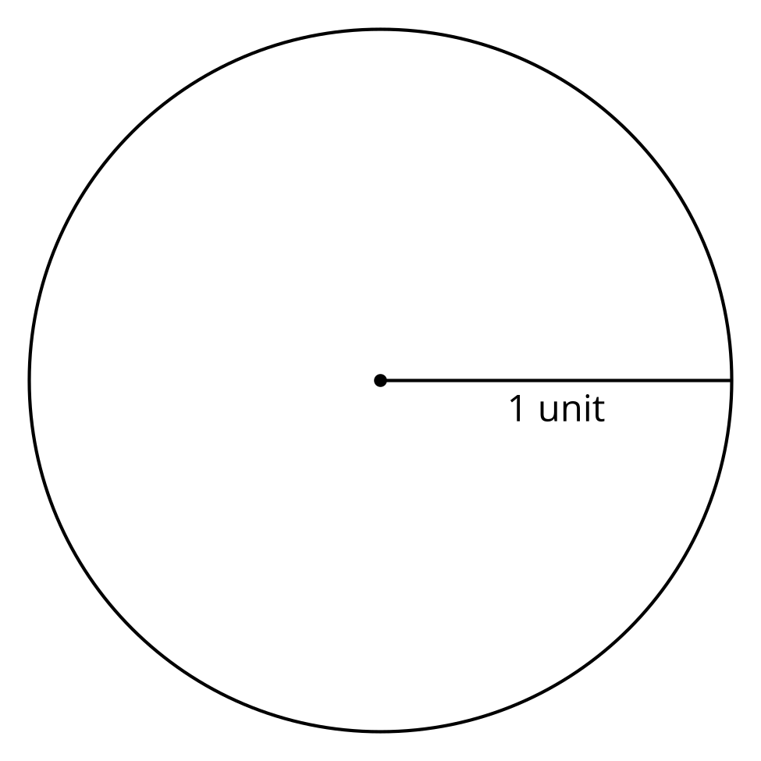
- (From Unit 7, Lesson 11.)

- Andre’s circle
- 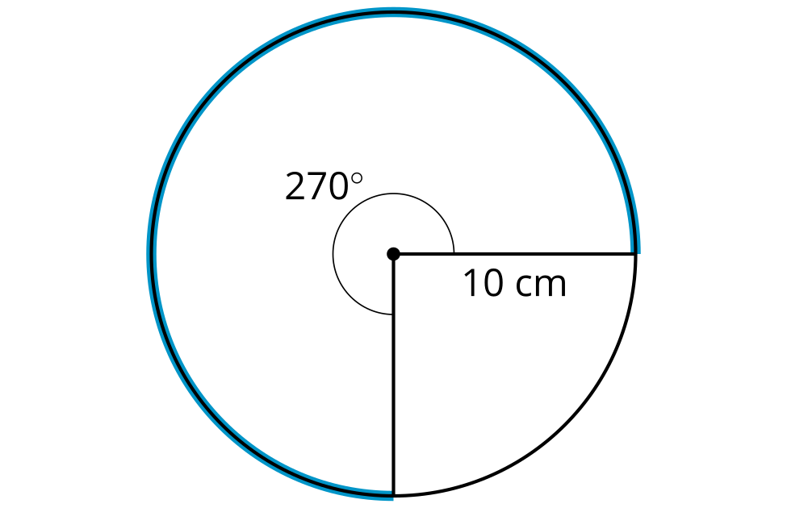

- Diego’s circle
- 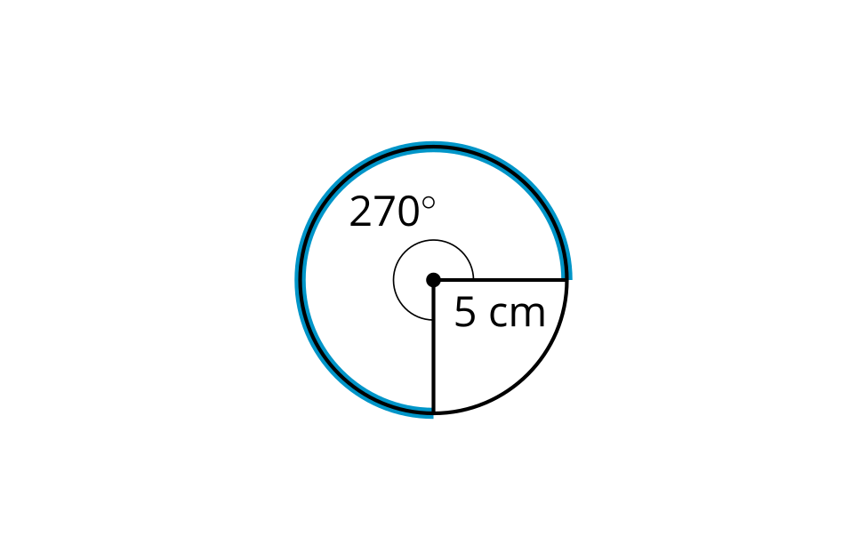
- Andre and Diego are each saving money. They each hope to save 500 dollars. They are tracking their progress on the circles in the image.
- Diego thinks that Andre has saved more money than Diego has saved. Andre thinks they have saved the same amount. Do you agree with either of them? Explain or show your reasoning.
- (From Unit 7, Lesson 10.)
- Clare missed class and Jada is teaching her how to construct the circumscribed circle of a triangle. Here are the instructions Jada wrote.
- “Construct all 3 perpendicular bisectors of the triangle’s sides. The point where the perpendicular bisectors intersect is called the circumcenter. Construct a circle centered at the circumcenter with radius set to the distance between the circumcenter and a vertex. If the triangle has a circumscribed circle, the circle you construct will go through all 3 vertices.”
- Do you agree with Jada’s instructions? Explain your reasoning.
- (From Unit 7, Lesson 5.)
© CC BY 2019 by Illustrative Mathematics®

