Lesson 4: Linear Models
- Let’s explore relationships between two numerical variables.

4.1: Notice and Wonder: Crowd Noise
What do you notice? What do you wonder?

$y=1.5x+22.7$
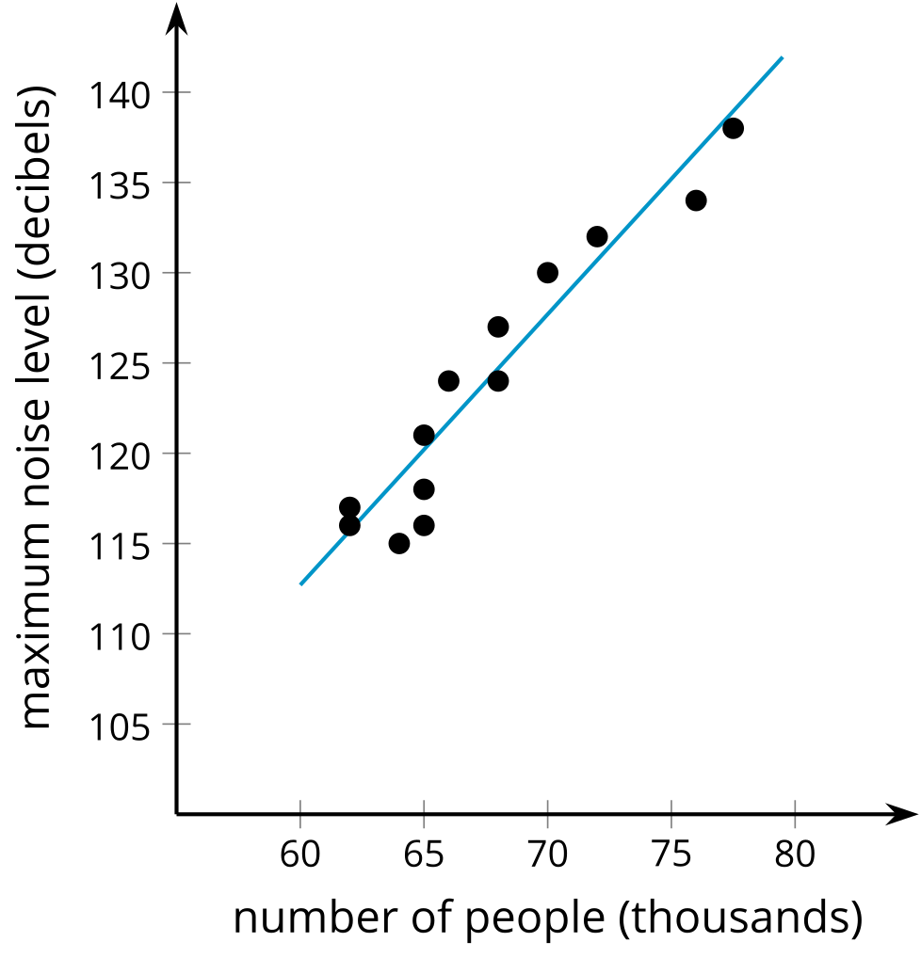

4.2: Orange You Glad We’re Boxing Fruit?
- Watch the video and record the weight for the number of oranges in the box.
- number of oranges | - weight in kilograms
- 3
- 4
- 5
- 6
- 7
- 8
- 9
- 10
- Create a scatter plot of the data.
- 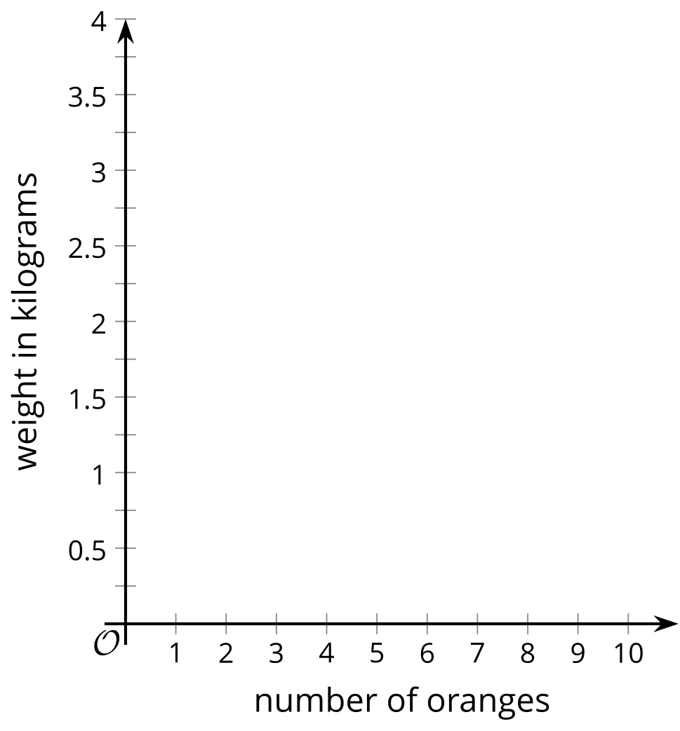
- Draw a line through the data that fits the data well.
- Estimate a value for the slope of the line that you drew. What does the value of the slope represent?
- Estimate the weight of a box containing 11 oranges. Will this estimate be close to the actual value? Explain your reasoning.
- Estimate the weight of a box containing 50 oranges. Will this estimate be close to the actual value? Explain your reasoning.
- Estimate the coordinates for the vertical intercept of the line you drew. What might the $y$-coordinate for this point represent?
- Which point(s) are best fit by your linear model? How did you decide?
- Which point(s) are fit the least well by your linear model? How did you decide?

4.3: Food Markup
The scatter plot shows the sale price of several food items, $y$, and the cost of the ingredients used to produce those items, $x$, as well as a line that models the data. The line is also represented by the equation $y=3.48x+0.76$.
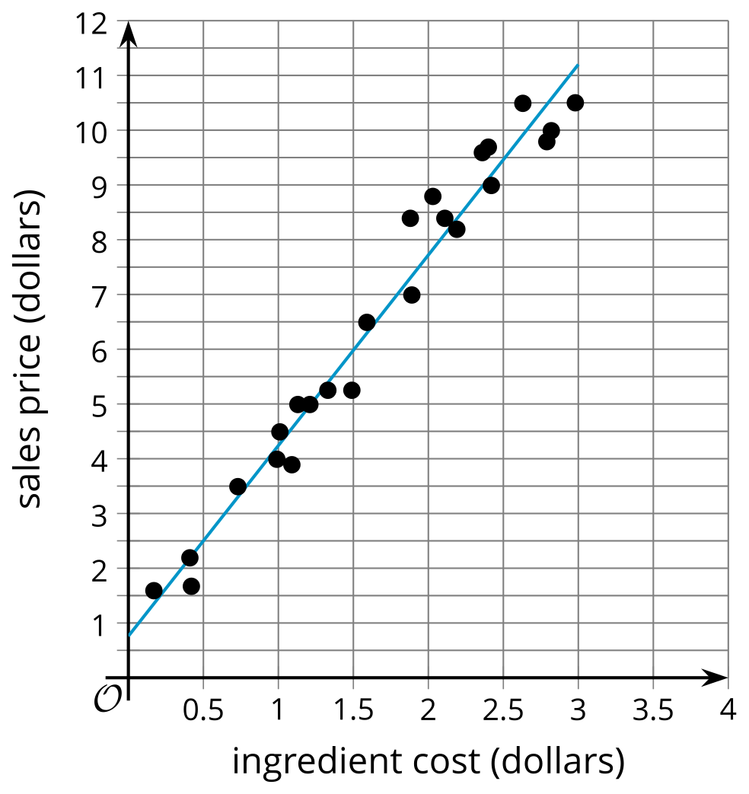
- What is the predicted sale price of an item that has ingredients that cost $1.50? Explain or show your reasoning.
- What is the predicted ingredient cost of an item that has a sale price of $7? Explain or show your reasoning.
- What is the slope of the linear model? What does that mean in this situation?
- What is the $y$-intercept of the linear model? What does this mean in this situation? Does this make sense?

4.4: The Slope is the Thing
- Here are several scatter plots.

- A. $y=\text{-}9.25x+400$
- 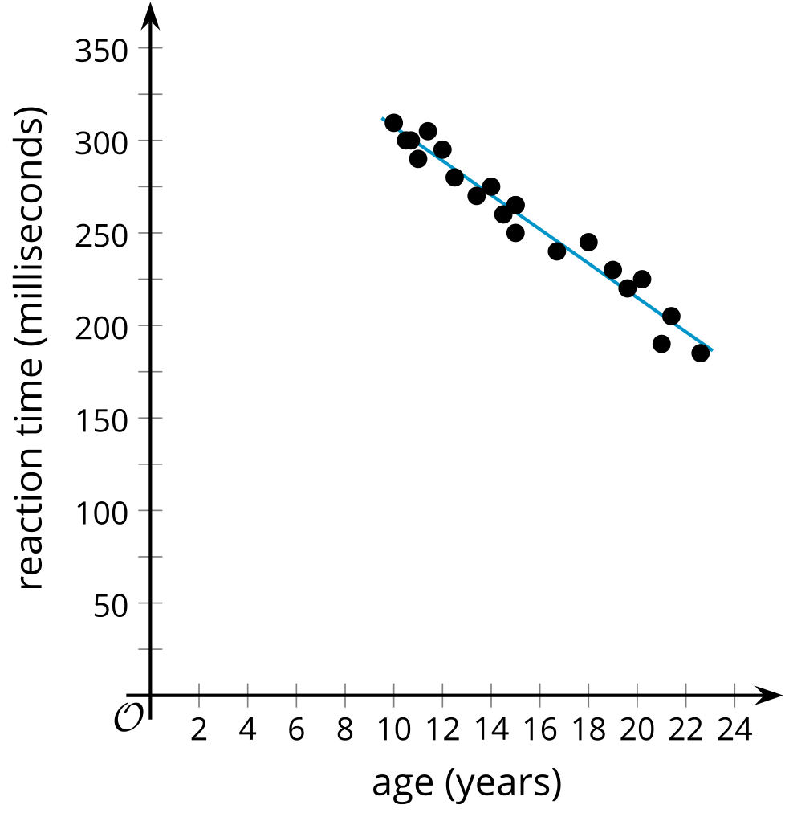

- B. $y=0.44x+0.04$
- 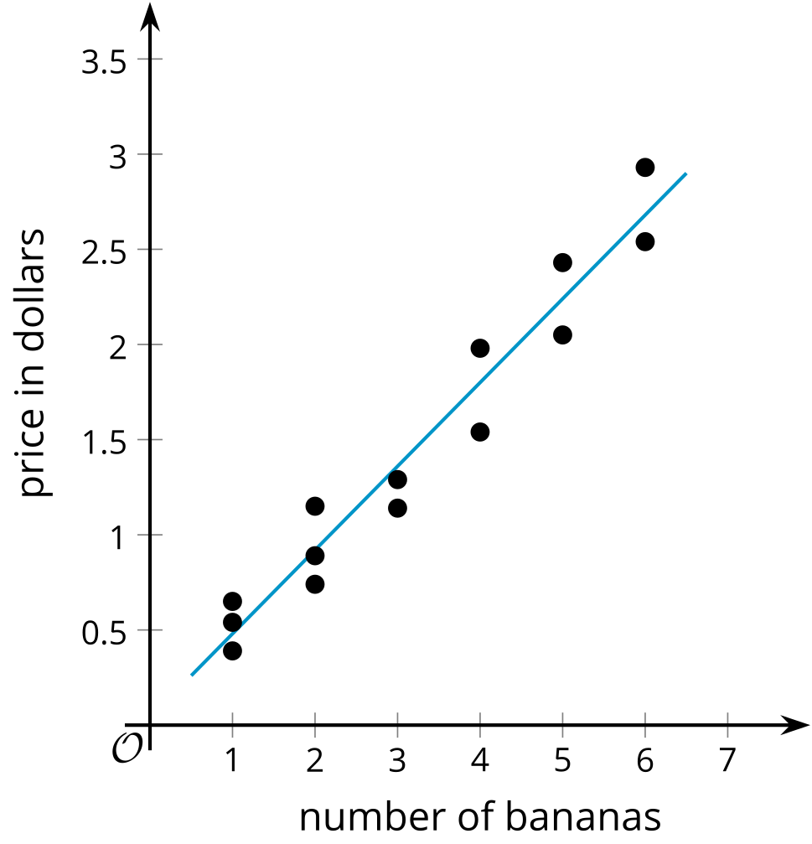

- C. $y=4x+87$
- 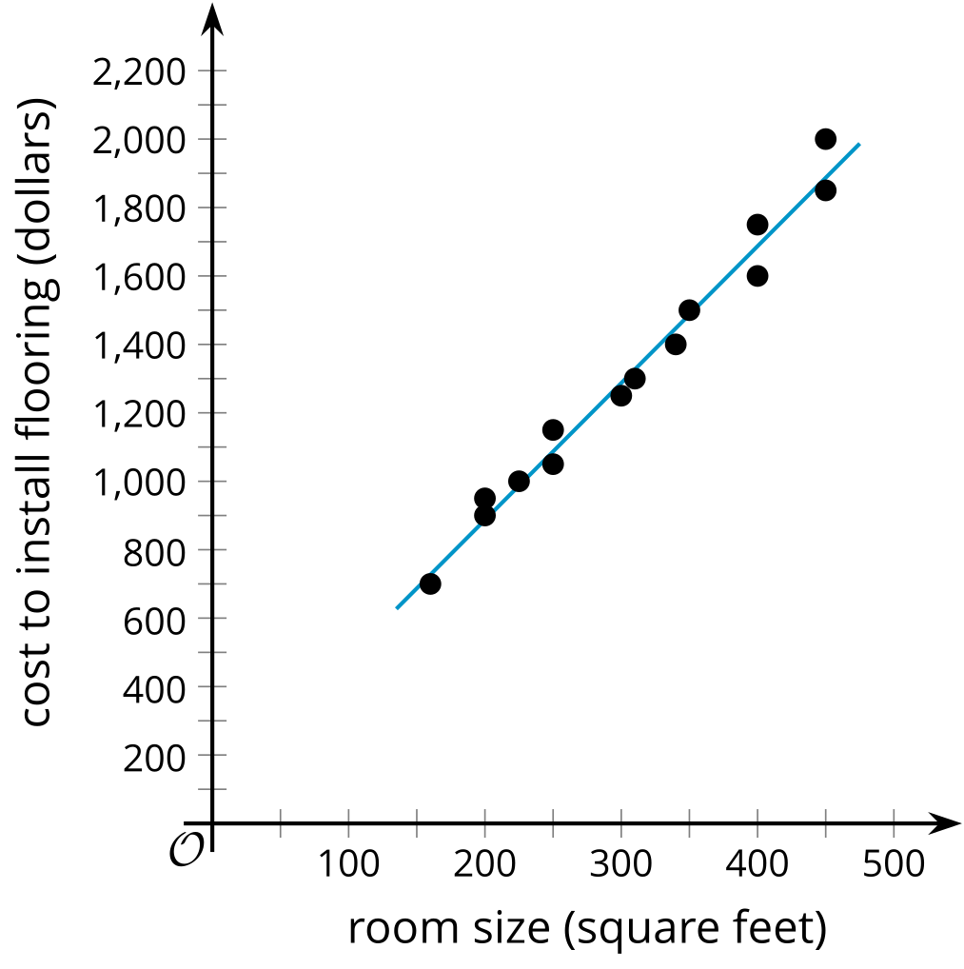

- D. $y=\text{-}2.4x+25.0$
- 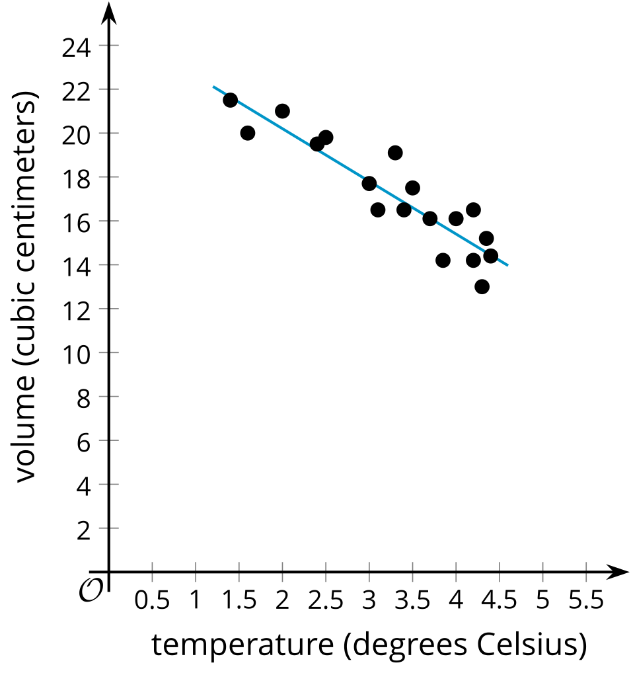
  - Using the horizontal axis for $x$ and the vertical axis for $y$, interpret the slope of each linear model in the situations shown in the scatter plots.
  - If the linear relationship continues to hold for each of these situations, interpret the $y$-intercept of each linear model in the situations provided.

Are you ready for more?
Clare, Diego, and Elena collect data on the mass and fuel economy of cars at different dealerships. Clare finds the line of best fit for data she collected for 12 used cars at a used car dealership. The line of best fit is $y=\frac{\text{-}9}{1000}x+34.3$ where $x$ is the car’s mass, in kilograms, and $y$ is the fuel economy, in miles per gallon.
Diego made a scatter plot for the data he collected for 10 new cars at a different dealership.
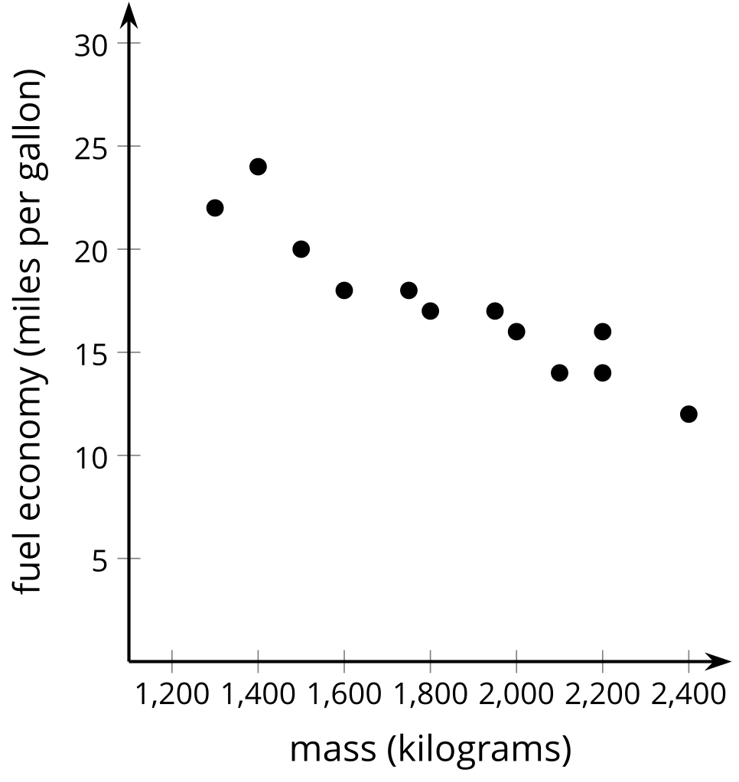
Elena made a table for data she collected on 11 hybrid cars at another dealership.
mass (kilograms) | fuel economy  (miles per gallon)
1,100 | 38
1,200 | 39
1,250 | 35
1,300 | 36
1,400 | 31
1,600 | 27
1,650 | 28
1,700 | 26
1,800 | 28
2,000 | 24
2,050 | 22
- Interpret the slope and $y$-intercept of Clare’s line of best fit in this situation.
- Diego looks at the data for new cars and used cars. He claims that the fuel economy of new cars decreases as the mass increases. He also claims that the fuel economy of used cars increases as the mass increases. Do you agree with Diego’s claims? Explain your reasoning.
- Elena looks at the data for hybrid cars and correctly claims that the fuel economy decreases as the mass increases. How could Elena compare the decrease in fuel economy as mass increases for hybrid cars to the decrease in fuel economy as mass increases for new cars? Explain your reasoning.

Lesson 4 Summary
While working in math class, it can be easy to forget that reality is somewhat messy. Not all oranges weigh exactly the same amount, beans have different lengths, and even the same person running a race multiple times will probably have different finishing times. We can approximate these messy situations with more precise mathematical tools to better understand what is happening. We can also predict or estimate additional results as long as we continue to keep in mind that reality will vary a little bit from what our mathematical model predicts.
For example, the data in this scatter plot represents the price of a package of broccoli and its weight. The data can be modeled by a line given by the equation $y=0.46x+0.92$. The data does not all fall on the line because there may be factors other than weight that go into the price, such as: the quality of the broccoli, the region where the package is sold, and any discounts happening in the store.

$y=0.46x+0.92$
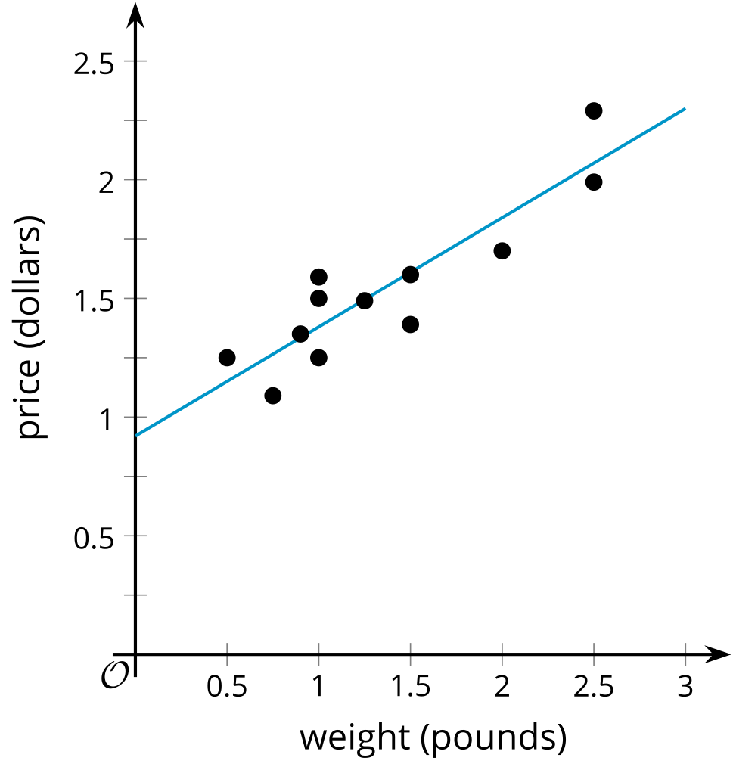
We can interpret the $y$-intercept of the line as the price for the package without any broccoli (which might include the cost of things like preparing the package and shipping costs for getting the vegetable to the store). In many situations, the data may not follow the same linear model farther away from the given data, especially as one variable gets close to zero. For this reason, the interpretation of the $y$-intercept should always be considered in context to determine if it is reasonable to make sense of the value in that way.
We can also interpret the slope as the approximate increase in price of the package for the addition of 1 pound of broccoli to the package.
The equation also allows us to predict additional values for the price of a package of broccoli for packages that have weights near the weights observed in the data set. For example, even though the data does not include the price of a package that contains 1.7 pounds of broccoli, we can predict the price to be about $1.70 based on the equation of the line, since $0.46⋅1.7+0.92≈1.70$.
On the other hand, it does not make sense to predict the price of 1,000 pounds of broccoli with this data, because there may be many more factors that will influence the pricing of packages that far away from the data presented here.
© CC BY 2019 by Illustrative Mathematics®

