Unit 2 Lesson 8: How Much for One?

1 Number Talk: Remainders in Division (Warm up)

Student Task Statement
Find the quotient mentally.
$246÷12$

2 Grocery Shopping

Student Task Statement
Answer each question and explain or show your reasoning. If you get stuck, consider drawing a double number line diagram.
- Eight avocados cost $4.
  - How much do 16 avocados cost?
  - How much do 20 avocados cost?
  - How much do 9 avocados cost?
- 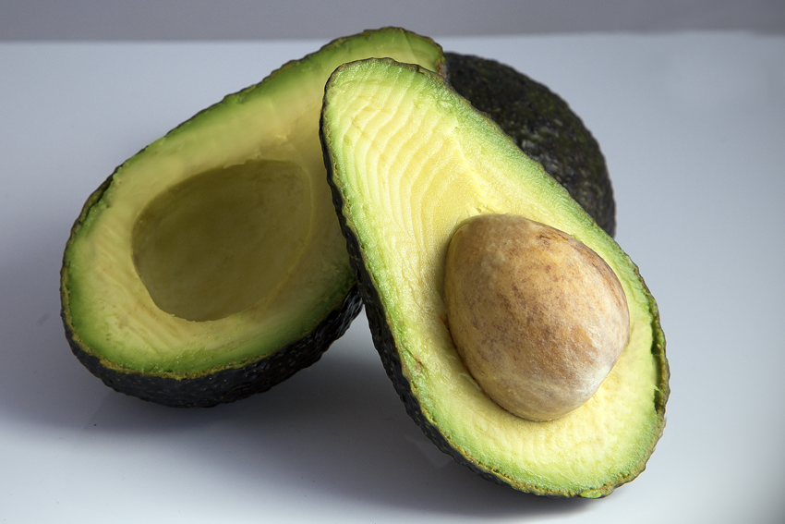
- Twelve large bottles of water cost $9.
  - How many bottles can you buy for $3?
  - What is the cost per bottle of water?
  - How much would 7 bottles of water cost?
- 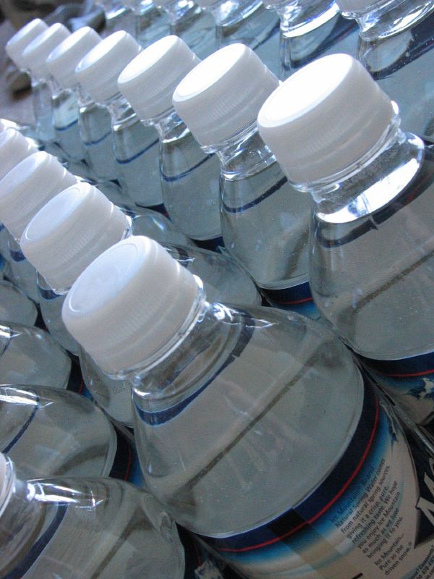
- A 10-pound sack of flour costs $8.
  - How much does 40 pounds of flour cost?
  - What is the cost per pound of flour?

3 More Shopping

Student Task Statement
- Four bags of chips cost $6.
  - What is the cost per bag?
  - At this rate, how much will 7 bags of chips cost?
- At a used book sale, 5 books cost $15.
  - What is the cost per book?
  - At this rate, how many books can you buy for $21?
- Neon bracelets cost $1 for 4.
  - What is the cost per bracelet?
  - At this rate, how much will 11 neon bracelets cost?
- Pause here so your teacher can review your work.
- 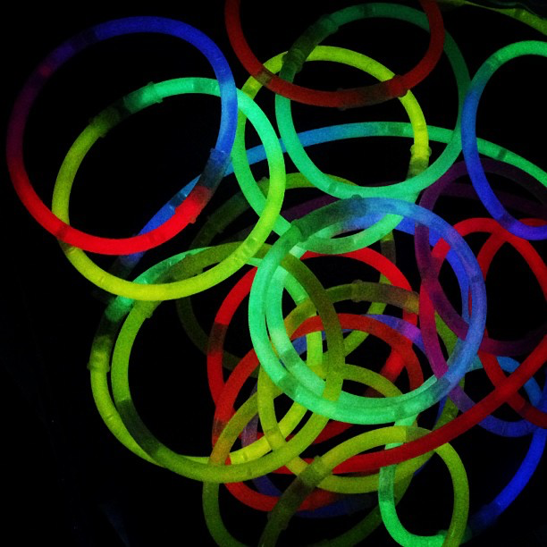
- Your teacher will assign you one of the problems. Create a visual display that shows your solution to the problem. Be prepared to share your solution with the class.
© CC BY Open Up Resources. Adaptations CC BY IM.

