Lesson 14 Practice Problems
- Complete the table with all of the missing information about three different cylinders.
- diameter of base (units) | - area of base (square units) | - height (units) | - volume (cubic units)
- 4 |  | - 10
- 6 |  |  | - $63π$
 | - $25π$ | - 6
- A cylinder has volume $45π$ and radius 3. What is its height?
- Three cylinders have a volume of 2826 cm³. Cylinder A has a height of 900 cm. Cylinder B has a height of 225 cm. Cylinder C has a height of 100 cm. Find the radius of each cylinder. Use 3.14 as an approximation for $π$.
- A gas company’s delivery truck has a cylindrical tank that is 14 feet in diameter and 40 feet long.
  - Sketch the tank, and mark the radius and the height.
  - How much gas can fit in the tank?
- (From Unit 5, Lesson 13.)
- Here is a graph that shows the water height of the ocean between September 22 and September 24, 2016 in Bodega Bay, CA.
- 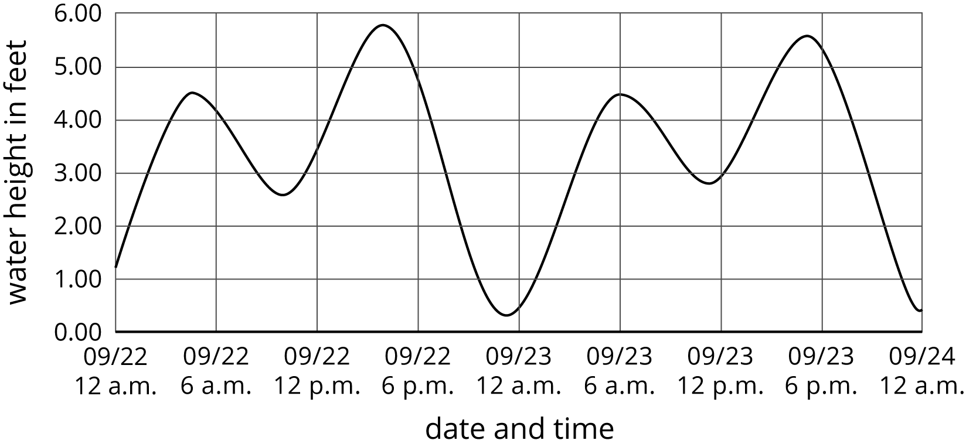
  - Estimate the water height at 12 p.m. on September 22.
  - How many times was the water height 5 feet? Find two times when this happens.
  - What was the lowest the water got during this time period? When does this occur?
  - Does the water ever reach a height of 6 feet?
- (From Unit 5, Lesson 5.)
© CC BY Open Up Resources. Adaptations CC BY IM.

