Lesson 13 Practice Problems

  - Sketch a cylinder.
  - Label its radius 3 and its height 10.
  - Shade in one of its bases.
- At a farm, animals are fed bales of hay and buckets of grain. Each bale of hay is in the shape a rectangular prism. The base has side lengths 2 feet and 3 feet, and the height is 5 feet. Each bucket of grain is a cylinder with a diameter of 3 feet. The height of the bucket is 5 feet, the same as the height of the bale.
  - Which is larger in area, the rectangular base of the bale or the circular base of the bucket? Explain how you know.
  - Which is larger in volume, the bale or the bucket? Explain how you know.
- Three cylinders have a height of 8 cm. Cylinder 1 has a radius of 1 cm. Cylinder 2 has a radius of 2 cm. Cylinder 3 has a radius of 3 cm. Find the volume of each cylinder.
- A one-quart container of tomato soup is shaped like a rectangular prism. A soup bowl shaped like a hemisphere can hold 8 oz of liquid. How many bowls will the soup container fill? Recall that 1 quart is equivalent to 32 fluid ounces (oz).
- (From Unit 5, Lesson 12.)
- Match each set of information about a circle with the area of that circle.
  - Circle A has a radius of 4 units.
  - Circle B has a radius of 10 units.
  - Circle C has a diameter of 16 units.
  - Circle D has a circumference of $4π$ units.
  - $4π$ square units
  - approximately 314 square units
  - $64π$ square units
  - $16π$ square units
- Two students join a puzzle solving club and get faster at finishing the puzzles as they get more practice. Student A improves their times faster than Student B.
- 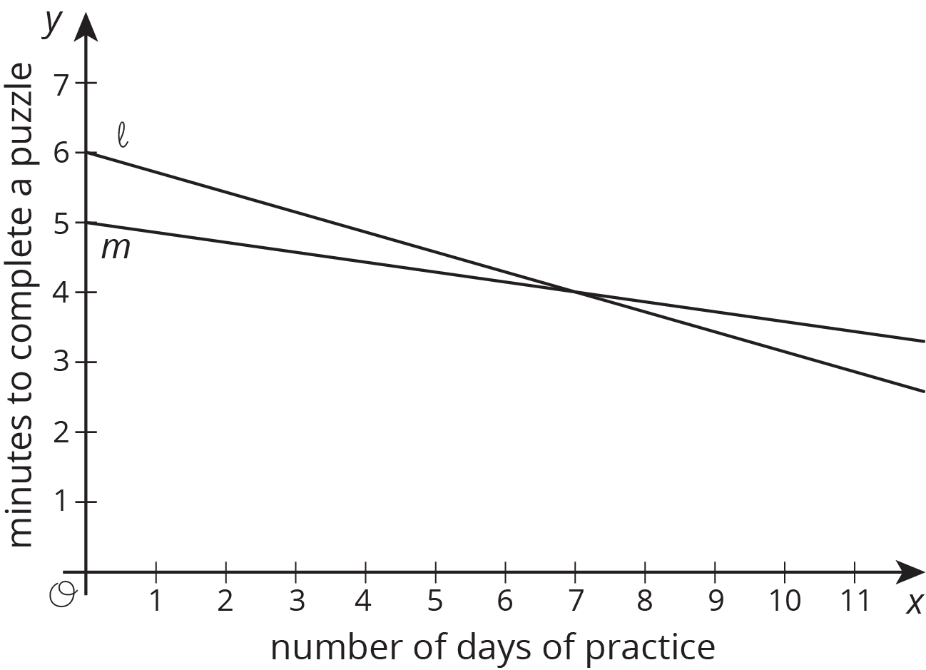
  - Match the students to the Lines $ℓ$ and $m$.
  - Which student was faster at puzzle solving before practice?
- (From Unit 5, Lesson 8.)
© CC BY Open Up Resources. Adaptations CC BY IM.

