Lesson 11 Practice Problems
- Cylinder A, B, and C have the same radius but different heights. Put the cylinders in order of their volume from least to greatest.
- 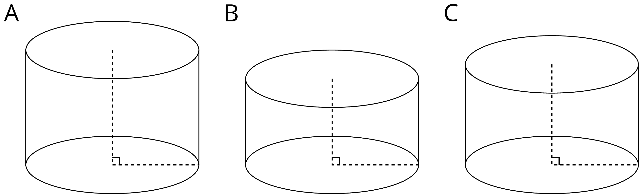

- Two cylinders, $a$ and $b$, each started with different amounts of water. The graph shows how the height of the water changed as the volume of water increased in each cylinder. Match the graphs of $a$ and $b$ to Cylinders P and Q. Explain your reasoning.
- 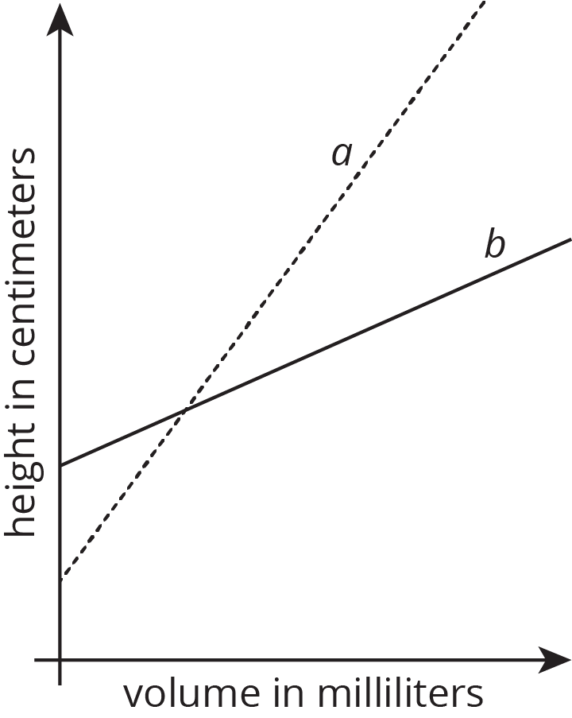
- 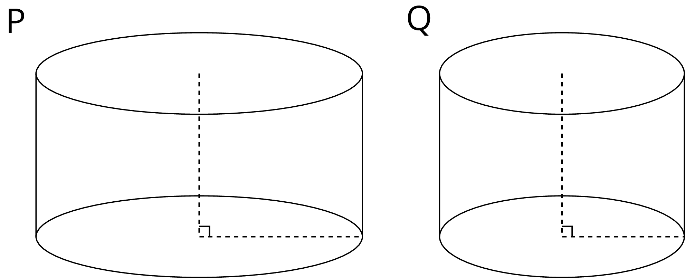

- Which of the following graphs could represent the volume of water in a cylinder as a function of its height? Explain your reasoning.
- 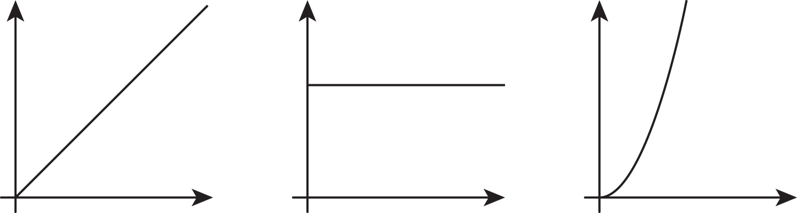

- Together, the areas of the rectangles sum to 30 square centimeters.
  - Write an equation showing the relationship between $x$ and $y$.
  - Fill in the table with the missing values.
- $x$ | - 3 |  | - 8 |  | - 12
- $y$ |  | - 5 |  | - 10
- (From Unit 5, Lesson 3.)
© CC BY Open Up Resources. Adaptations CC BY IM.

