Unit 1 Lesson 4: Making the Moves

1 Reflection Quick Image (Warm up)

Images for Launch
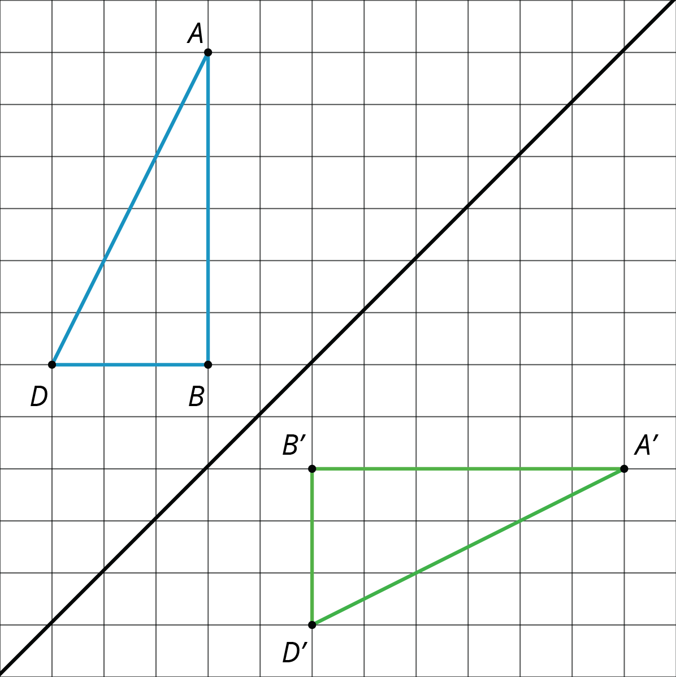

Student Task Statement
Here is an incomplete image. Your teacher will display the completed image twice, for a few seconds each time. Your job is to complete the image on your copy.
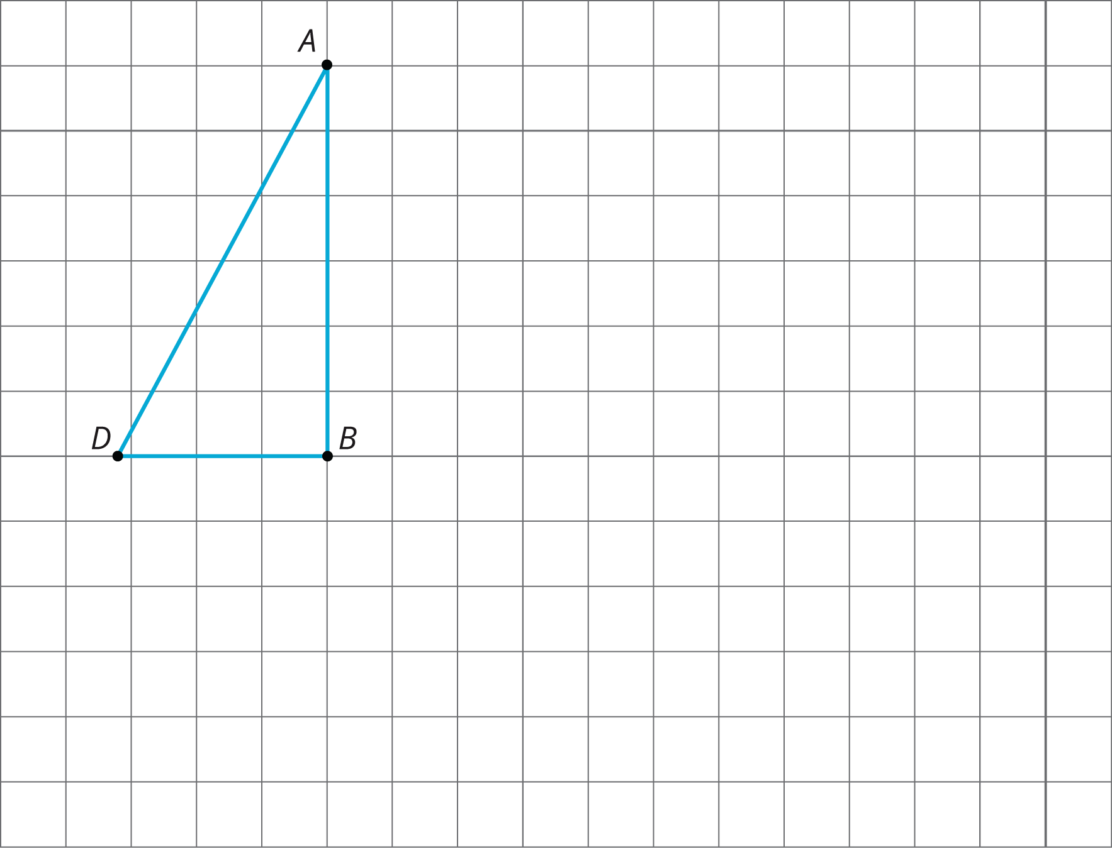

2 Make That Move

Student Task Statement
Your partner will describe the image of this triangle after a certain transformation. Sketch it here.
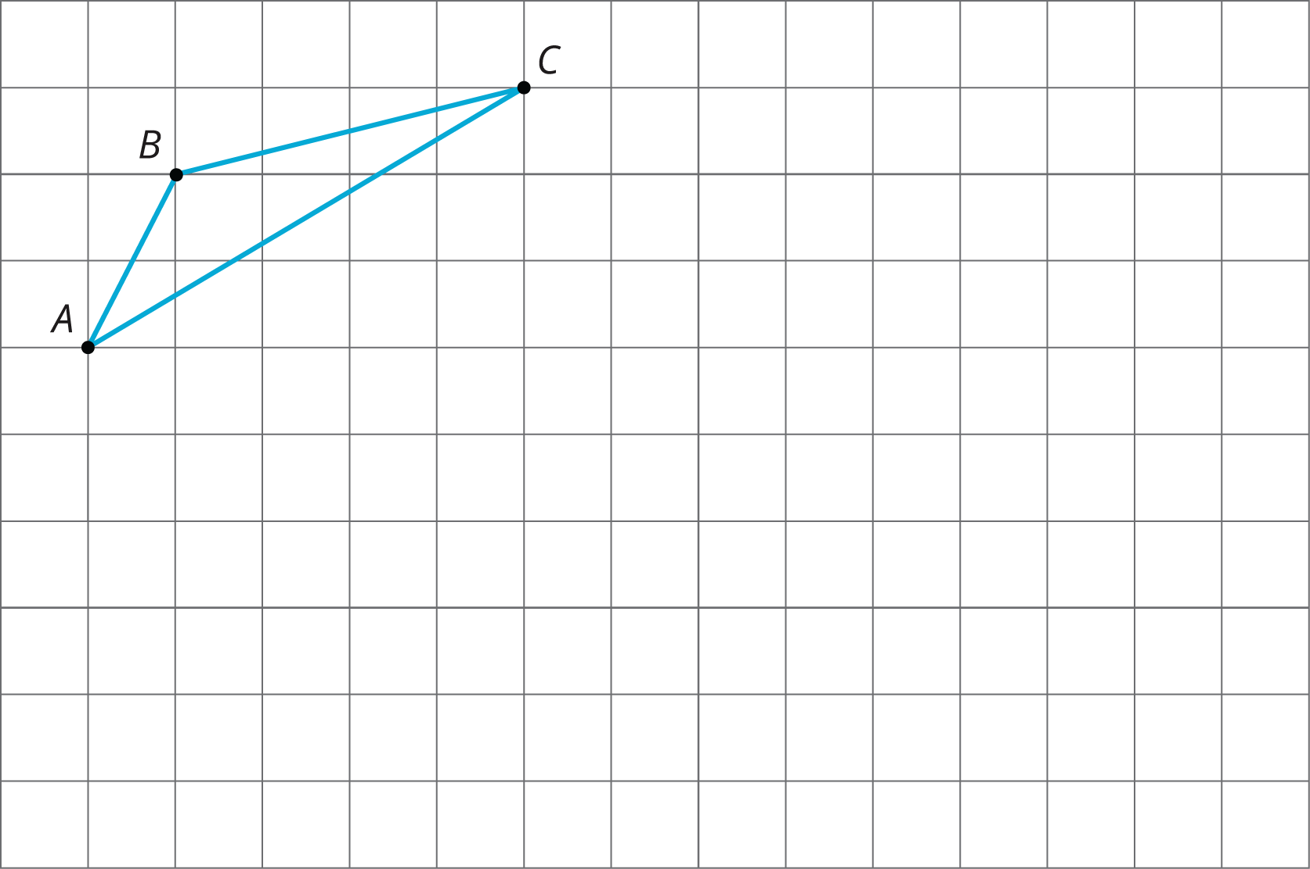

3 A to B to C

Images for Launch
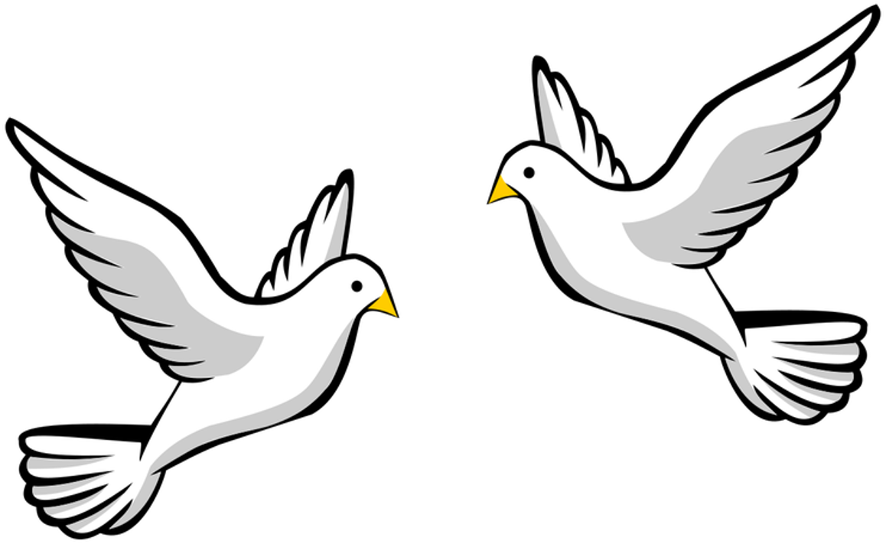

Student Task Statement
Here are some figures on an isometric grid.
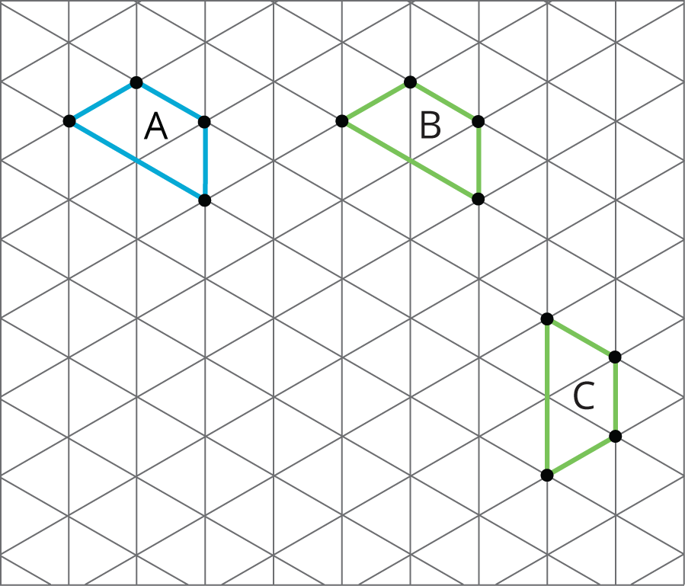
- Name a transformation that takes Figure $A$ to Figure $B$. Name a transformation that takes Figure $B$ to Figure $C$.
- What is one sequence of transformations that takes Figure $A$ to Figure $C$? Explain how you know.
© CC BY Open Up Resources. Adaptations CC BY IM.

