Lesson 17: Working with Rigid Transformations
- Let’s compare transformed figures.

17.1: Math Talk: From Here to There
Segment $CD$ is the perpendicular bisector of segment $AB$. Find each transformation mentally.
A transformation that takes $A$ to $B$.
A transformation that takes $B$ to $A$.
A transformation that takes $C$ to $D$.
A transformation that takes $D$ to $C$.
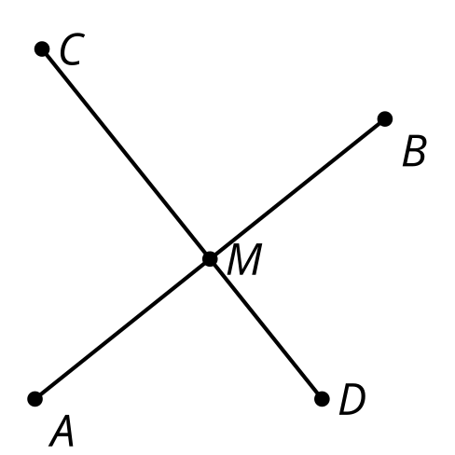

17.2: Card Sort: How Did This Get There?
- Your teacher will give you a set of cards that show transformations of figures.
  - Sort the cards into categories of your choosing. Be prepared to explain the meaning of your categories.
  - Then sort the cards into categories in a different way. Be prepared to explain the meaning of your new categories.
- For each card with a rigid transformation: write a sequence of rotations, translations, and reflections to get from the original figure to the image. Be precise.

Are you ready for more?
Diego observes that although it was often easier to use a sequence of reflections, rotations, and translations to describe the rigid transformations in the cards, each of them could be done with just a single reflection, rotation, or translation. However, Priya draws her own card, shown, which she claims can not be done as a single reflection, rotation, or translation.
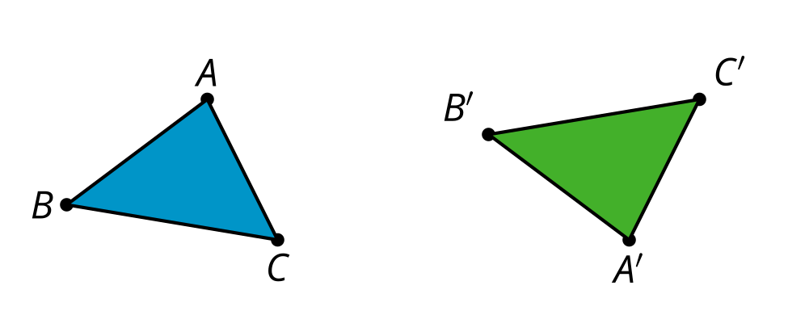
- For each rigid transformation from the card sort, write the transformation as a single reflection, rotation, or translation.
- Justify why Priya’s transformation cannot be written as a single reflection, rotation, or translation.

17.3: Reflecting on Reflection
Diego says, “I see why a reflection could take $RSTU$ to $R^{′}S^{′}T^{′}U^{′}$, but I’m not sure where the line of reflection is. I’ll just guess.”
- How could Diego see that a reflection could work without knowing where the line of reflection is?
- How could Diego find an exact line of reflection that would work?

Lesson 17 Summary
If 2 figures are congruent, we can always find a rigid transformation that takes one onto the other.
Look at congruent figures $ABC$ and $DEF$. It looks like ​​​​​$DEF$ might be a reflection and translation of $ABC$. But is there a way to describe a sequence of transformations without guessing where the line of reflection might be?
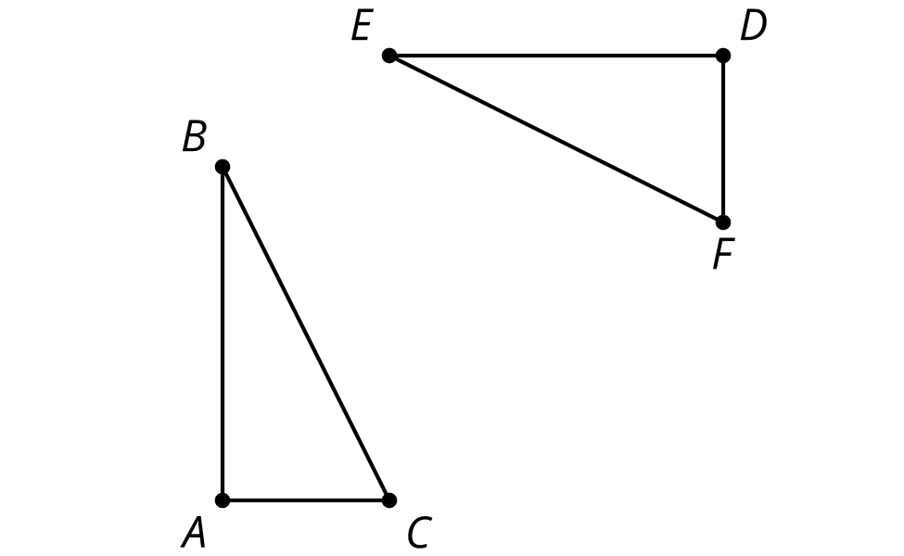
Our goal is to take the image of $E$ onto $B$. Then we want to take the image of $D$ onto $A$ without moving $E$ and $B$. Finally, we need to take the image of $F$ onto $C$ without moving any of the matching points.
We can start with translation: Translate triangle $DEF$ by the directed line segment from $E$ to $B$.
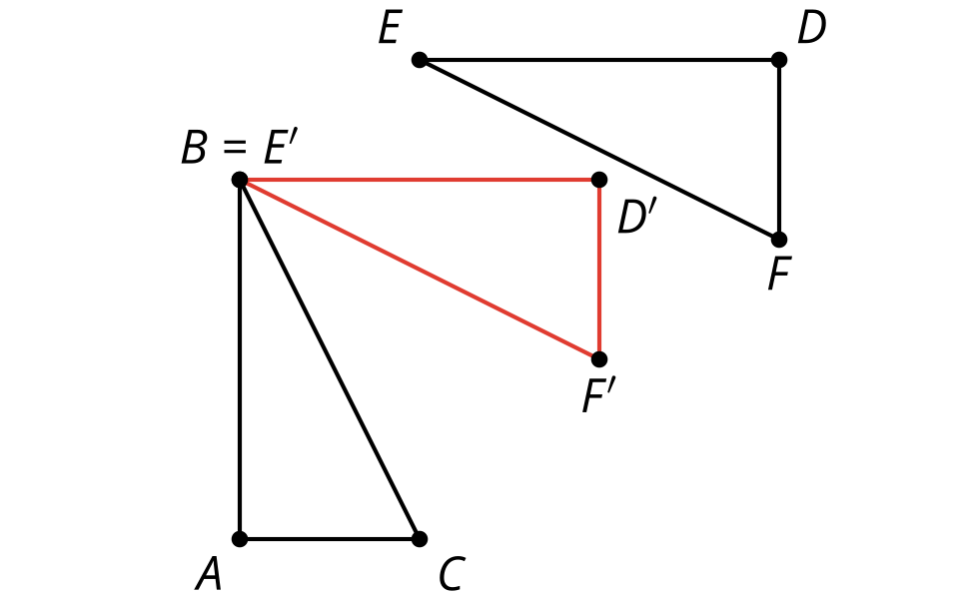
Now, a pair of corresponding points coincides. Is there a transformation we could use to take $D^{′}$ onto $A$ that leaves $B$ and $E^{′}$ in place? Rotations have a fixed point, so rotate triangle $D^{′}E^{′}F^{′}$ by angle $D^{′}BA$ using point $B$ as the center.
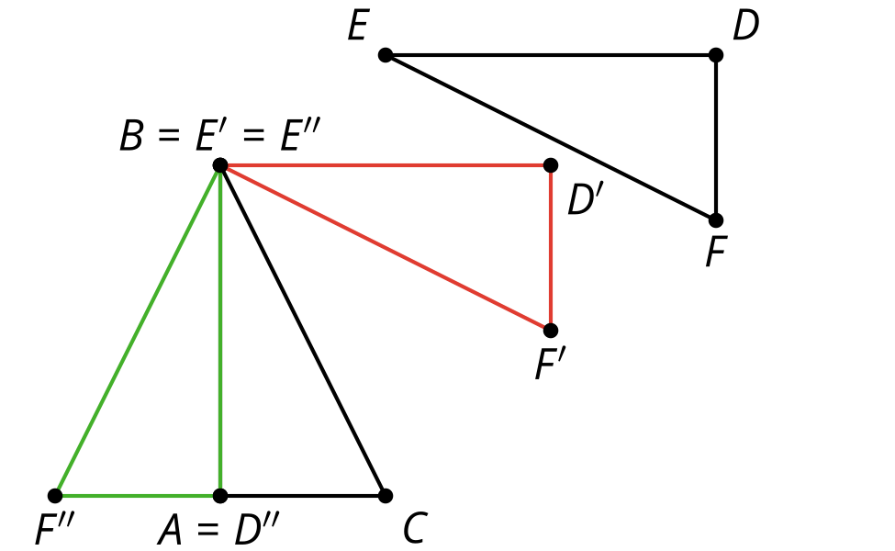
Now, 2 pairs of corresponding points coincide. Reflecting across line $AB$ will take $D^{″}E^{″}F^{″}$ onto $ABC$, which is what we were trying to do. We know $D^{″}$ and $E^{″}$ won’t move, since points on the line of reflection don't move. How do we know $F^{″}$ will end up on $C$? Since the triangles are congruent, $F^{″}$and $C$ are the same distance from the line of reflection.
It is always possible to describe transformations using existing points, angles, and segments. It could take an extra step, but we can be confident transformations work if we don't guess where the line of reflection or center of rotation might be.
© CC BY 2019 by Illustrative Mathematics®

