Unit 7 Lesson 3: Squares and Equations

1 Math Talk: Squaring Values (Warm up)

Student Task Statement
Mentally evaluate each expression.
$7^{2}$
${\left(\text{-}7\right)}^{2}$
$\text{-}7^{2}$
${\left(\text{-}\frac{2}{5}\right)}^{2}$

2 Squares with Squares

Images for Launch

Student Task Statement
Let $p^{2}=q$
- Select all pairs of values that could be $p$ and $q$.
  - $p=6,q=36$
  - $p=\text{-}6,q=36$
  - $p=\text{-}2,q=\text{-}4$
  - $p=\text{-}10,q=100$
  - $p=\frac{1}{2},q=\frac{1}{4}$
  - $p=\text{-}0.2,q=0.4$
- List one other possible pair of values for $p$ and $q$ that make the equation true.
- Use the diagrams to find the value of the side length for each square, then find the value for $x$.
- 1. The square has an area of 25.
- 2. The square has an area of 36.
- 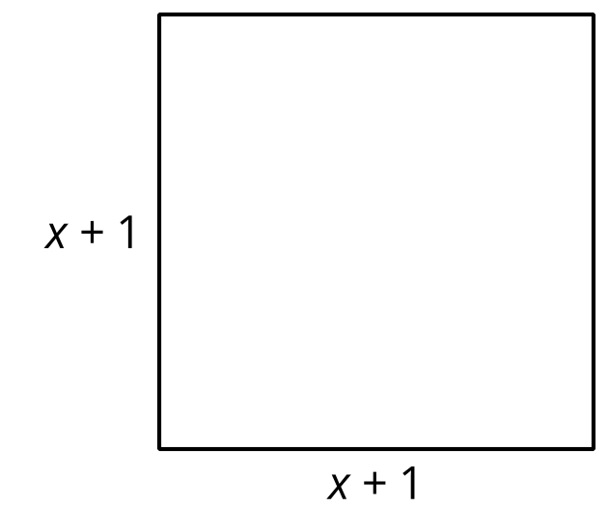
- 3. The square has an area of 100
- 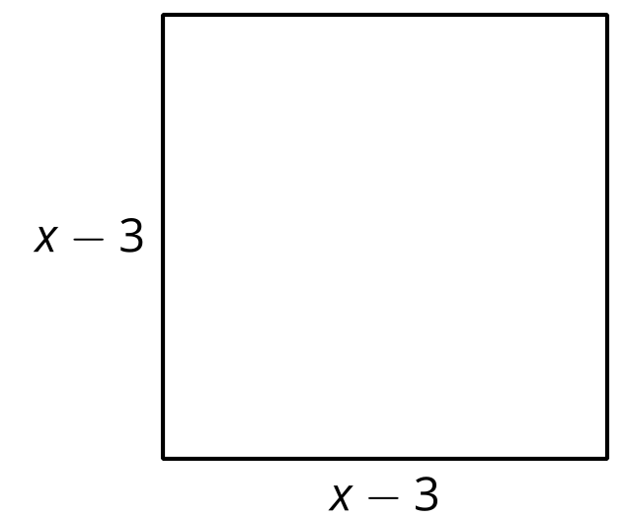

3 Matching Solutions and Equations

Student Task Statement
Here are some equations and a list of numbers. Which numbers are solutions to which equations?
- $c^{2}=121$
- $5⋅d^{2}=500$
- $80=m^{2}−1$
- $100={\left(n+3\right)}^{2}$
- -13
- -11
- -10
- -9
- -7
- 7
- 9
- 10
- 11
- 13
© CC BY 2019 by Illustrative Mathematics®

