Lesson 14: Resuélvelo a tu manera

Standards Alignments
Addressing | 2.NBT.B.5, 2.OA.A.1

Teacher-facing Learning Goals
- Use diagrams or equations to represent and solve one- and two-step story problems within 100.

Student-facing Learning Goals
- Resolvamos problemas-historia y compartamos con otros cómo pensamos.

Lesson Purpose
The purpose of this lesson is for students to represent and solve one- and two-step story problems. Students use representations to make sense of problems, support their calculations, and explain their thinking.
In previous lessons, students solved different problem types within 100. Students made sense of story problems and connected story problems to diagrams and equations. The activities in this lesson can be used to assess the methods students use to make sense of and solve story problems on their own. Students are introduced to the idea that story problems could have more than one step. In the first activity, students solve a Put Together / Take Apart, Result Unknown problem that includes three addends. Students are presented the story in two separate parts. In the second activity, students work in groups to solve related story problems on their own and then work together to solve a two-step Put Together / Take Apart problem.
This lesson has a Student Section Summary.

Access for:

Students with Disabilities
- Action and Expression (Activity 2)

English Learners
- MLR8 (Activity 1)

Instructional Routines
MLR7 Compare and Connect (Activity 2), Number Talk (Warm-up)

Materials to Gather
- Base-ten blocks: Activity 1
- Base-ten blocks: Activity 2
- Connecting cubes: Activity 1
- Tools for creating a visual display: Activity 2

Lesson Timeline
Warm-up | 10 min
Activity 1 | 15 min
Activity 2 | 20 min
Lesson Synthesis | 10 min
Cool-down | 5 min

Teacher Reflection Question
Think about times when students were able to make connections to and build on the ideas of their peers during discussions today. What norms or routines allowed students to engage with other students’ ideas?

Cool-down
(to be completed at the end of the lesson) 5min
Las semillas de Jada

Standards Alignments
Addressing | 2.OA.A.1

Student-facing Task Statement
- Jada tiene 15 semillas de manzana y 23 semillas de naranja. ¿Cuántas semillas tiene en total? Muestra cómo pensaste.
- Jada recolectó 37 semillas más. ¿Cuántas semillas tiene ahora? Muestra cómo pensaste.

Student Responses
- 38 seeds. Sample response:
  - 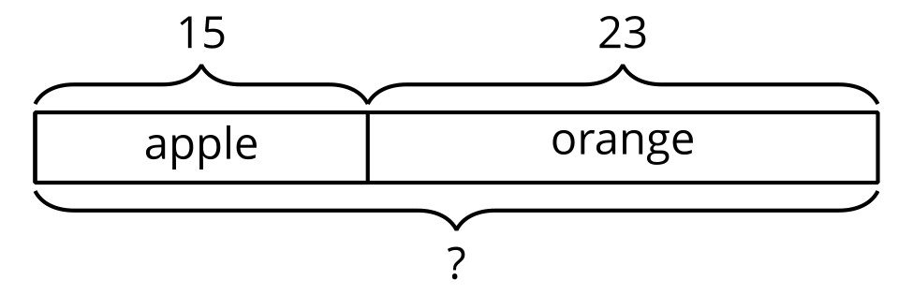
  - $15+23=?$
$15+20=35$
$5+3=38$
- 75 seeds. Sample response:
  - 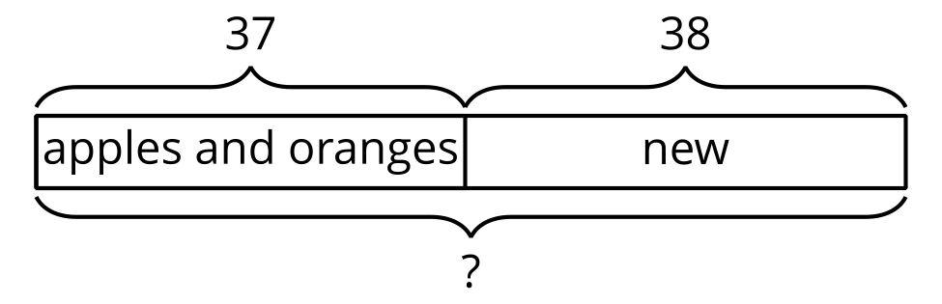
  - $37+38=?$
$7+8=15$
$30+30=60$
$60+15=75$

