Unit 7 Lesson 20: Representing Contexts with Equations

1 Don't Solve It (Warm up)

Student Task Statement
Is the solution positive or negative?
$\left(\text{-}8.7\right)\left(1.4\right)=a$
$\text{-}8.7b=1.4$
$\text{-}8.7+c=\text{-}1.4$
$\text{-}8.7−d=\text{-}1.4$

2 Warmer or Colder than Before?

Student Task Statement
For each situation,
- Find two equations that could represent the situation from the bank of equations. (Some equations will not be used.)
- Explain what the variable $v$ represents in the situation.
- Determine the value of the variable that makes the equation true, and explain your reasoning.
Bank of equations:
$\text{-}3v=9$
$\text{-}4⋅3=v$
$\text{-}4⋅\text{-}3=v$
$v=\text{-}\frac{1}{3}⋅9$
$v=\text{-}16+6$
$v=4+\left(\text{-}12\right)$
$\text{-}3v=\text{-}6$
$v=\text{-}\frac{1}{3}⋅\left(\text{-}6\right)$
$v=\frac{1}{3}⋅\left(\text{-}6\right)$
$v=\text{-}16−\left(6\right)$
$\text{-}6+v=\text{-}16$
$v=4+12$
$v+12=4$
$v=9+3$
$\text{-}4=\frac{1}{3}v$
$4=3v$
- Between 6 a.m. and noon, the temperature rose 12 degrees Fahrenheit to 4 degrees Fahrenheit.
- At midnight the temperature was -6 degrees. By 4 a.m. the temperature had fallen to -16 degrees.
- The temperature is 0 degrees at midnight and dropping 3 degrees per hour. The temperature is -6 degrees at a certain time.
- The temperature is 0 degrees at midnight and dropping 3 degrees per hour. The temperature is 9 degrees at a certain time.
- The temperature at 9 p.m. is one third the temperature at midnight.

3 Animals Changing Altitudes (Optional)

Student Task Statement
- Match each situation with a diagram.
  - A penguin is standing 3 feet above sea level and then dives down 10 feet. What is its depth?
  - A dolphin is swimming 3 feet below sea level and then jumps up 10 feet. What is its height at the top of the jump?
  - A sea turtle is swimming 3 feet below sea level and then dives down 10 feet. What is its depth?
  - An eagle is flying 10 feet above sea level and then dives down to 3 feet above sea level. What was its change in altitude?
  - A pelican is flying 10 feet above sea level and then dives down reaching 3 feet below sea level. What was its change in altitude?
  - A shark is swimming 10 feet below sea level and then swims up reaching 3 feet below sea level. What was its change in depth?
- Next, write an equation to represent each animal's situation and answer the question. Be prepared to explain your reasoning.
Diagrams
A
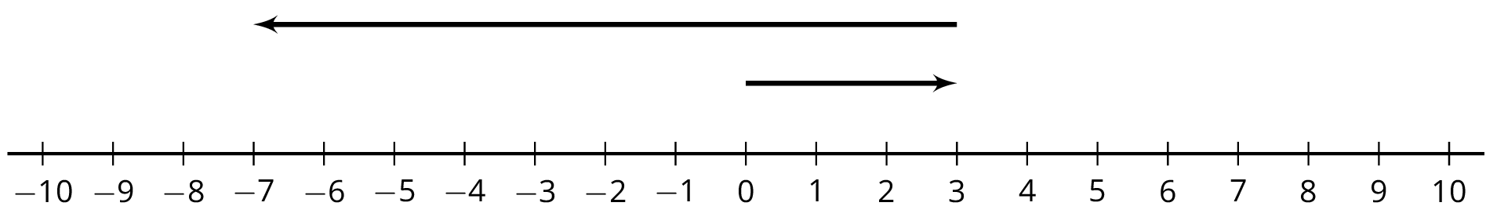
B
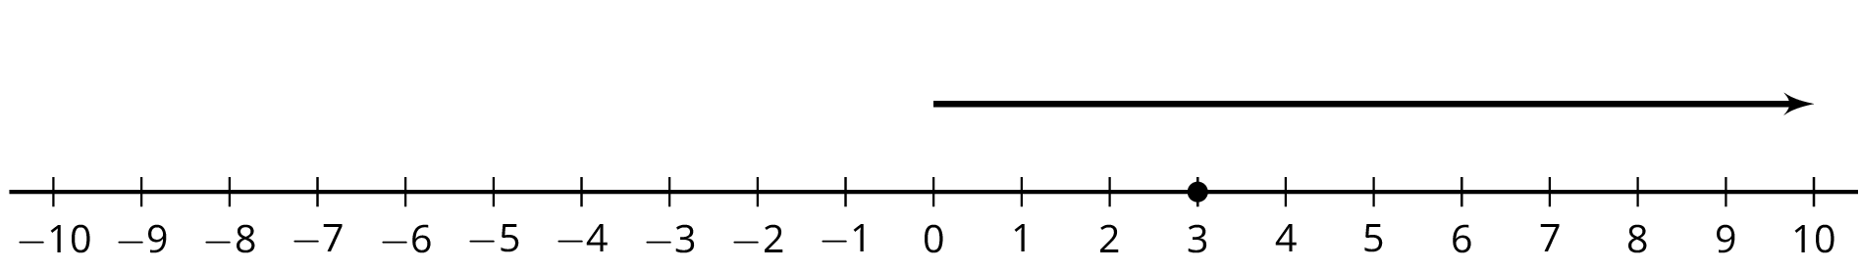
C
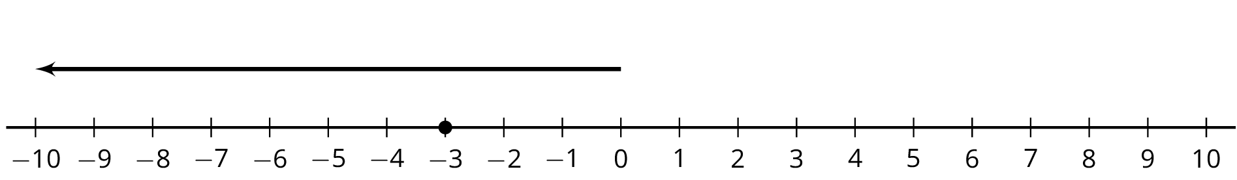
D
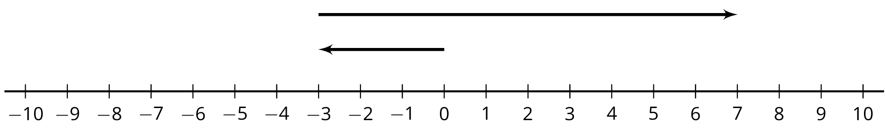
E
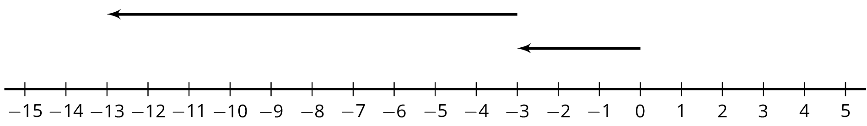
F
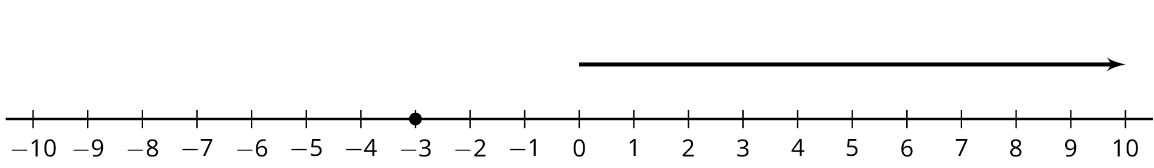

4 Equations Tell a Story

Student Task Statement
Your teacher will assign your group one of these situations. Create a visual display about your situation that includes:
- An equation that represents your situation
- What your variable and each term in the equation represent
- How the operations in the equation represent the relationships in the story
- How you use inverses to solve for the unknown quantity
- The solution to your equation
- As a $7\frac{1}{4}$ inch candle burns down, its height decreases $\frac{3}{4}$ inch each hour. How many hours does it take for the candle to burn completely?
- On Monday $\frac{1}{9}$ of the enrolled students in a school were absent. There were 4,512 students present. How many students are enrolled at the school?
- A hiker begins at sea level and descends 25 feet every minute. How long will it take to get to an elevation of -750 feet?
- Jada practices the violin for the same amount of time every day. On Tuesday she practices for 35 minutes. How much does Jada practice in a week?
- The temperature has been dropping $2\frac{1}{2}$ degrees every hour and the current temperature is $\text{-}{15}^{∘}\text{F}$. How many hours ago was the temperature $0^{∘}\text{F}$?
- The population of a school increased by 12%, and now the population is 476. What was the population before the increase?
- During a 5% off sale, Diego pays $74.10 for a new hockey stick. What was the original price?
- A store buys sweaters for $8 and sells them for $26. How many sweaters does the store need to sell to make a profit of $990?
© CC BY Open Up Resources. Adaptations CC BY IM.

