Lesson 15: Symmetry
- Let’s describe some symmetries of shapes.

15.1: Back to the Start
Here is a segment $AB$:
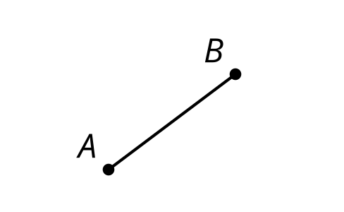
If you translate the segment up 5 units then down 5 units, it looks the same as it did originally.
- What other rigid transformations create an image that fits exactly over the original segment?
- Are there any single rigid motions that do the same thing?

15.2: Self Reflection
Determine all the lines of symmetry for the shape your teacher assigns you. Create a visual display about your shape. Include these parts in your display:
- the name of your shape
- the definition of your shape
- drawings of each line of symmetry
- a description in words of each line of symmetry
- one non-example in a different color (a description and drawing of a reflection not over a line of symmetry)

Are you ready for more?
Look at all of the shapes the class explored and focus on those which had more than one line of symmetry.
- What is true for all the lines of symmetry in these shapes?
- Give an example of a shape that has two or more lines of symmetry that do not intersect at the same point.
- What would happen if you did a sequence of two different reflections across lines of symmetry for the shapes you explored in class?

15.3: Diabolic Diagonals
Kiran thinks both diagonals of a kite are lines of symmetry. Tyler thinks only 1 diagonal is a line of symmetry. Who is correct? Explain how you know.

Lesson 15 Summary
A shape has symmetry if there is a rigid transformation which creates an image that fits exactly over the original shape. A shape has reflection symmetry if there is a reflection that takes the shape to itself, and the line of reflection in this case is called a line of symmetry. A regular hexagon has many lines of symmetry. Here are 2 of them. What other lines create a reflection where the image is the same as the original figure?
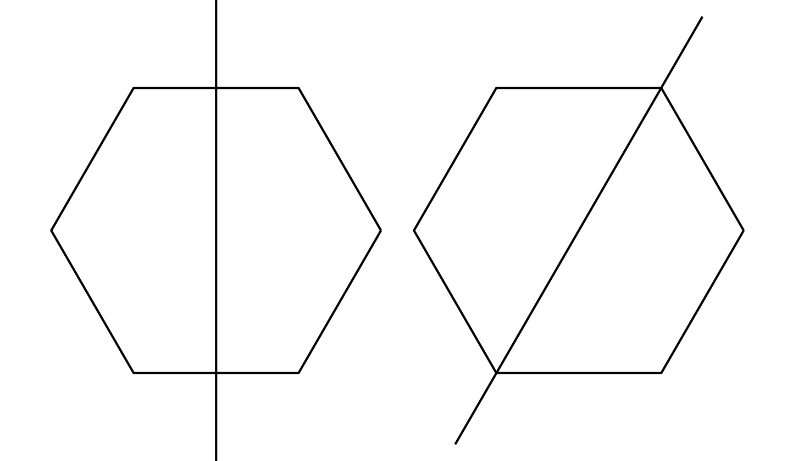
© CC BY 2019 by Illustrative Mathematics®

