Lesson 12 Practice Problems

  - Sketch a cube and label its side length as 4 cm (this will be Cube A).
  - Sketch a cube with sides that are twice as long as Cube A and label its side length (this will be Cube B).
  - Find the volumes of Cube A and Cube B.
- Two paper drink cups are shaped like cones. The small cone can hold 6 oz of water. The large cone is $\frac{4}{3}$ the height and $\frac{4}{3}$ the diameter of the small cone. Which of these could be the amount of water the large cone holds?
  - 8 cm
  - 14 oz
  - 4.5 oz
  - 14 cm
- The graph represents the volume of a cylinder with a height equal to its radius.
  - When the diameter is 2 cm, what is the radius of the cylinder?
  - Express the volume of a cube of side length $s$ as an equation.
  - Make a table for volume of the cube at $s=$ 0 cm, $s=$ 1 cm, $s=$ 2 cm, and $s=$ 3 cm.
  - Which volume is greater: the volume of the cube when $s=$ 3 cm, or the volume of the cylinder when its diameter is 3 cm?
- 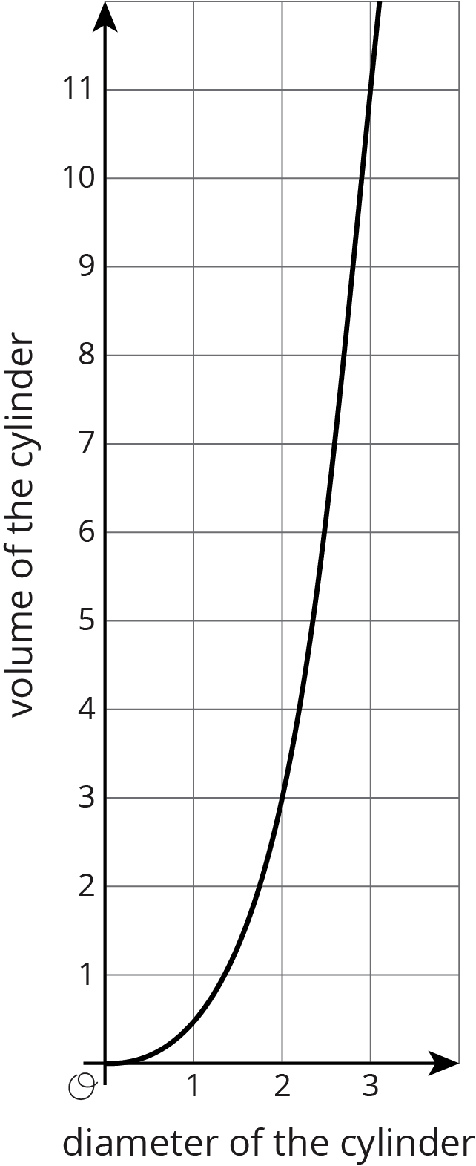

- (From Unit 5, Lesson 7.)
- Select all the points that are on a line with slope 2 that also contains the point $\left(2,\text{-}1\right)$.
  - $\left(3,1\right)$
  - $\left(1,1\right)$
  - $\left(1,\text{-}3\right)$
  - $\left(4,0\right)$
  - $\left(6,7\right)$
- (From Unit 3, Lesson 10.)
- Several glass aquariums of various sizes are for sale at a pet shop. They are all shaped like rectangular prisms. A 15-gallon tank is 24 inches long, 12 inches wide, and 12 inches tall. Match the dimensions of the other tanks with the volume of water they can each hold.
  - Tank 1: 36 inches long, 18 inches wide, and 12 inches tall
  - Tank 2: 16 inches long, 8 inches wide, and 10 inches tall
  - Tank 3: 30 inches long, 12 inches wide, and 12 inches tall
  - Tank 4: 20 inches long, 10 inches wide, and 12 inches tall
  - 5 gallons
  - 10 gallons
  - 20 gallons
  - 30 gallons
- Solve: $\left\{\begin{matrix}y=\text{-}2x−20 \\ y=x+4\end{matrix}\right.$
- (From Unit 4, Lesson 14.)
© CC BY Open Up Resources. Adaptations CC BY IM.

