Lesson 15 Practice Problems
- Select all quadrilaterals that have 180 degree rotational symmetry.
  - trapezoid
  - isosceles trapezoid
  - parallelogram
  - rhombus
  - rectangle
  - square
- (From Unit 2, Lesson 14.)
- Lin wrote a proof to show that diagonal $EG$ is a line of symmetry for rhombus $EFGH$. Fill in the blanks to complete her proof.
- 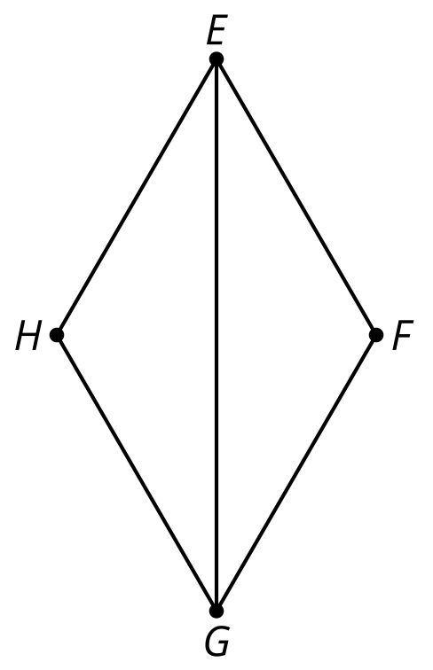
- Because $EFGH$ is a rhombus, the distance from $E$ to $\underset{_}{1}$ is the same as the distance from $E$ to $\underset{_}{2}$. Since $E$ is the same distance from $\underset{_}{3}$ as it is from $\underset{_}{4}$, it must lie on the perpendicular bisector of segment $\underset{_}{5}$. By the same reasoning, $G$ must lie on the perpendicular bisector of $\underset{_}{6}$. Therefore, line $\underset{_}{7}$ is the perpendicular bisector of segment $FH$. So reflecting rhombus $EFGH$ across line $\underset{_}{8}$ will take $E$ to $\underset{_}{9}$ and $G$ to $\underset{_}{10}$ (because $E$ and $G$ are on the line of reflection) and $F$ to $\underset{_}{11}$and $H$ to $\underset{_}{12}$ (since $FH$ is perpendicular to the line of reflection, and $F$ and $H$ are the same distance from the line of reflection, on opposite sides). Since the image of rhombus $EFGH$ reflected across $EG$ is rhombus $EHGF$ (the same rhombus!), line $EG$ must be a line of symmetry for rhombus $EFGH$.
- (From Unit 2, Lesson 14.)
- In quadrilateral $ABCD$, $AD$ is congruent to $BC$, and $AD$ is parallel to $BC$. Andre has written a proof to show that $ABCD$ is a parallelogram. Fill in the blanks to complete the proof.
- 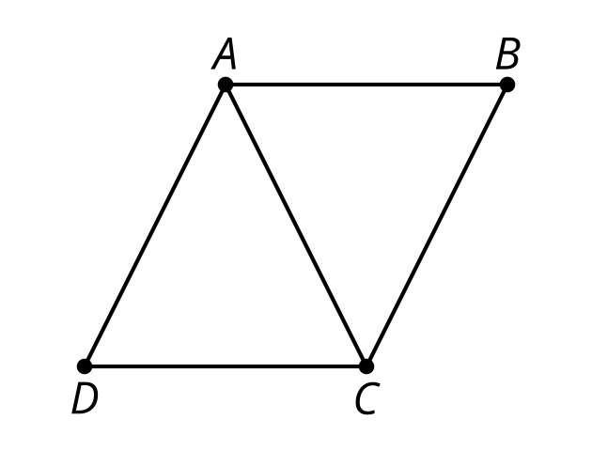
- Since $AD$ is parallel to $\underset{_}{1}$, alternate interior angles $\underset{_}{2}$ and $\underset{_}{3}$ are congruent. $AC$ is congruent to $\underset{_}{4}$ since segments are congruent to themselves. Along with the given information that $AD$ is congruent to $BC$, triangle $ADC$ is congruent to $\underset{_}{5}$by the $\underset{_}{6}$ Triangle Congruence. Since the triangles are congruent, all pairs of corresponding angles are congruent, so angle $DCA$ is congruent to $\underset{_}{7}$. Since those alternate interior angles are congruent, $AB$ must be parallel to $\underset{_}{8}$. Since we define a parallelogram as a quadrilateral with both pairs of opposite sides parallel, $ABCD$ is a parallelogram.
- (From Unit 2, Lesson 13.)
- Select the statement that must be true.
  - Parallelograms have at least one right angle.
  - If a quadrilateral has opposite sides that are both congruent and parallel, then it is a parallelogram.
  - Parallelograms have congruent diagonals.
  - The height of a parallelogram is greater than the lengths of the sides.
- (From Unit 2, Lesson 13.)
- $EFGH$ is a parallelogram and angle $HEF$ is a right angle. Select all statements that must be true.
- 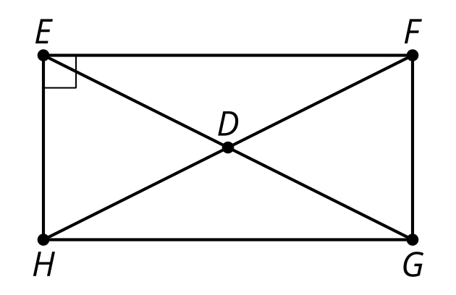
  - $EFGH$ is a rectangle.
  - Triangle $HEF$ is congruent to triangle $GFH$.
  - Triangle $HEF$ is congruent to triangle $FGH$.
  - $ED$ is congruent to $HD$, $DG$, and $DF$.
  - Triangle $EDH$ is congruent to triangle $HDG$.
- (From Unit 2, Lesson 12.)
- Figure $ABCD$ is a parallelogram. Is triangle $ADB$ congruent to triangle $CBD$? Show or explain your reasoning.

- $\overset{¯}{AB}≅\overset{¯}{CD},∠ADB≅∠CBD$
- 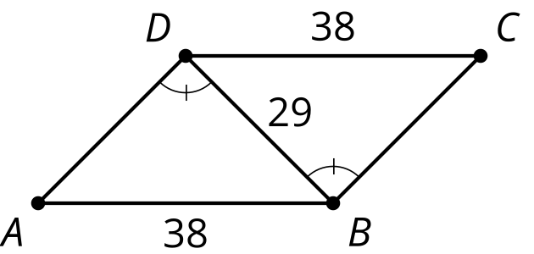

- (From Unit 2, Lesson 11.)
- Figure $KLMN$ is a parallelogram. Prove that triangle $KNL$ is congruent to triangle $MLN$.
- 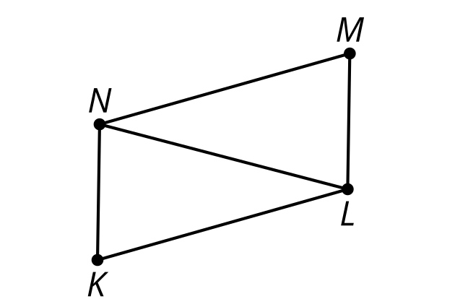

- (From Unit 2, Lesson 7.)
© CC BY 2019 by Illustrative Mathematics®

