Lesson 5: More Linear Relationships
Let’s explore some more relationships between two variables.

5.1: Growing
Look for a growing pattern. Describe the pattern you see.
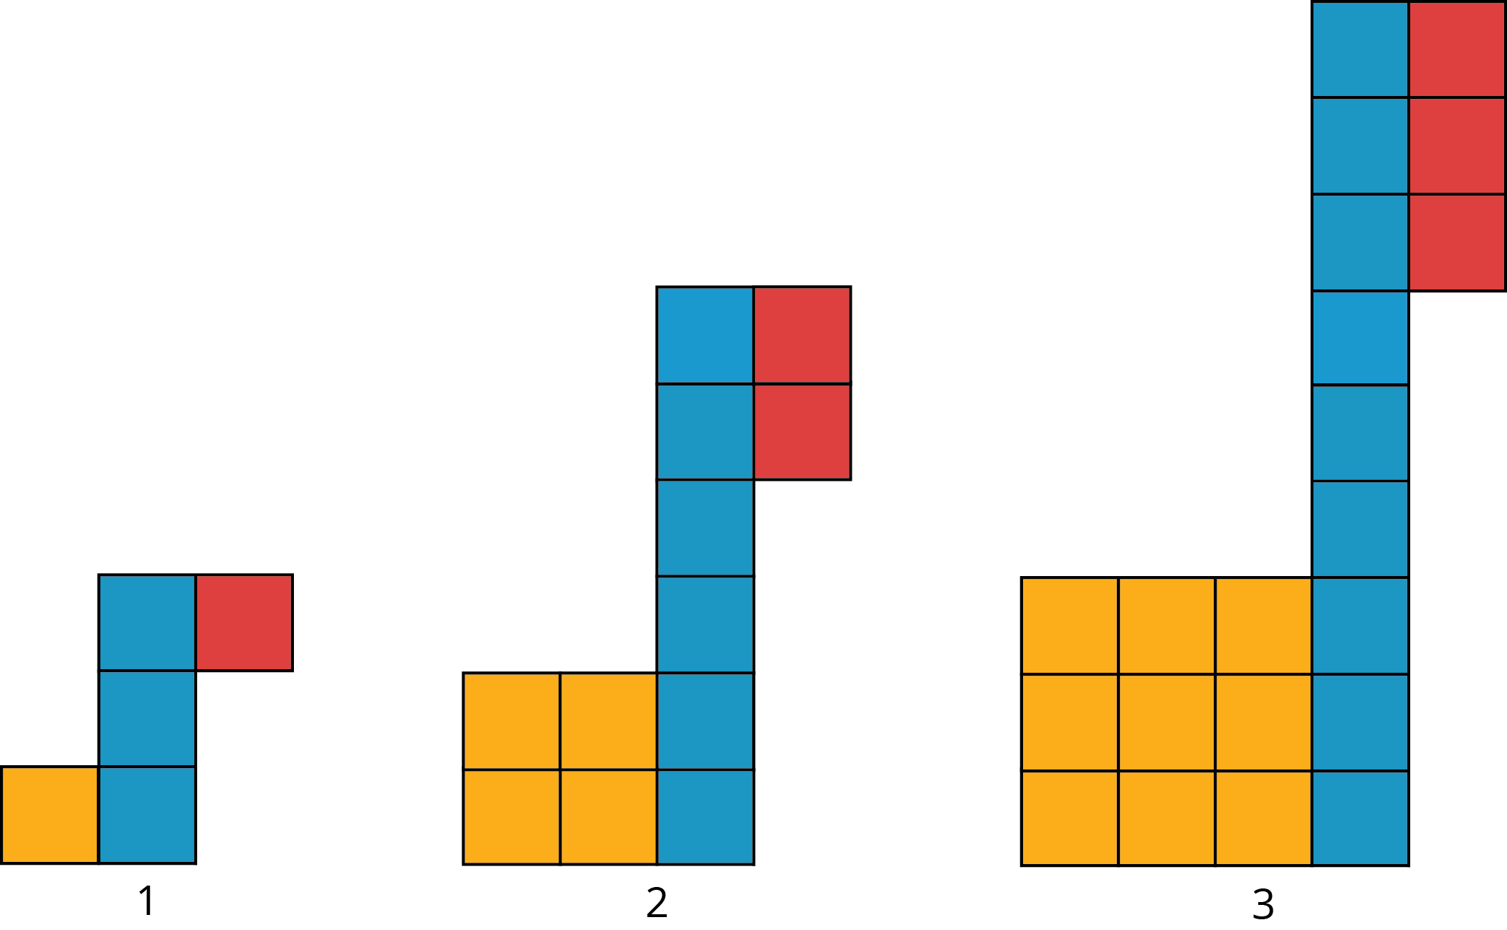
- If your pattern continues growing in the same way, how many tiles of each color will be in the 4th and 5th diagram? The 10th diagram?
- How many tiles of each color will be in the $n$th diagram? Be prepared to explain how your reasoning.

5.2: Slopes, Vertical Intercepts, and Graphs
Your teacher will give you 6 cards describing different situations and 6 cards with graphs.
- Match each situation to a graph.
- Pick one proportional relationship and one non-proportional relationship and answer the following questions about them.
  - How can you find the slope from the graph? Explain or show your reasoning.
  - Explain what the slope means in the situation.
  - Find the point where the line crosses the vertical axis. What does that point tell you about the situation?

5.3: Summer Reading
Lin has a summer reading assignment. After reading the first 30 pages of the book, she plans to read 40 pages each day until she finishes. Lin makes the graph shown here to track how many total pages she'll read over the next few days.
After day 1, Lin reaches page 70, which matches the point $\left(1,70\right)$ she made on her graph. After day 4, Lin reaches page 190, which does not match the point $\left(4,160\right)$ she made on her graph. Lin is not sure what went wrong since she knows she followed her reading plan.
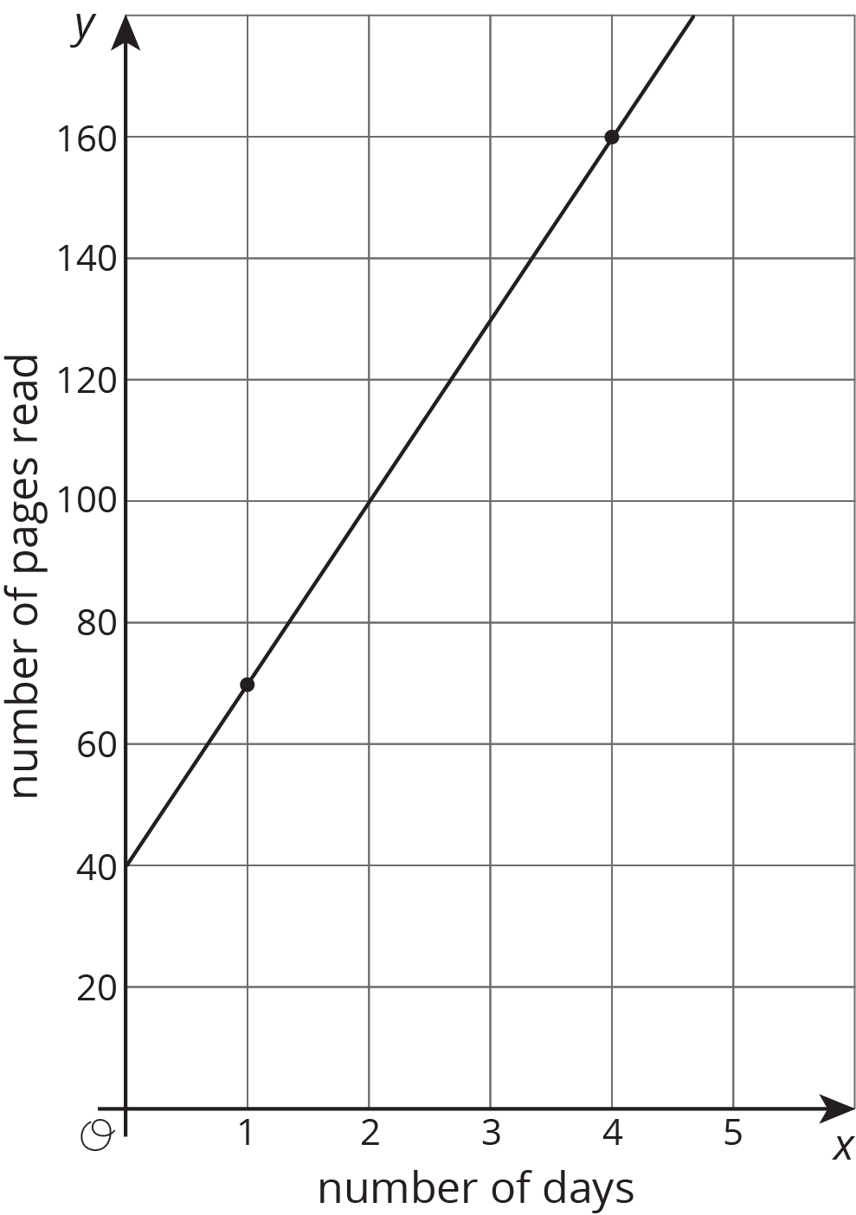
- Sketch a line showing Lin's original plan on the axes.
- What does the vertical intercept mean in this situation? How do the vertical intercepts of the two lines compare?
- What does the slope mean in this situation? How do the slopes of the two lines compare?

Are you ready for more?
Jada's grandparents started a savings account for her in 2010. The table shows the amount in the account each year.
If this relationship is graphed with the year on the horizontal axis and the amount in dollars on the vertical axis, what is the vertical intercept? What does it mean in this context?
year | amount in dollars
2010 | 600
2012 | 750
2014 | 900
2016 | 1050

Lesson 5 Summary
At the start of summer break, Jada and Lin decide to save some of the money they earn helping out their neighbors to use during the school year. Jada starts by putting $20 into a savings jar in her room and plans to save $10 a week. Lin starts by putting $10 into a savings jar in her room plans to save $20 a week. Here are graphs of how much money they will save after 10 weeks if they each follow their plans:
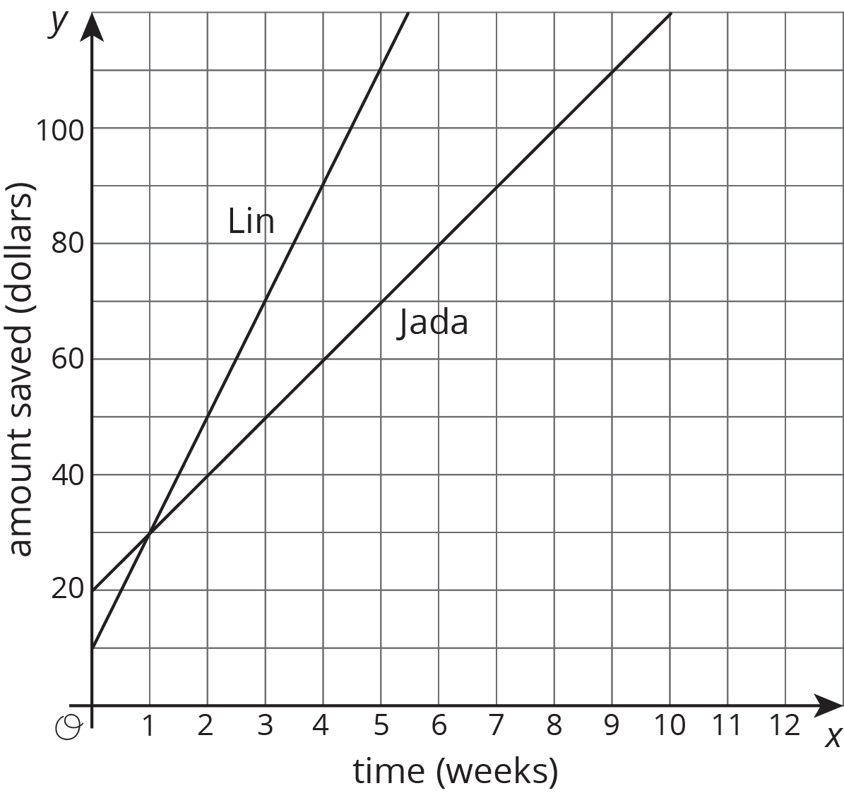
The value where a line intersects the vertical axis is called the vertical intercept. When the vertical axis is labeled with a variable like $y$, this value is also often called the $y$-intercept. Jada's graph has a vertical intercept of $20 while Lin's graph has a vertical intercept of $10. These values reflect the amount of money they each started with. At 1 week they will have saved the same amount, $30. But after week 1, Lin is saving more money per week (so she has a larger rate of change), so she will end up saving more money over the summer if they each follow their plans.
© CC BY Open Up Resources. Adaptations CC BY IM.

