Lesson 5: Más división

Standards Alignments
Addressing | 5.NBT.B.6

Teacher-facing Learning Goals
- Find whole-number quotients of whole numbers with up to four-digit dividends and two-digit divisors, using strategies based on place value, the properties of operations, and the relationship between multiplication and division.

Student-facing Learning Goals
- Dividamos.

Lesson Purpose
The purpose of this lesson is for students to find whole-number quotients of whole numbers with up to four-digit dividends and two-digit divisors, using strategies based on place value, the properties of operations, and the relationship between multiplication and division.
In previous units, students learned to find whole number quotients by successively subtracting and recording partial quotients.
The purpose of this lesson is for students to practice using this method to find whole number quotients. Students can choose which multiples of the divisor to subtract from the dividend. They reflect on the advantages and disadvantages of their choices when dividing. If students need additional support with the concepts in this lesson, refer back to Unit 4, Section B in the curriculum materials.
This lesson has a Student Section Summary.

Access for:

Students with Disabilities
- Engagement (Activity 2)

English Learners
- MLR8 (Activity 2)

Instructional Routines
Estimation Exploration (Warm-up)

Lesson Timeline
Warm-up | 10 min
Activity 1 | 20 min
Activity 2 | 15 min
Lesson Synthesis | 10 min
Cool-down | 5 min

Teacher Reflection Question
What do your students think it means to be good at math? How are you helping them change negative impressions they might have about their ability to reason mathematically?

Cool-down
(to be completed at the end of the lesson) 5min
Cocientes parciales

Standards Alignments
Addressing | 5.NBT.B.6

Student-facing Task Statement
- Encuentra el valor del cociente.
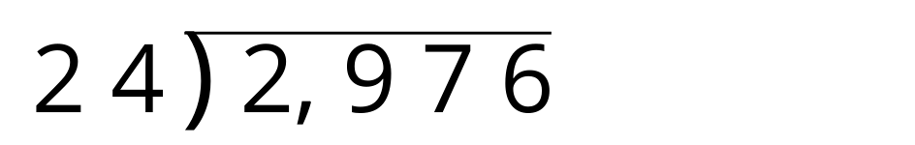

Student Responses
