Lesson 11 Practice Problems
- Which of the following criteria always proves triangles congruent? Select all that apply.
  - 3 congruent angles
  - 3 congruent sides
  - Corresponding congruent Side-Angle-Side
  - Corresponding congruent Side-Side-Angle
  - Corresponding congruent Angle-Side-Angle
- Here are some measurements for triangle $ABC$ and triangle $XYZ$:
  - Angle $ABC$ and angle $XYZ$ are both 30°
  - $BC$ and $YZ$ both measure 6 units
  - $CA$ and $ZX$ both measure 4 units
- Lin thinks thinks these triangles must be congruent. Priya says she knows they might not be congruent. Construct 2 triangles with the given measurements that aren't congruent. Explain why triangles with 3 congruent parts aren't necessarily congruent.
- Jada states that diagonal $WY$ bisects angles $ZWX$ and $ZYX$. Is she correct? Explain your reasoning,
- 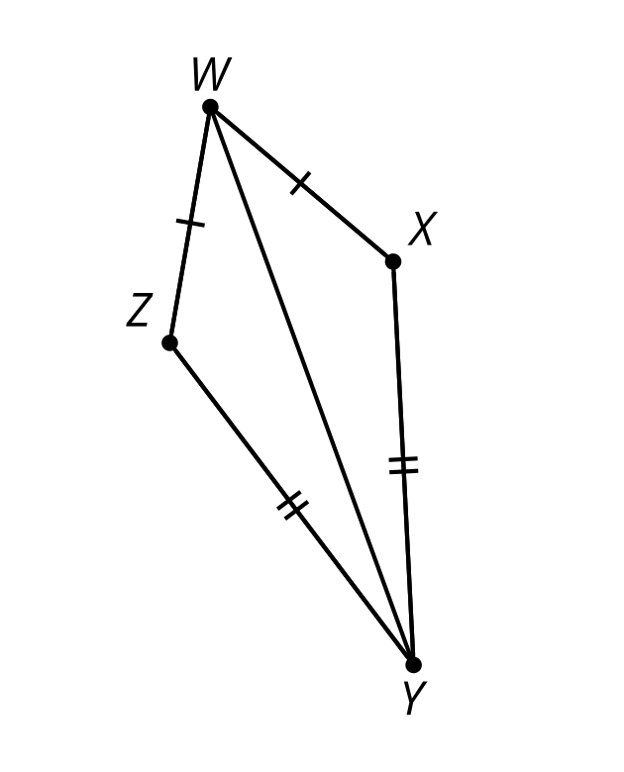
- (From Unit 2, Lesson 9.)
- Select all true statements based on the diagram.
- 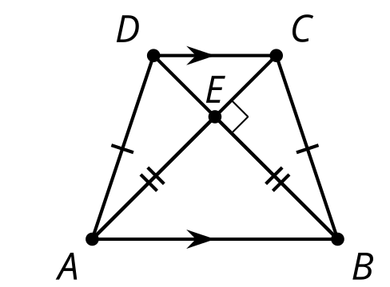
  - Angle $CBE$ is congruent to angle $DAE$.
  - Angle $CEB$ is congruent to angle $DEA$.
  - Segment $DA$ is congruent to segment $CB$.
  - Segment $DC$ is congruent to segment $AB$.
  - Line $DC$ is parallel to line $AB$.
  - Line $DA$ is parallel to line $CB$.
- (From Unit 2, Lesson 10.)
- $WXYZ$ is a kite. Angle $WXY$ has a measure of 94 degrees and angle $ZWX$ has a measure of 112 degrees. Find the measure of angle $ZYW$.
- 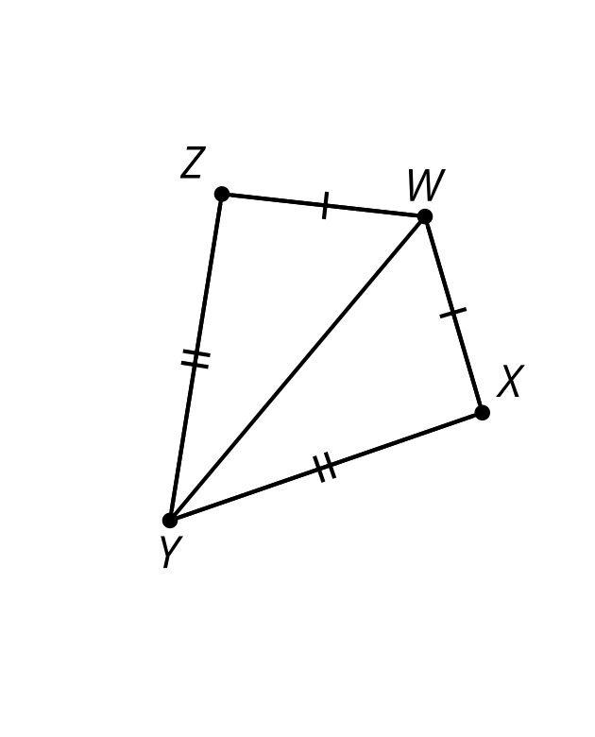
- (From Unit 2, Lesson 9.)
- Andre is thinking through a proof using a reflection to show that a triangle is isosceles given that its base angles are congruent. Complete the missing information for his proof.
- 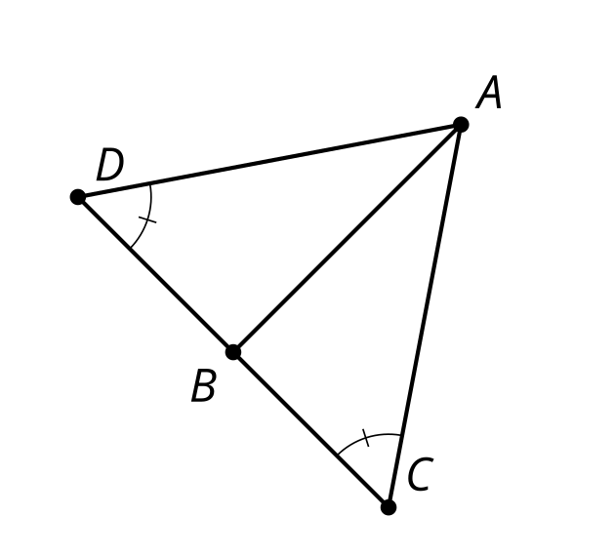
- Construct $AB$ such that $AB$ is the perpendicular bisector of segment $CD$. We know angle $ADB$ is congruent to $\underset{_}{1}$. $DB$ is congruent to $\underset{_}{2}$ since $AB$ is the perpendicular bisector of $CD$. Angle $\underset{_}{3}$ is congruent to angle $\underset{_}{4}$ because they are both right angles. Triangle $ABC$ is congruent to triangle $\underset{_}{5}$ because of the $\underset{_}{6}$ Triangle Congruence Theorem. $AD$ is congruent to $\underset{_}{7}$ because they are corresponding parts of congruent triangles. Therefore, triangle $ADC$ is an isosceles triangle.
- (From Unit 2, Lesson 8.)
- The triangles are congruent. Which sequence of rigid motions takes triangle $DEF$ onto triangle $BAC$?
- 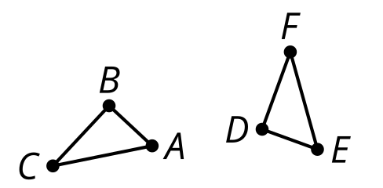
  - Translate $DEF$ using directed line segment $EA$. Rotate $D^{′}E^{′}F^{′}$ using $A$ as the center so that $D^{′}$ coincides with $C$. Reflect $D^{″}E^{″}F^{″}$ across line $AC$.
  - Translate $DEF$ using directed line segment $EA$. Rotate $D^{′}E^{′}F^{′}$ using $A$ as the center so that $D^{′}$ coincides with $C$. Reflect $D^{″}E^{″}F^{″}$ across line $AB$.
  - Translate $DEF$ using directed line segment $EA$. Rotate $D^{′}E^{′}F^{′}$ using $A$ as the center so that $D^{′}$ coincides with $B$. Reflect $D^{″}E^{″}F^{″}$ across line $AC$.
  - Translate $DEF$ using directed line segment $EA$. Rotate $D^{′}E^{′}F^{′}$ using $A$ as the center so that $D^{′}$ coincides with $B$. Reflect $D^{″}E^{″}F^{″}$ across line $AB$.
- (From Unit 2, Lesson 3.)
© CC BY 2019 by Illustrative Mathematics®

