Unit 3 Lesson 12: Arithmetic with Complex Numbers

1 Math Talk: Telescoping Sums (Warm up)

Student Task Statement
Find the value of these expressions mentally.
$2−2+20−20+200−200$
$100−50+10−10+50−100$
$3+2+1+0−1−2−3$
$1+2+4+8+16+32−16−8−4−2−1$

2 Adding Complex Numbers

Student Task Statement
- This diagram represents $\left(2+3i\right)+\left(\text{-}8−8i\right)$.
- 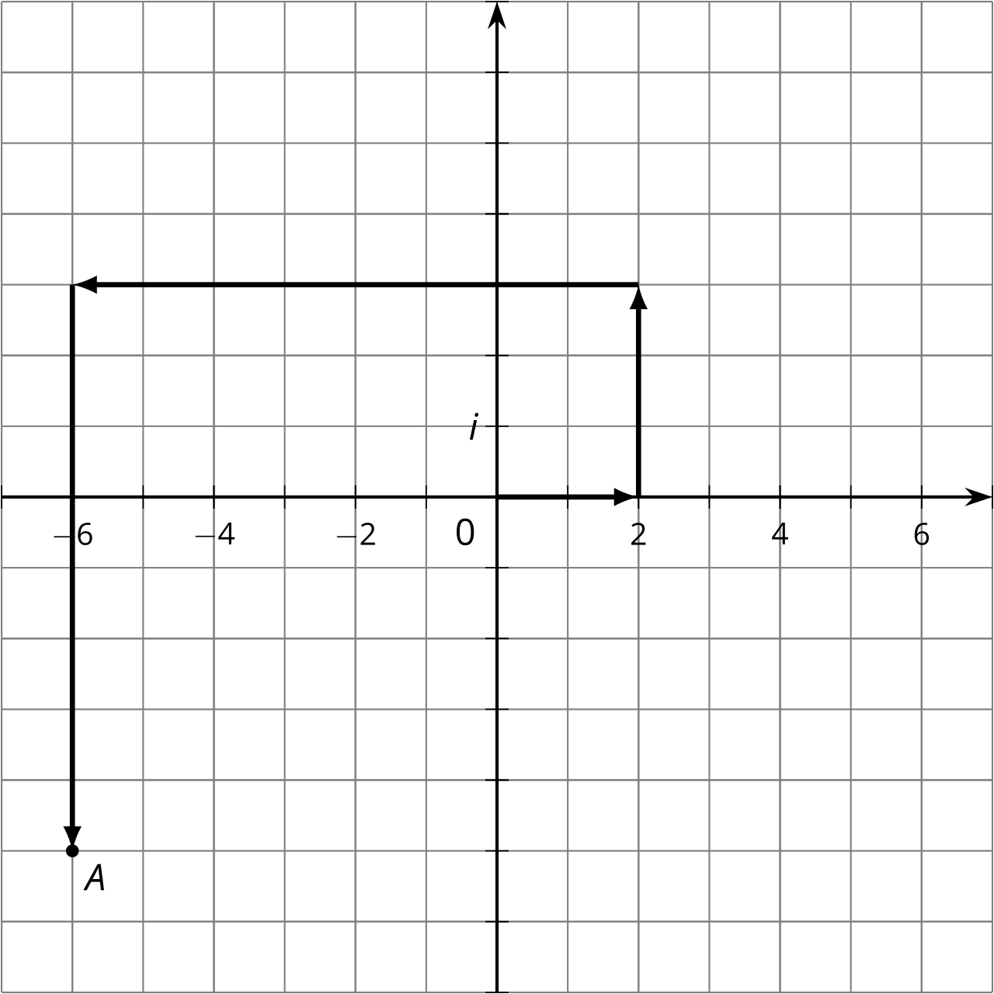
  - How do you see $2+3i$ represented?
  - How do you see $\text{-}8−8i$ represented?
  - What complex number does $A$ represent?
  - Add “like terms” in the expression $\left(2+3i\right)+\left(\text{-}8−8i\right)$. What do you get?
- Write these sums and differences in the form $a+bi$, where $a$ and $b$ are real numbers.
  - $\left(\text{-}3+2i\right)+\left(4−5i\right)$ (Check your work by drawing a diagram.)
  - $\left(\text{-}37−45i\right)+\left(11+81i\right)$
  - $\left(\text{-}3+2i\right)−\left(4−5i\right)$
  - $\left(\text{-}37−45i\right)−\left(11+81i\right)$

3 Multiplication on the Complex Plane

Student Task Statement
- Draw points to represent 2, 2², 2³, and 2⁴ on the real number line.

  - Write $2i$, ${\left(2i\right)}^{2}$, ${\left(2i\right)}^{3}$, and ${\left(2i\right)}^{4}$ in the form $a+bi$.
  - Plot $2i$, ${\left(2i\right)}^{2}$, ${\left(2i\right)}^{3}$, and ${\left(2i\right)}^{4}$ on the complex plane.
  - 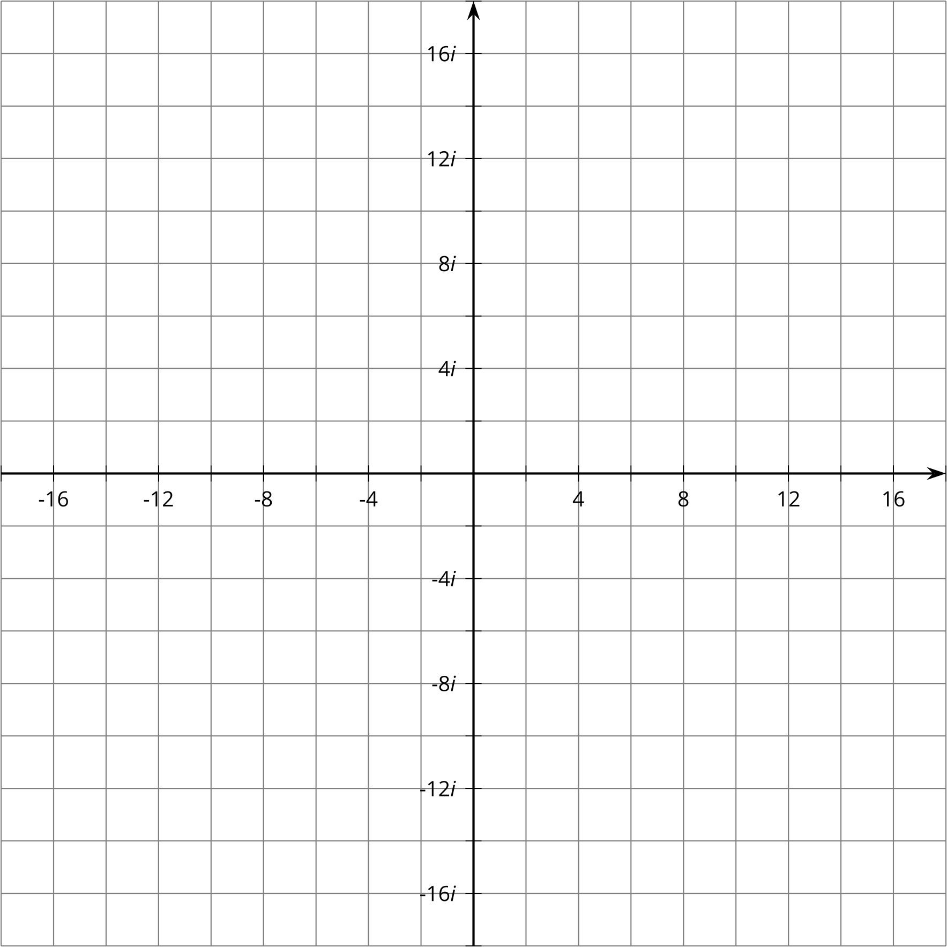
© CC BY 2019 by Illustrative Mathematics®

