Lesson 12: Problemas-historia y diagramas

Standards Alignments
Addressing | 2.NBT.B.5, 2.OA.A.1
Building Towards | 2.OA.A.1

Teacher-facing Learning Goals
- Make sense of diagrams that represent story problems.
- Solve one-step story problems within 100.

Student-facing Learning Goals
- Demos sentido a los diagramas y resolvamos problemas-historia.

Lesson Purpose
The purpose of this lesson is for students to solve story problems of different problem types within 100. Students interpret tape diagrams and connect them to different types of story problems.
In previous lessons, students solved different story problems within 50 and compared different diagrams and methods. Students interpreted and used tape diagrams to represent Compare story problems.
The problems in this lesson include some of the more challenging types (for example, Add To, Start Unknown). Students are introduced to tape diagrams as a way to represent the known and unknown quantities in Add To and Put Together / Take Apart problem types. Students are encouraged to find the unknown values in the way that makes the most sense to them. Students have opportunities to practice composing and decomposing a ten when using strategies based on adding or subtracting by place.

Access for:

Students with Disabilities
- Engagement (Activity 2)

Instructional Routines
Card Sort (Activity 2), MLR6 Three Reads (Activity 1), Notice and Wonder (Warm-up)

Materials to Gather
- Base-ten blocks: Activity 1
- Base-ten blocks: Activity 2

Materials to Copy
- Story Problem and Diagram Cards, Spanish (groups of 2): Activity 2

Lesson Timeline
Warm-up | 10 min
Activity 1 | 15 min
Activity 2 | 20 min
Lesson Synthesis | 10 min
Cool-down | 5 min

Teacher Reflection Question
How does matching the story problems to tape diagrams help students understand the relationship between the known and unknown quantities in a story problem? How will the work of today's lesson help students interpret and use equations to represent story problems?

Cool-down
(to be completed at the end of the lesson) 5min
Encuentra cuál corresponde

Standards Alignments
Addressing | 2.OA.A.1

Student-facing Task Statement
Mai juega un juego con semillas. Ella tiene algunas semillas en sus manos y ubicó 29 semillas en el tablero de juego. Tiene 53 semillas en total. ¿Cuántas semillas tiene Mai en sus manos?
- Marca el diagrama que mejor corresponda al problema-historia.

  - 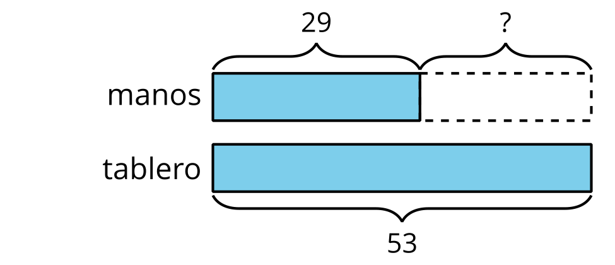

  - 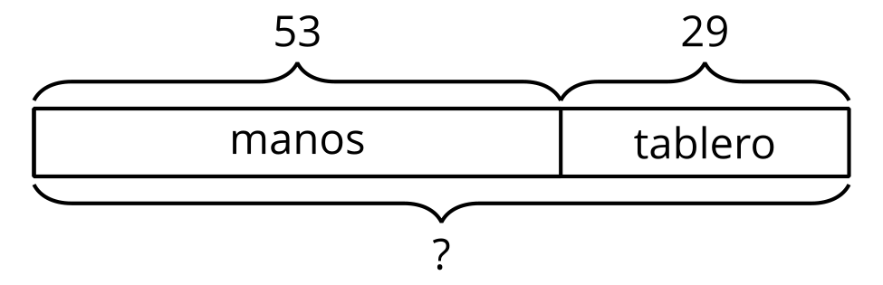

  - 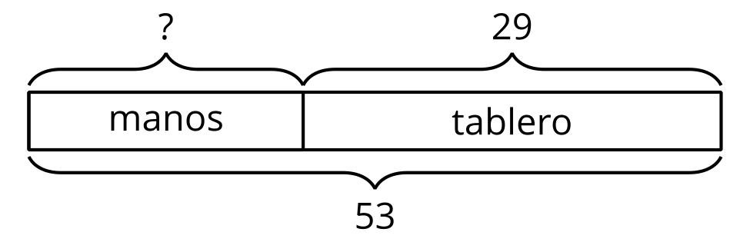
- Explica tu elección.

Student Responses
- C
- It shows we know how many seeds Mai has altogether, but we don’t know how many she has in her hands. The first part of the bar has a question mark to show that.

