Unit 2 Lesson 12: Solving More Ratio Problems

1 You Tell the Story (Warm up)

Student Task Statement
Describe a situation with two quantities that this tape diagram could represent.
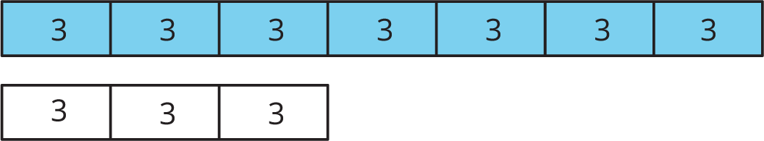

2 A Trip to the Aquarium

Student Task Statement
Consider the problem: A teacher is planning a class trip to the aquarium. The aquarium requires 2 chaperones for every 15 students. The teacher plans accordingly and orders a total of 85 tickets. How many tickets are for chaperones, and how many are for students?
- Solve this problem in one of three ways:
- Use a triple number line.
- 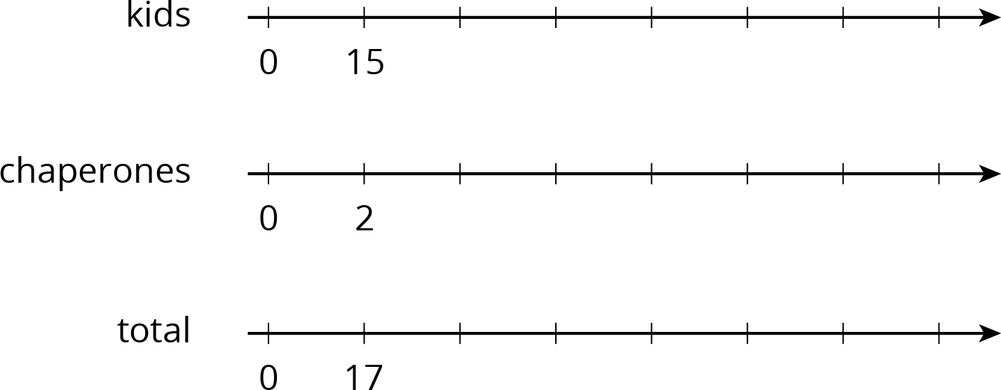
- Use a table.
(Fill rows as needed.)
- kids | - chaperones | - total
- 15 | - 2 | - 17
- Use a tape diagram.
- After your class discusses all three strategies, which do you prefer for this problem and why?

3 Salad Dressing and Moving Boxes

Student Task Statement
Solve each problem, and show your thinking. Organize it so it can be followed by others. If you get stuck, consider drawing a double number line, table, or tape diagram.
- A recipe for salad dressing calls for 4 parts oil for every 3 parts vinegar. How much oil should you use to make a total of 28 teaspoons of dressing?
- Andre and Han are moving boxes. Andre can move 4 boxes every half hour. Han can move 5 boxes every half hour. How long will it take Andre and Han to move all 72 boxes?
© CC BY Open Up Resources. Adaptations CC BY IM.

