Lesson 9 Practice Problems
- The student government snack shop sold 32 items this week. For each snack type, what percentage of all snacks sold were of that type?
- snack type | - number of items sold
- fruit cup | - 8
- veggie sticks | - 6
- chips | - 14
- water | - 4
- Select all the options that have the same value as $3\frac{1}{2}\%$ of 20.
  - 3.5% of 20
  - $3\frac{1}{2}⋅20$
  - $\left(0.35\right)⋅20$
  - $\left(0.035\right)⋅20$
  - 7% of 10
- 22% of 65 is 14.3. What is 22.6% of 65? Explain your reasoning.
- A bakery used 30% more sugar this month than last month. If the bakery used 560 kilograms of sugar last month, how much did it use this month?
- (From Unit 4, Lesson 7.)
- Match each situation to a diagram. The diagrams can be used more than once.
- 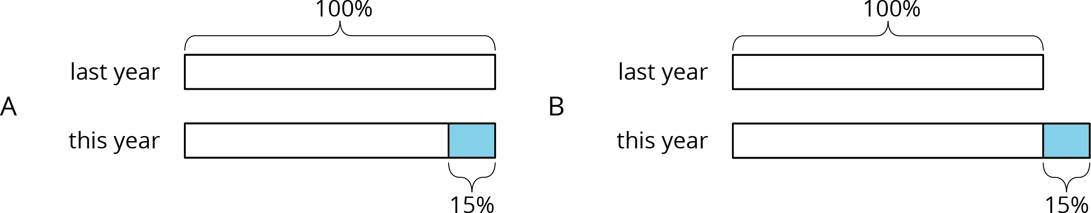
  - The amount of apples this year decreased by 15% compared with last year's amount.
  - The amount of pears this year is 85% of last year's amount.
  - The amount of cherries this year increased by 15% compared with last year's amount.
  - The amount of oranges this year is 115% of last year's amount.
  - Diagram A
  - Diagram B
- (From Unit 4, Lesson 6.)
- A certain type of car has room for 4 passengers.
  - Write an equation relating the number of cars ($n$) to the number of passengers ($p$).
  - How many passengers could fit in 78 cars?
  - How many cars would be needed to fit 78 passengers?
- (From Unit 2, Lesson 6.)
© CC BY Open Up Resources. Adaptations CC BY IM.

