Lesson 10 Practice Problems
- Painters and carpenters use scaffolding to climb buildings from the outside. What shapes do you see? Why does one figure have more right angles?
- 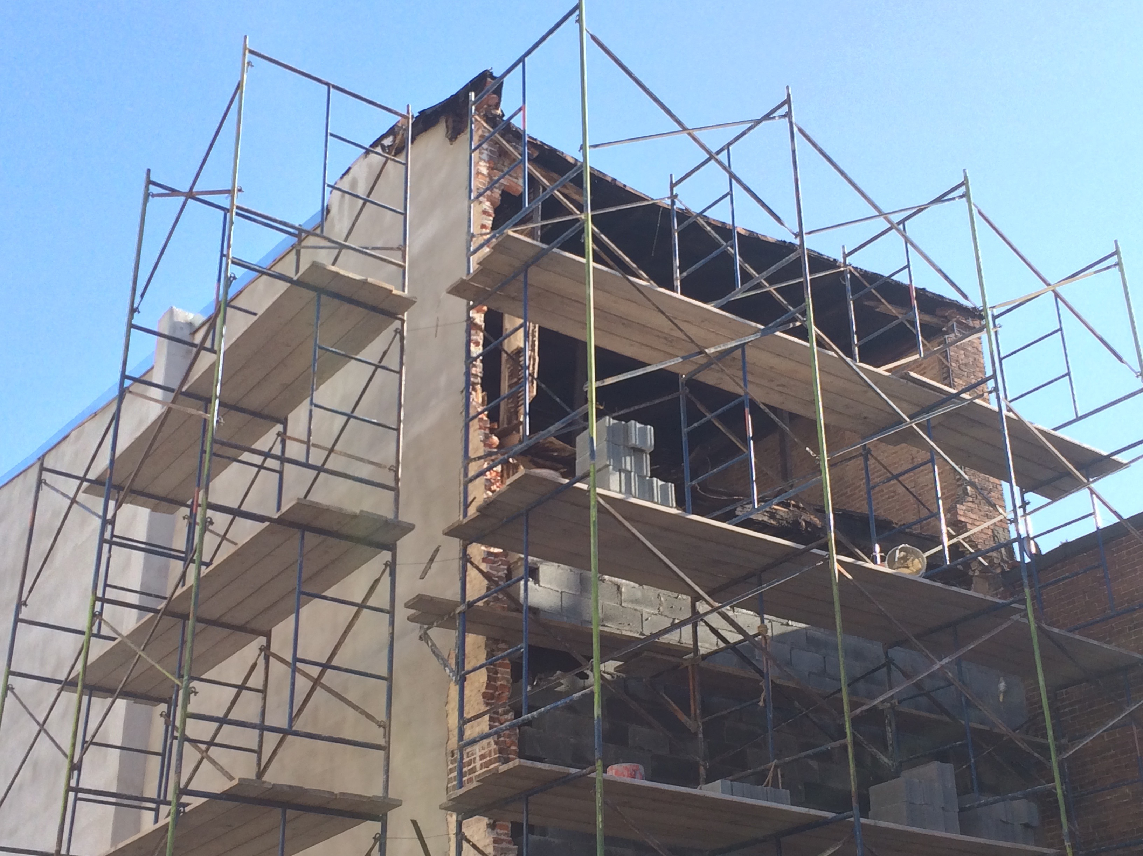
- 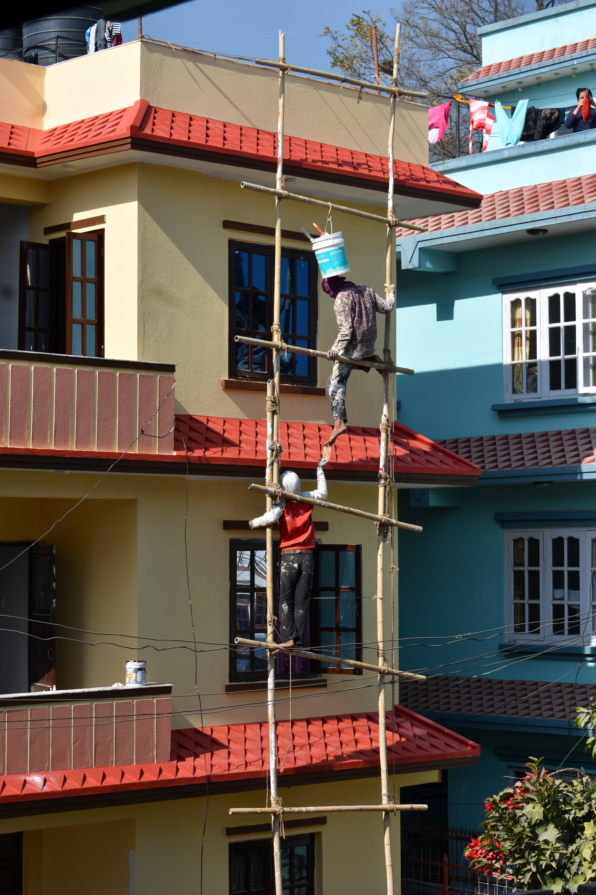
- Select all true statements based on the diagram.
- 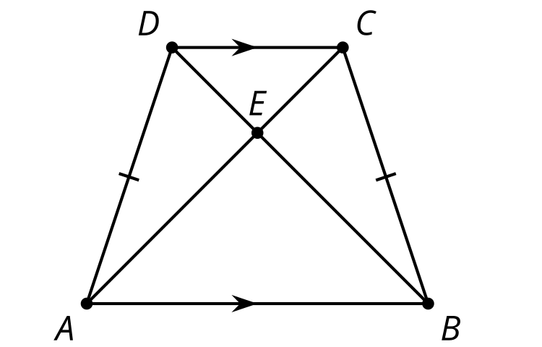
  - Angle $CBE$ is congruent to angle $ABE$.
  - Angle $CEB$ is congruent to angle $DEA$.
  - Segment $DA$ is congruent to segment $CB$.
  - Segment $DC$ is congruent to segment $AB$.
  - Line $DC$ is parallel to line $AB$.
  - Line $DA$ is parallel to line $CB$.
- Prove $ABCD$ is a parallelogram.
- 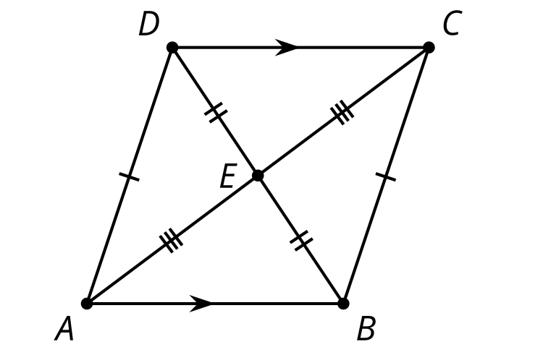
- Tyler has proven that triangle $WYZ$ is congruent to triangle $WYX$ using the Side-Side-Side Triangle Congruence Theorem. Why can he now conclude that diagonal $WY$ bisects angles $ZWX$ and $ZYX$?
- 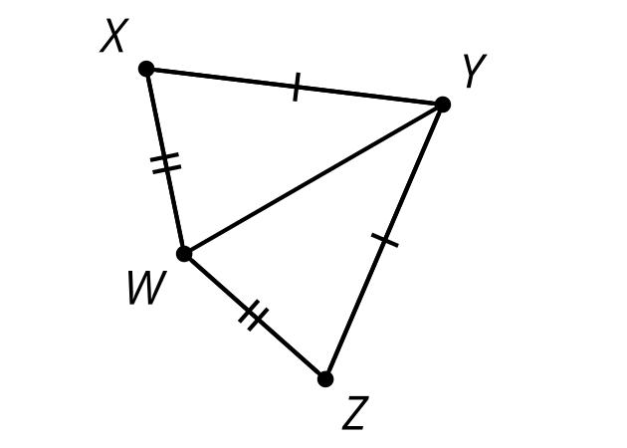
- (From Unit 2, Lesson 9.)
- $WXYZ$ is a kite. Angle $WXY$ has a measure of 133 degrees and angle $ZYX$ has a measure of 34 degrees. Find the measure of angle $ZWY$.
- 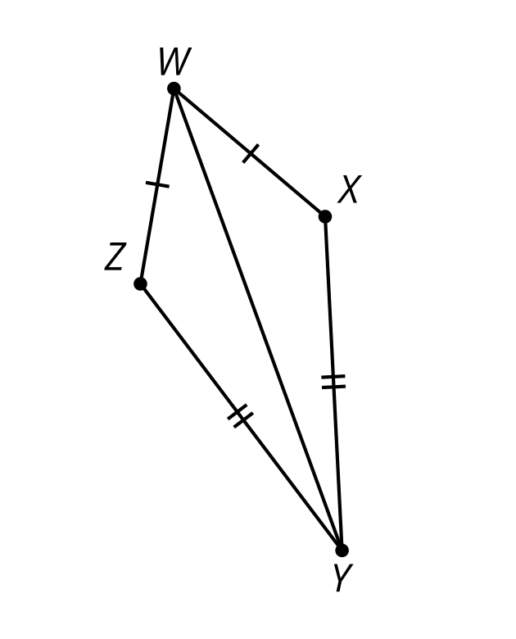
- (From Unit 2, Lesson 9.)
- Elena is thinking through a proof using a reflection to show that the base angles of an isosceles triangle are congruent. Complete the missing information for her proof.
- 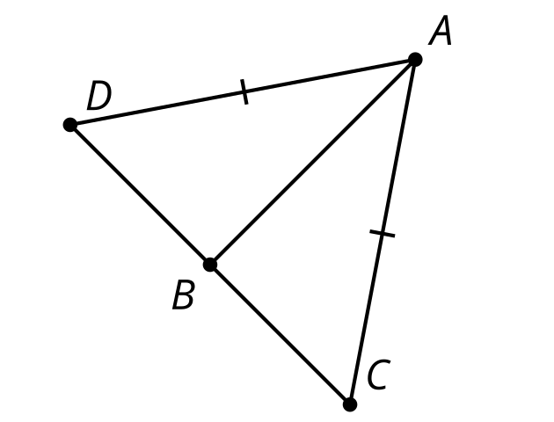
- Call the midpoint of segment $CD$ $\underset{_}{1}$. Construct the perpendicular bisector of segment $CD$. The perpendicular bisector of $CD$ must go through $B$ since it's the midpoint. $A$ is also on the perpendicular of $CD$ because the distance from $A$ to $\underset{_}{2}$ is the same as the distance from $A$ to $\underset{_}{3}$. We want to show triangle $ADC$ is congruent to triangle $ACD$. Reflect triangle $ADC$ across line $\underset{_}{4}$. Since $\underset{_}{5}$ is on the line of reflection, it definitely lines up with itself. $DB$ is congruent to $\underset{_}{6}$ since $AB$ is the perpendicular bisector of $CD$. $D^{′}$ will coincide with $\underset{_}{7}$ since it is on the other side of a perpendicular line and the same distance from it (and that’s the definition of reflection!). $C^{′}$ will coincide with $\underset{_}{8}$ since it is on the other side of a perpendicular line and the same distance from it (and that’s the definition of reflection!). Since the rigid transformation will take triangle $ADC$ onto triangle $ACD$, that means angle $\underset{_}{9}$ will be taken onto angle $\underset{_}{10}$ (they are corresponding parts under the same reflection), and therefore they are congruent.
- (From Unit 2, Lesson 8.)
- Segment $EG$ is an angle bisector of angle $FGH$. Noah wrote a proof to show that triangle $HEG$ is congruent to triangle $FEG$. Noah's proof is not correct. Why is Noah's proof incorrect?
- 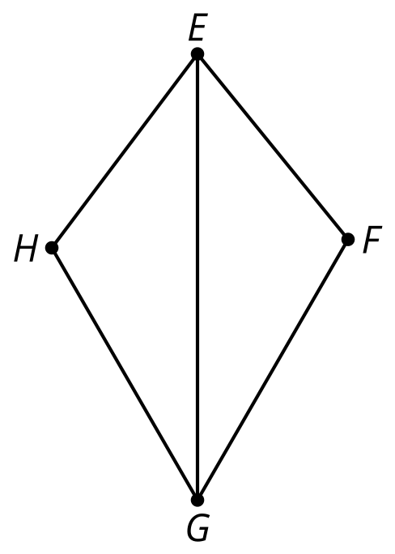
- ​​​​​​
  - Side $EG$ is congruent to side $EG$ because they're the same segment.
  - Angle $EGH$ is congruent to angle $EGF$ because segment $EG$ is an angle bisector of angle $FGH$.
  - Angle $HEG$ is congruent to angle $FEG$ because segment $EG$ is an angle bisector of angle $FGH$.
  - By the Angle-Side-Angle Triangle Congruence Theorem, triangle $HEG$ is congruent to triangle $FEG$.
- (From Unit 2, Lesson 7.)
- Figure $HNMLKEFG$ is the image of figure $ABCDKLMN$ after being rotated 90 degrees counterclockwise around point $K$. Draw an auxiliary line in figure $ABCDKLMN$ to create a quadrilateral. Draw the image of the auxiliary line when rotated 90 degrees counterclockwise around point $K$.
- Write a congruence statement for the quadrilateral you created in figure $ABCDKLMN$ and the image of the quadrilateral in figure $HNMLKEFG$.
- 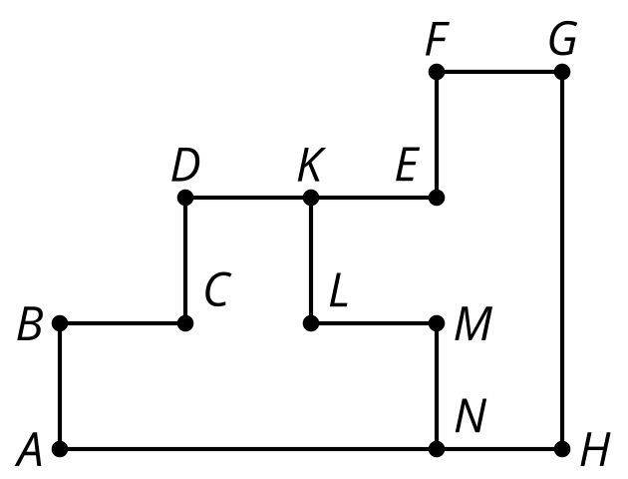
- (From Unit 2, Lesson 2.)
© CC BY 2019 by Illustrative Mathematics®

