Lesson 10 Practice Problems
- Sketch the graph of the function defined by the sum of function $F$ and each of these functions.
- 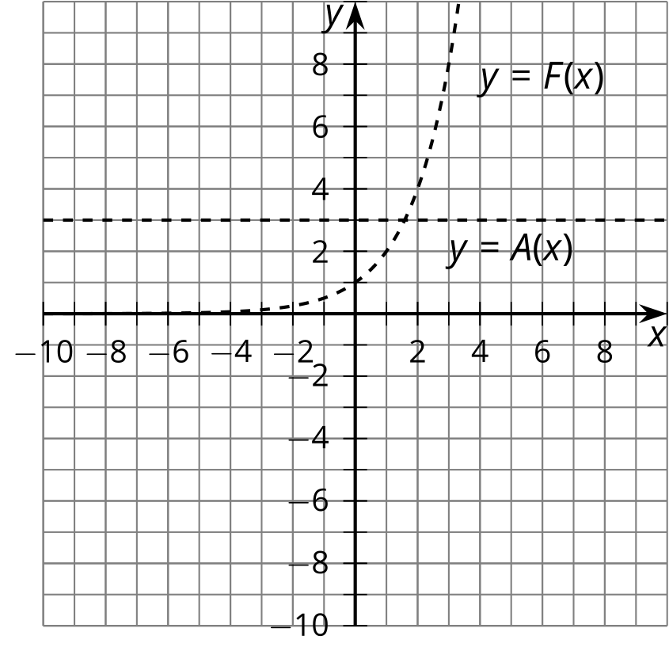
- 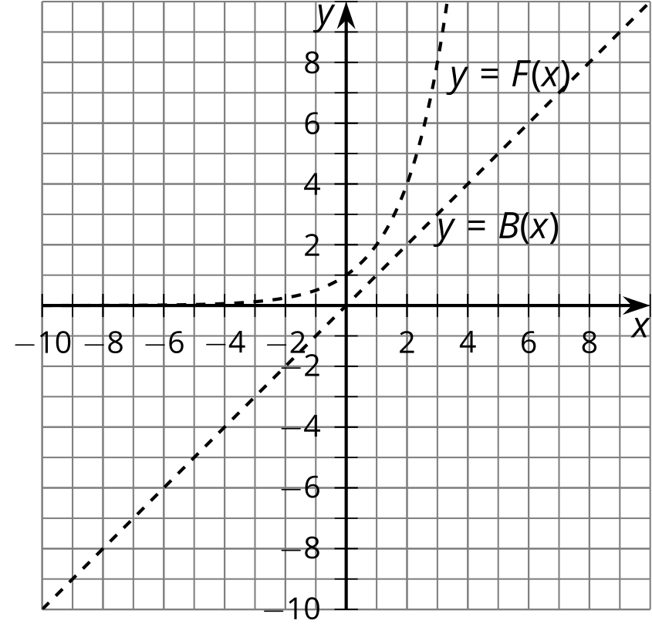
- 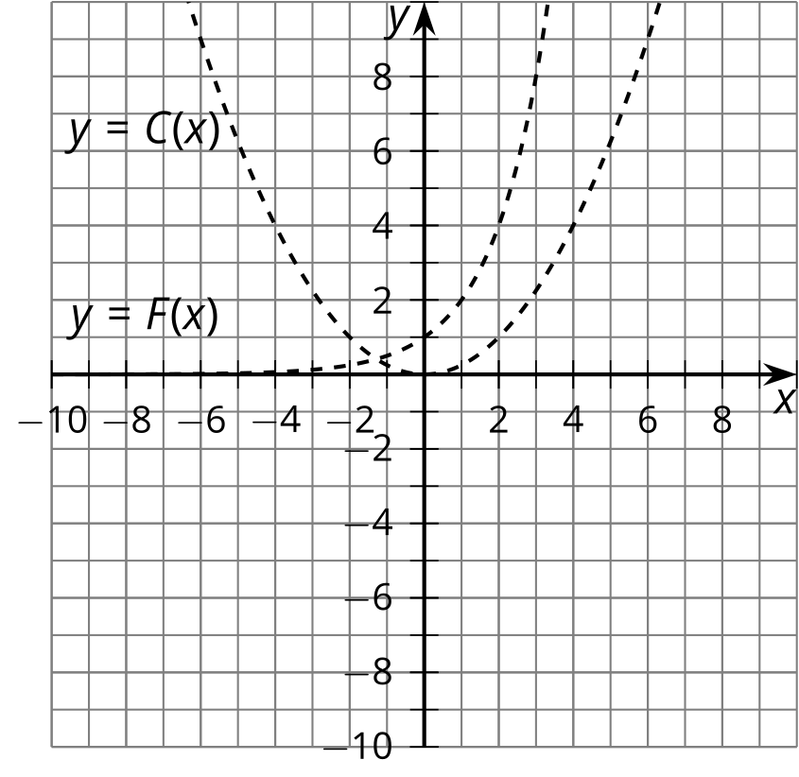
- 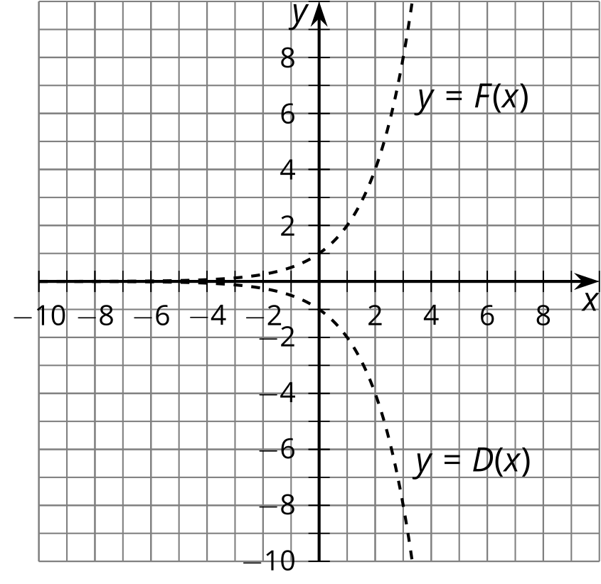
- Here are graphs of two functions $f$ and $g$. The function $h$ is defined by $h\left(x\right)=f\left(x\right)−g\left(x\right)$.
- 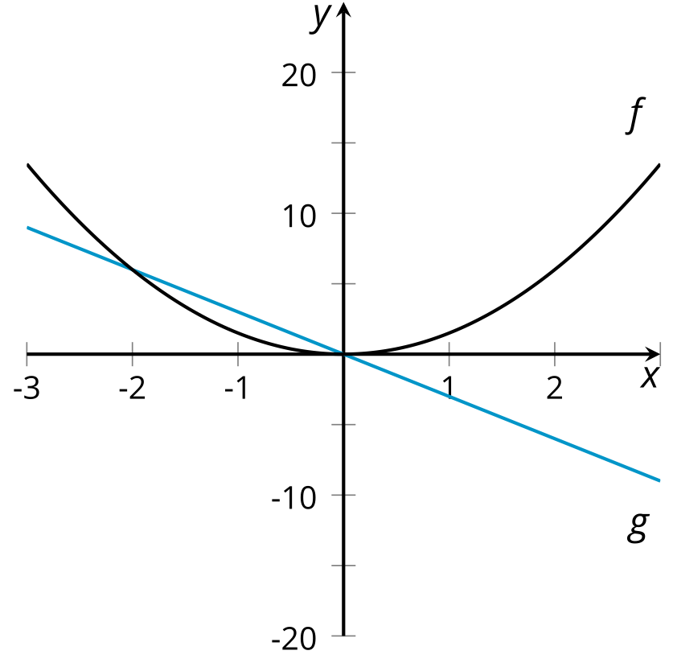
  - For which values of $x$ is $h\left(x\right)=0$? Explain how you know.
  - For which values of $x$ is $h\left(x\right)<0$? For which values of $x$ is $h\left(x\right)>0$?
  - Sketch a graph of $h$.
- The graph of each of these quadratic equations is a parabola. Explain how to find the vertex of each parabola by applying transformations to the graph of $y=x^{2}$.
  - $y={\left(x−1\right)}^{2}$
  - $y={\left(x−1\right)}^{2}+5$
  - $y=\text{-}{\left(x−1\right)}^{2}+5$
- (From Unit 5, Lesson 7.)
- The table shows the approximate United States population and the amount of sugar consumed in the given years.
- year | - 1800 | - 1850 | - 1900 | - 1950 | - 2000
- population (millions) | - 5 | - 23 | - 76 | - 161 | - 291
- pounds of sugar consumed (millions) | - 30 | - 460 | - 3,000 | - 12,000 | - 32,000
  - About how many pounds of sugar per year were consumed by each person in the 1800? 1850? 1900? 1950? 2000?
  - Plot the numbers on the graph.
- 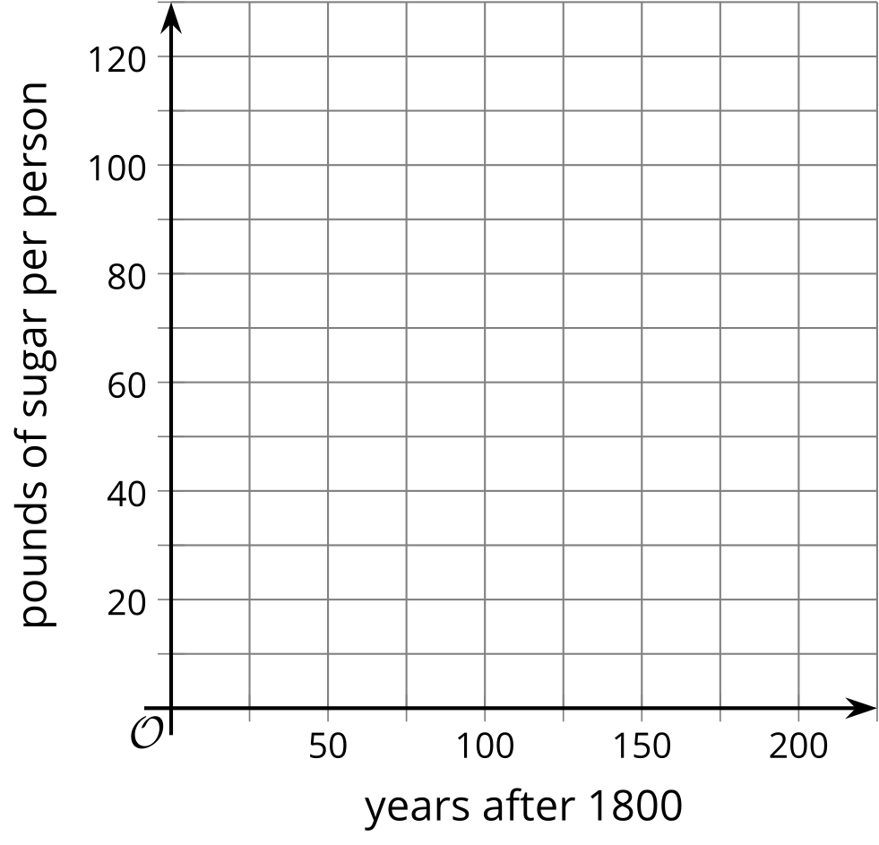
- Here is a graph of a function $f$.
  - Use the graph to explain why this function is neither odd nor even.
  - An equation defining $f$ is $f\left(x\right)=x^{2}−2x$. Use the equation to verify that $f$ is neither odd nor even.
- 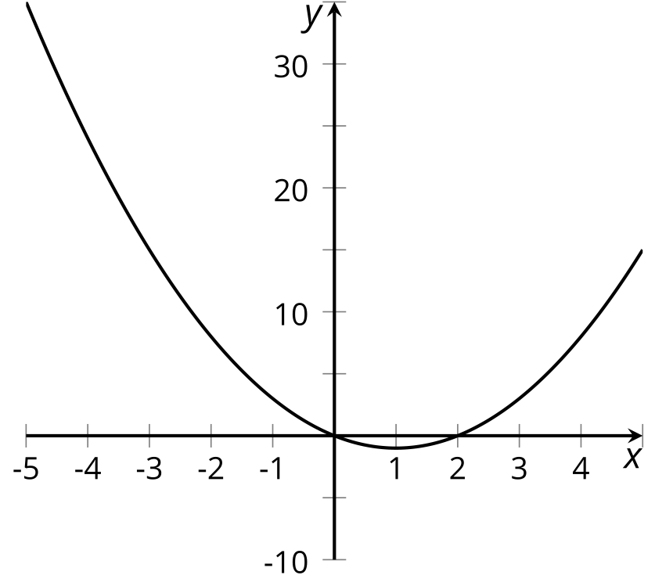
- (From Unit 5, Lesson 6.)
- In the table, we have the function $f$ which gives Clare’s height $f\left(t\right)$ above the ground, in feet, $t$ seconds after starting her descent from the top of the original Ferris wheel. Today Clare tried out two new Ferris wheels. The first one, whose height is given by the function $p$, is half the height of the original and turns at the same speed. The second one, whose height is given by the function $r$, is the same height has the original but turns at twice the speed.
- $t$ | - $f\left(t\right)$ | - $p\left(t\right)$ (half the height,  same speed) | - $r\left(t\right)$ (same height,  twice the speed)
- 0 | - 212
- 5 | - 181
- 10 | - 106
- 15 | - 31
- 20 | - 0
  - Fill in the table for functions $p$ and $r$.
  - Explain why there is not enough information to determine $r\left(15\right)$ and $r\left(20\right)$.
  - Express $p$ and $r$ in terms of $f$.
- (From Unit 5, Lesson 9.)
© CC BY 2019 by Illustrative Mathematics®

