Unit 2 Lesson 11: Part-Part-Whole Ratios

1 True or False: Multiplying by a Unit Fraction (Warm up)

Student Task Statement
True or false?
$\frac{1}{5}⋅45=\frac{45}{5}$
$\frac{1}{5}⋅20=\frac{1}{4}⋅24$
$42⋅\frac{1}{6}=\frac{1}{6}⋅42$
$486⋅\frac{1}{12}=\frac{480}{12}+\frac{6}{12}$

2 Cubes of Paint

Images for Launch
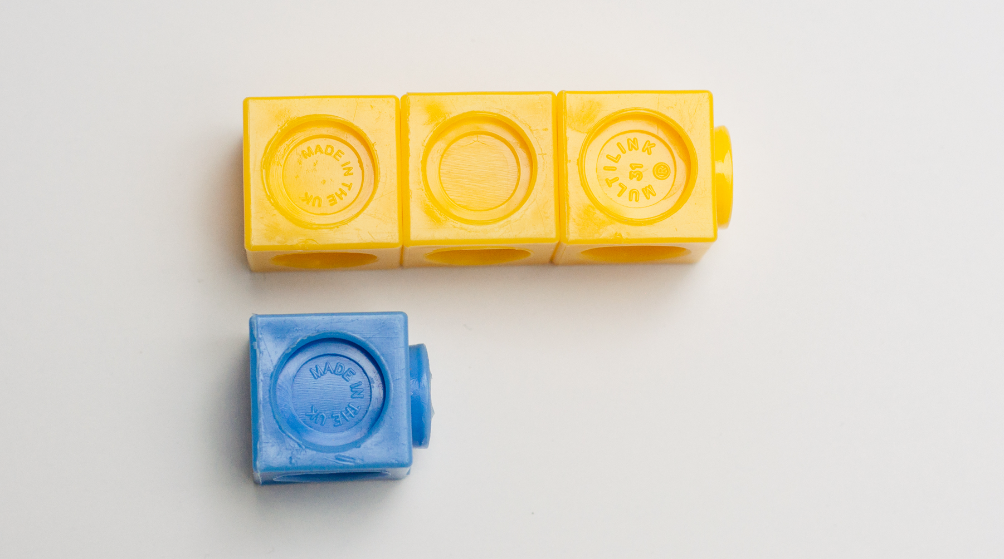

Student Task Statement
A recipe for maroon paint says, “Mix 5 ml of red paint with 3 ml of blue paint.”
- Use snap cubes to represent the amounts of red and blue paint in the recipe. Then, draw a sketch of your snap-cube representation of the maroon paint.
  - What amount does each cube represent?
  - How many milliliters of maroon paint will there be?

  - Suppose each cube represents 2 ml. How much of each color paint is there?
  - Red: _______ ml
  - Blue: _______ ml
  - Maroon: _______ ml
  - Suppose each cube represents 5 ml. How much of each color paint is there?
  - Red: _______ ml
  - Blue: _______ ml
  - Maroon: _______ ml

  - Suppose you need 80 ml of maroon paint. How much red and blue paint would you mix? Be prepared to explain your reasoning.
  - Red: _______ ml
  - Blue: _______ ml
  - Maroon: 80 ml
  - If the original recipe is for one batch of maroon paint, how many batches are in 80 ml of maroon paint?

Activity Synthesis
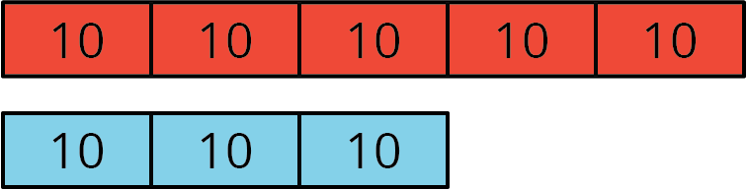
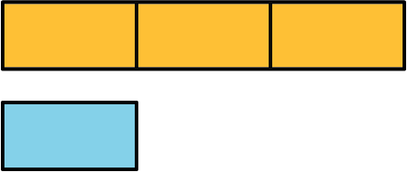
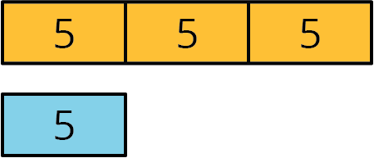

3 Sneakers, Chicken, and Fruit Juice

Student Task Statement
Solve each of the following problems and show your thinking. If you get stuck, consider drawing a tape diagram to represent the situation.
- The ratio of students wearing sneakers to those wearing boots is 5 to 6. If there are 33 students in the class, and all of them are wearing either sneakers or boots, how many of them are wearing sneakers?
- A recipe for chicken marinade says, “Mix 3 parts oil with 2 parts soy sauce and 1 part orange juice.” If you need 42 cups of marinade in all, how much of each ingredient should you use?
- Elena makes fruit punch by mixing 4 parts cranberry juice to 3 parts apple juice to 2 parts grape juice. If one batch of fruit punch includes 30 cups of apple juice, how large is this batch of fruit punch?

4 Invent Your Own Ratio Problem (Optional)

Student Task Statement
- Invent another ratio problem that can be solved with a tape diagram and solve it. If you get stuck, consider looking back at the problems you solved in the earlier activity.
- Create a visual display that includes:
  - The new problem that you wrote, without the solution.
  - Enough work space for someone to show a solution.
- Trade your display with another group, and solve each other’s problem. Include a tape diagram as part of your solution. Be prepared to share the solution with the class.
- When the solution to the problem you invented is being shared by another group, check their answer for accuracy.
© CC BY Open Up Resources. Adaptations CC BY IM.

