Lesson 1 Practice Problems
- A girl throws a paper airplane from her treehouse. The height of the plane is a function of time and can be modeled by the equation $h\left(t\right)=25+2.5t−\frac{1}{2}t^{2}$. Height is measured in feet and time is measured in seconds after the airplane is thrown.
  - Evaluate $h\left(0\right)$ and explain what this value means in this situation.
  - What would a solution to $h\left(t\right)=0$ mean in this situation?
  - What does the equation $h\left(9\right)=7$ mean?
  - What does the model say about the airplane 2.5 seconds after the girl throws it if each of these statements is true?
  - $h\left(2\right)=28$
  - $h\left(2.5\right)=28.125$
  - $h\left(3\right)=28$
- A square picture has a frame that is 3 inches thick all the way around. The total side length of the picture and frame is $x$ inches.
- Which expression represents the area of the square picture, without the frame? If you get stuck, try sketching a diagram.
  - $\left(2x+3\right)\left(2x+3\right)$
  - $\left(x+6\right)\left(x+6\right)$
  - $\left(2x−3\right)\left(2x−3\right)$
  - $\left(x−6\right)\left(x−6\right)$
- The revenue from a youth league baseball game depends on the price per ticket, $x$.
- Here is a graph that represents the revenue function, $R$.
- 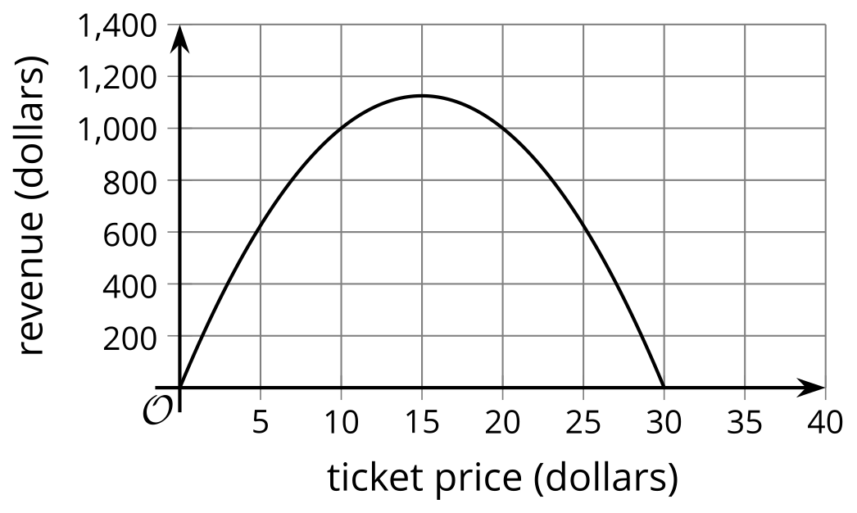
- Select all the true statements.
  - $R\left(5\right)$ is a little more than 600.
  - $R\left(600\right)$ is a little less than 5.
  - The maximum possible ticket price is $15.
  - The maximum possible revenue is about $1,125.
  - If tickets cost $10, the predicted revenue is $1,000.
  - If tickets cost $20, the predicted revenue is $1,000.
- A garden designer designed a square decorative pool. The pool is surrounded by a walkway.
- On two opposite sides of the pool, the walkway is 8 feet. On the other two opposite sides, the walkway is 10 feet.
- Here is a diagram of the design.​​​​​​
- 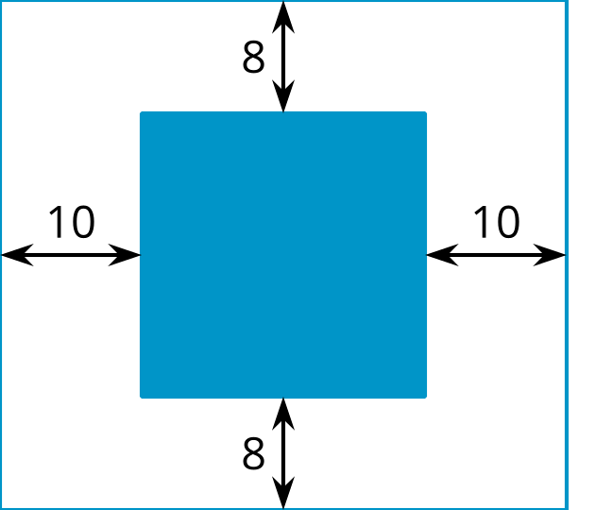
- The final design for the pool and walkway covers a total area of 1,440 square feet.
  - The side length of the square pool is $x$. Write an expression that represents:
    - the total length of the rectangle (including the pool and walkway)
    - the total width of the rectangle (including the pool and walkway)
    - the total area of the pool and walkway
  - Write an equation of the form: $\text{your expression}=1,​440$. What does a solution to the equation mean in this situation?
- Suppose $m$ and $c$ each represent the position number of a letter in the alphabet, but $m$ represents the letters in the original message and $c$ represents the letters in a secret code. The equation $c=m+2$ is used to encode a message.
  - Write an equation that can be used to decode the secret code into the original message.
  - What does this code say: "OCVJ KU HWP!"?
- (From Unit 4, Lesson 15.)
- An American traveler who is heading to Europe is exchanging some U.S. dollars for European euros. At the time of his travel, 1 dollar can be exchanged for 0.91 euros.
  - Find the amount of money in euros that the American traveler would get if he exchanged 100 dollars.
  - What if he exchanged 500 dollars?
  - Write an equation that gives the amount of money in euros, $e$, as a function of the dollar amount being exchanged, $d$.
  - Upon returning to America, the traveler has 42 euros to exchange back into U.S. dollars. How many dollars would he get if the exchange rate is still the same?
  - Write an equation that gives the amount of money in dollars, $d$, as a function of the euro amount being exchanged, $e$.
- (From Unit 4, Lesson 15.)
- A random sample of people are asked to give a taste score—either "low" or "high"—to two different types of ice cream. The two types of ice cream have identical formulas, except they differ in the percentage of sugar in the ice cream.
- What values could be used to complete the table so that it suggests there is an association between taste score and percentage of sugar? Explain your reasoning.
 | - 12% sugar | - 15% sugar
- low taste score | - 239
- high taste score | - 126
- (From Unit 3, Lesson 3.)
© CC BY 2019 by Illustrative Mathematics®

