Unit 7 Lesson 15: Multiplying Rational Numbers

1 Which One Doesn’t Belong: Expressions (Warm up)

Student Task Statement
Which expression doesn’t belong?
$7.9x$
$7.9⋅\left(\text{-}10\right)$
$7.9+x$
$\text{-}79$

2 Rational Numbers Multiplication Grid (Optional)

Student Task Statement
- Complete the shaded boxes in the multiplication square.
- 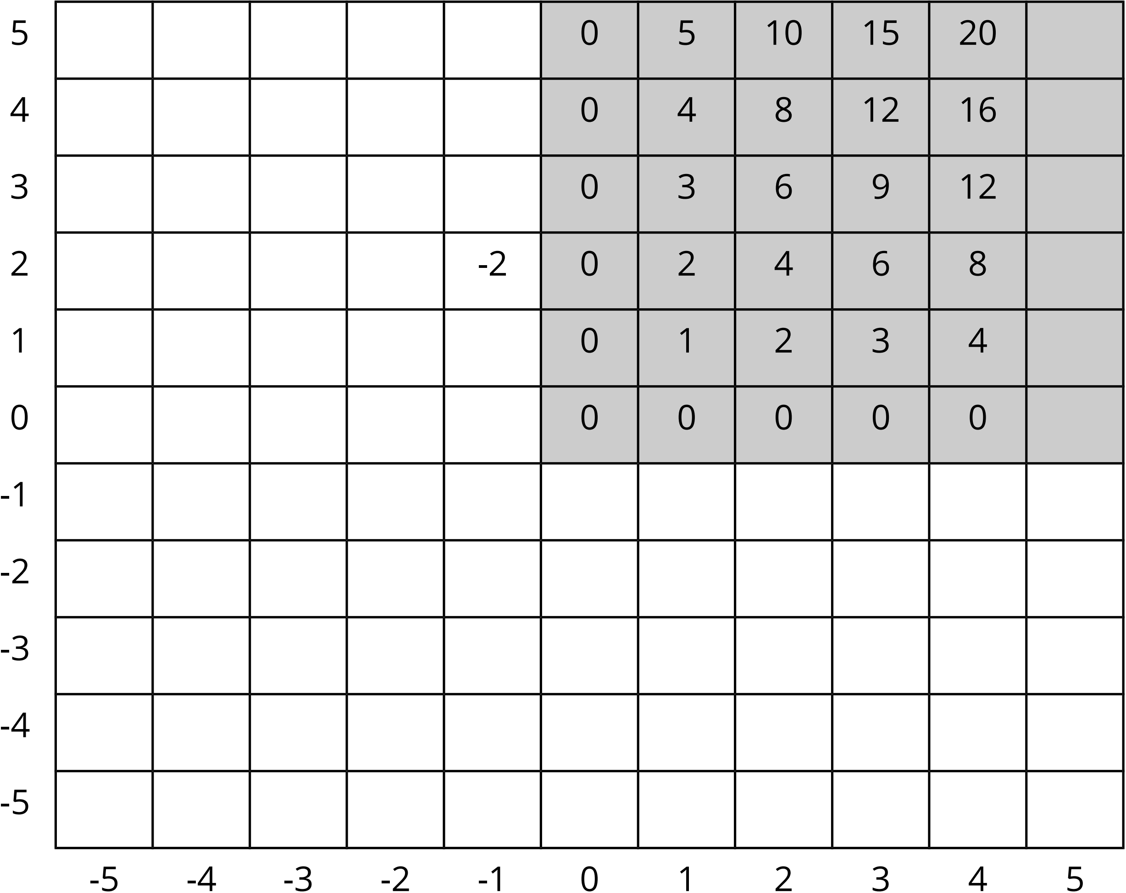
- Look at the patterns along the rows and columns. Continue those patterns into the unshaded boxes.
- Complete the whole table.
- What does this tell you about multiplication with negative numbers?

Activity Synthesis
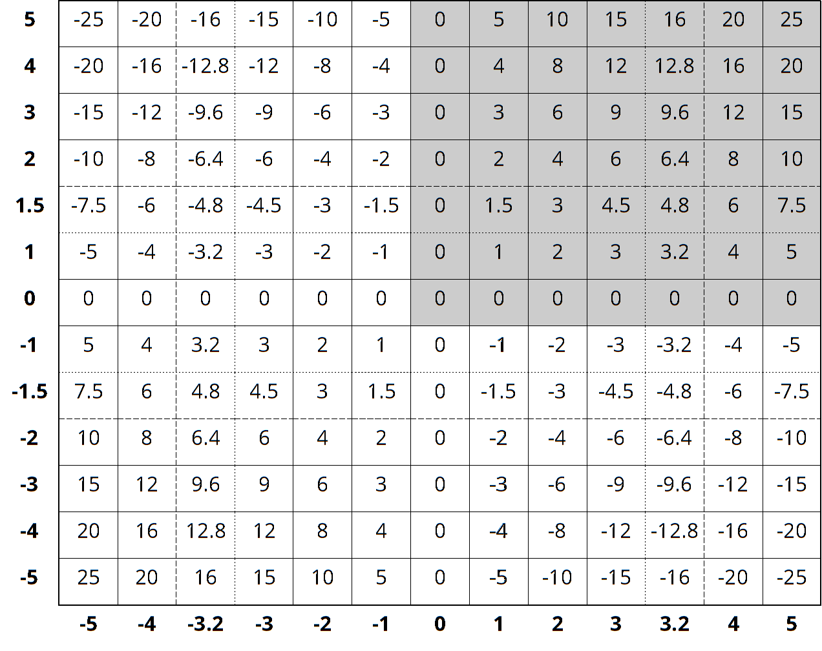

3 Card Sort: Matching Expressions (Optional)

Student Task Statement
Your teacher will give you cards with multiplication expressions on them. Match the expressions that are equal to each other. There will be 3 cards in each group.

4 Row Game: Multiplying Rational Numbers (Optional)

Student Task Statement
Evaluate the expressions in one of the columns. Your partner will work on the other column. Check in with your partner after you finish each row. Your answers in each row should be the same. If your answers aren’t the same, work together to find the error.
column A | column B
$790÷10$ | $\left(7.9\right)⋅10$
$\text{-}\frac{6}{7}⋅7$ | $\left(0.1\right)⋅\text{-}60$
$\left(2.1\right)⋅\text{-}2$ | $\left(\text{-}8.4\right)⋅\frac{1}{2}$
$\left(2.5\right)⋅\left(\text{-}3.25\right)$ | $\text{-}\frac{5}{2}⋅\frac{13}{4}$
$\text{-}10⋅\left(3.2\right)⋅\left(\text{-}7.3\right)$ | $5⋅\left(\text{-}1.6\right)⋅\left(\text{-}29.2\right)$
© CC BY Open Up Resources. Adaptations CC BY IM.

