Unit 2 Lesson 9: Navigating a Table of Equivalent Ratios

1 Number Talk: Multiplying by a Unit Fraction (Warm up)

Student Task Statement
Find the product mentally.
$\frac{1}{3}⋅21$
$\frac{1}{6}⋅21$
$\left(5.6\right)⋅\frac{1}{8}$
$\frac{1}{4}⋅\left(5.6\right)$

2 Comparing Taco Prices

Student Task Statement
number of tacos | price in dollars
Use the table to help you solve these problems. Explain or show your reasoning.
- Noah bought 4 tacos and paid $6. At this rate, how many tacos could he buy for $15?
- Jada’s family bought 50 tacos for a party and paid $72. Were Jada’s tacos the same price as Noah’s tacos?

3 Hourly Wages

Student Task Statement
Lin is paid $90 for 5 hours of work. She used the table to calculate how much she would be paid at this rate for 8 hours of work.
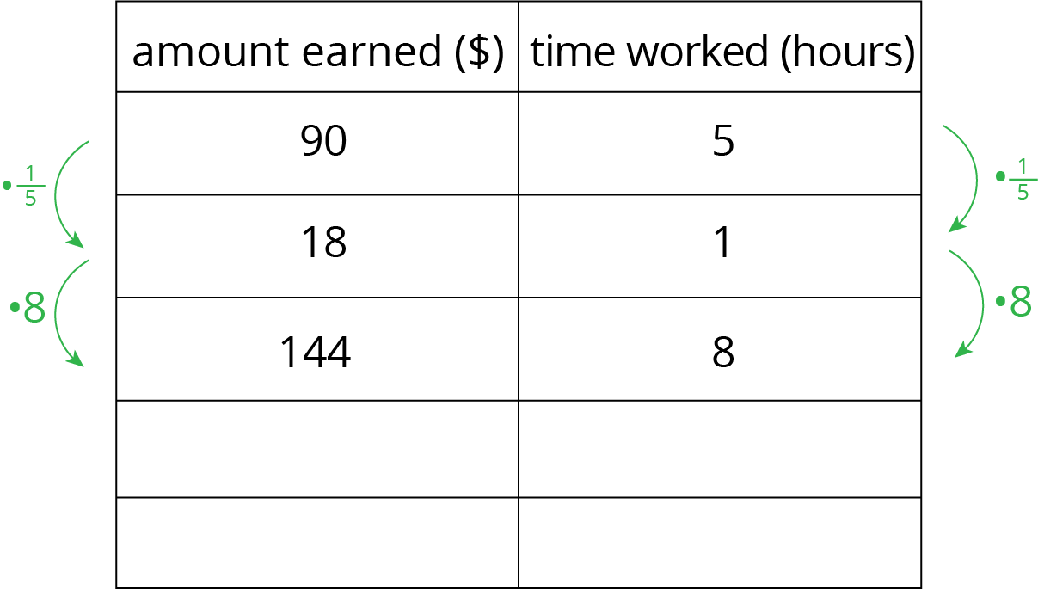
- What is the meaning of the 18 that appears in the table?
- Why was the number $\frac{1}{5}$ used as a multiplier?
- Explain how Lin used this table to solve the problem.
- At this rate, how much would Lin be paid for 3 hours of work? For 2.1 hours of work?

4 Zeno’s Memory Card (Optional)

Student Task Statement
In 2016, 128 gigabytes (GB) of portable computer memory cost $32.
- Here is a double number line that represents the situation:
- One set of tick marks has already been drawn to show the result of multiplying 128 and 32 each by $\frac{1}{2}$. Label the amount of memory and the cost for these tick marks.
- Next, keep multiplying by $\frac{1}{2}$ and drawing and labeling new tick marks, until you can no longer clearly label each new tick mark with a number.
- Here is a table that represents the situation. Find the cost of 1 gigabyte. You can use as many rows as you need.
- memory (gigabytes) | - cost (dollars)
- 128 | - 32
- Did you prefer the double number line or the table for solving this problem? Why?
© CC BY Open Up Resources. Adaptations CC BY IM.

