Lesson 7 Practice Problems
- What triangle congruence theorem could you use to prove triangle $ADE$ is congruent to triangle $CBE$?
- 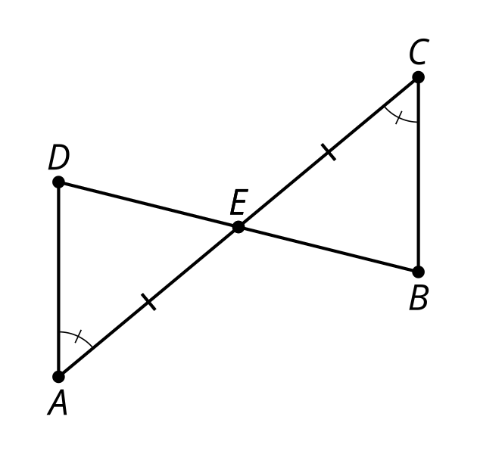
- Han wrote a proof that triangle $BCD$ is congruent to triangle $DAB$. Han's proof is incomplete. How can Han fix his proof?

- $DC∥AB$
- 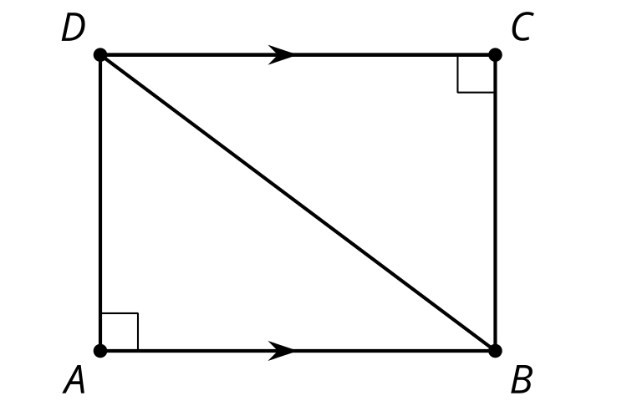
  - Line $AB$ is parallel to line $DC$ and cut by transversal $DB$. So angles $CDB$ and $ABD$ are alternate interior angles and must be congruent.
  - Side $DB$ is congruent to side $BD$ because they're the same segment.
  - Angle $A$ is congruent to angle $C$ because they're both right angles.
  - By the Angle-Side-Angle Triangle Congruence Theorem, triangle $BCD$ is congruent to triangle $DAB$.
- Segment $GE$ is an angle bisector of both angle $HEF$ and angle $FGH$. Prove triangle $HGE$ is congruent to triangle $FGE$.
- 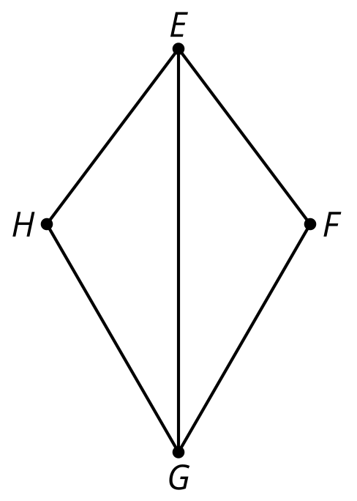
- Triangles $ACD$ and $BCD$ are isosceles. Angle $BAC$ has a measure of 33 degrees and angle $BDC$ has a measure of 35 degrees. Find the measure of angle $ABD$.
- 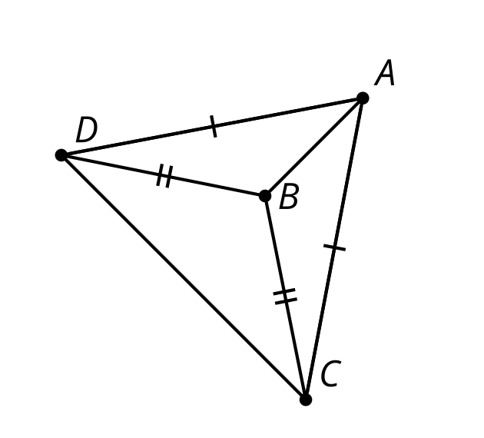
- (From Unit 2, Lesson 6.)
- Which conjecture is possible to prove?
  - All triangles with at least one side length of 5 are congruent.
  - All pentagons with at least one side length of 5 are congruent.
  - All rectangles with at least one side length of 5 are congruent.
  - All squares with at least one side length of 5 are congruent.
- (From Unit 2, Lesson 5.)
- Andre is drawing a triangle that is congruent to this one. He begins by constructing an angle congruent to angle $LKJ$. What is the least amount of additional information that Andre needs to construct a triangle congruent to this one?
- 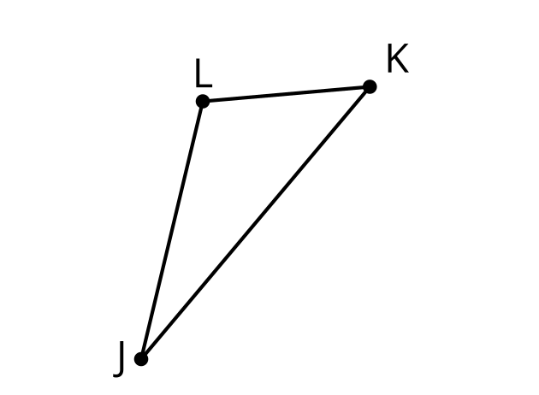
- (From Unit 2, Lesson 4.)
- Here is a diagram of a straightedge and compass construction. $C$ is the center of one circle, and $B$ is the center of the other. Which segment has the same length as segment $CA$?

- 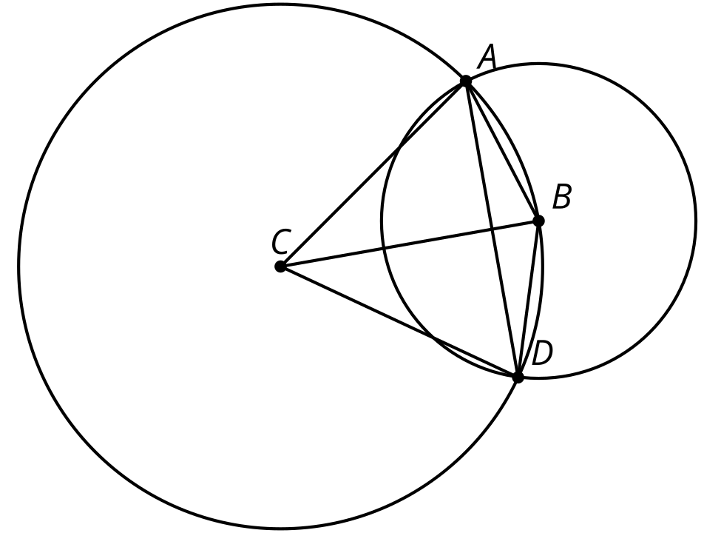

  - $BA$
  - $BD$
  - $CB$
  - $AD$
- (From Unit 1, Lesson 1.)
© CC BY 2019 by Illustrative Mathematics®

